**VoLTE: End to end QoS control**

The end to end QoS control is an important factor to be considered to provide a qualified service to users. It would become more so when the service is required to be provided in real time such as voice call or multimedia streaming.  If the voice call service is provided through the best-effort network where the QoS is not guaranteed, the users will experience frequent call attempt failure, call setup delay, call drop, voice cracking, etc.

In the following are introduced several different level of QoS control methodologies for VoLTE service.

**I. Separated APN for VoLTE**

The UE can attach multiple PDNs at the same time and each PDN connection can have multiple EPS bearers. Each PDN connectivity has one default EPS bearer and can have multiple dedicated EPS bearers up to 11 in total. The UE is assigned with a different IP address for each APN by the P-GW during PDN connectivity procedure for each APN.

[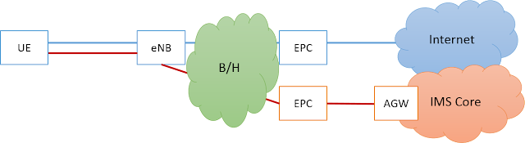](https://blogger.googleusercontent.com/img/b/R29vZ2xl/AVvXsEja5vOjoN8i-KKBvm9vPq7eJippJ-cO-XQEiHE9BRm72QsEtuy75wi5CXFY2MhUNtGekdkdK3Twlp6EKNkU1vysO1eQsn4yuTdBvCNWTNi5bwnEX-LDhjU90xxvdfyOMzrxSND5twwnmkM/s1600/multiple+pdn.png)

In general, the operator uses an IMS APN separately from the Internet APN. This dedicated APN for VoLTE service may have the intention to provide the quality of VoLTE service not to be affected by other non-real time service such as the internet service. The default APN is provided by the network based on subscriber profile fetched from the HSS during the initial attach procedure.

The following diagram shows a call flow of initial attach procedure. During the initial attach procedure, the MME obtains the APN list from the HSS in the Location Update Answer message as a part of subscriber's profile. The MME determines the default APN based on the received APN list and parameters, creates the GTP-C session with the corresponding S-GW/P-GW. Once the GTP-C session is created successfully, the default APN information is delivered to the UE in the Attach Accept message. If the default APN is pre-configured in the UE, the same should also be the part of the subscriber profile stored in HSS in order to avoid the conflict which leads to the attach failure. If the default APN is not an IMS APN, the UE has to trigger additional PDN Connectivity with its APN parameter set to "IMS".

NOTE the EPS bearer creation procedure is not shown in this diagram.

[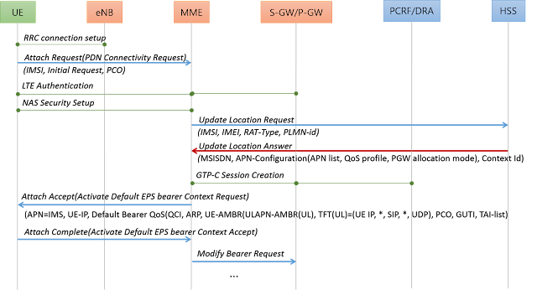](https://blogger.googleusercontent.com/img/b/R29vZ2xl/AVvXsEgmF4I0h3toQQ8l4sTO7j0Y-nHQlrBws9DyLnplh8jXZ9PQHUTP8UWcKNbBrN4g2WfeTB1kdwSihL6RJlSJYfTFTT6AzP9qRij5juXYXZkrOj5rBdB6cM9cuxjXYIjnh8F3w18eQ6pkO1M/s1600/initial+attach.png)

The following shows an example of the Location Update Answer message from the HSS which contains the APN list for the subscriber. Each APN-Configuration AVP under the APN-Configuration-Profile AVP contains the APN information. The Context-Identifier AVP which is one of sub AVPs of the APN-Configuration-Profile AVP is used to determine the defalut APN. Whereas, the same AVP under the Configuration-Profile AVP indicates the context identifier for respective APNs. Given this, the APN whose own Context-Identifier is matched with the upper level Context-Identifier will become the defualt APN.

In this example, there are three APNs in total and the "IMS" APN will be selected as a default APN of which Context-Identifier(=10) has the same value as upper level Context-Identifier.

[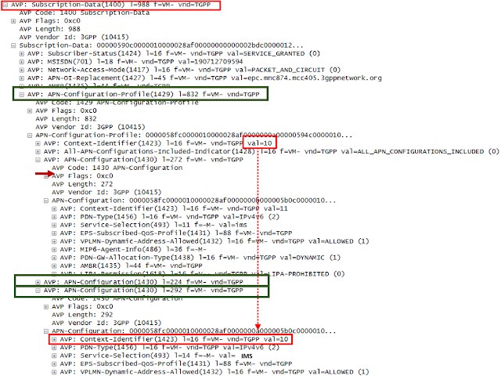](https://blogger.googleusercontent.com/img/b/R29vZ2xl/AVvXsEhN7rgQBv9GoC8MWUavS7c_DWfhJ8Xmo5x8Zxj2Um_56Lwhcll5LZMcR_w8ELuJdFH6YtMyo_Ei-Vi3aWCq7WbMhQ4aSykgE3tBvdxyrT5ue6Q7u2RaV9wcWxrOKoHw-o-x0GmbLeOqBy0/s1600/pcap-apnlist.png)

**II. PCC(Policy and Charging Control) rules**

When the PDN connection is established with the IMS APN, the EPC and the PCRF creates the EPS bearer of QCI=5 for IMS signaling. Since then, all the SIP signaling in VoLTE goes through this EPS bearer of QCI=5. Subsequently, when the user requests a VoLTE call setup and the media information is exchanged end to end, the EPC and the UE creates dedicated EPS bearer(e.g., QCI=1 for Voice, QCI=2 for Video, etc) to transfer media traffic.

The PCC architecture consists of P-CSCF(i.e., AF), PCRF, P-GW(i.e., PCEF) and S-GW(i.e., BBERRF). All of these components are involved in delivering the service data flow to the right EPS bearer with the right QoS conditions. The PCC rules generated or assigned by the PCRF define the mapping relations between the QoS paramemters and the service data flows. Upon receiving a VoLTE request(i.e., SIP INVITE with SDP offer), the P-CSCF extracts the 5-tuples of media information(i.e., source ip address, destination ip address, source port, destination port, protocol), codec profile, etc. The P-CSCF interworks these service data flow information to the PCRF and the PCRF either dynamically generates the corresponding PCC rules or assigns the predefined PCC rule. The PCC rules are provisioned to the P-GW. As its logical name suggests(i.e., PCEF), the P-GW performs gating control for the uplink/downlink traffic based on the given PCC rules. After successful PCC provisioning, the P-GW initiates the dedicated EPS bearer creation via the S-GW towards the eNB.   
  
[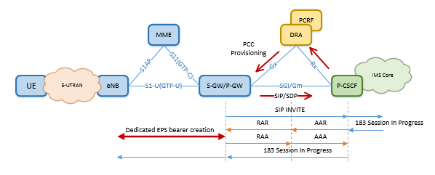](https://blogger.googleusercontent.com/img/b/R29vZ2xl/AVvXsEhuJNtWAudE-bnOmFU_vpm1aCrxSdAeQrzDgBM-1cO7XMmVYRDohcOPpsZvbMwHC6lH9OF0DURULxEeIt1ioBsu1mLzCDZtuczFAM46Sv3KXL1COVVYYt3VIU9HYjLr2wTwcjVjDxZejXM/s1600/PCC.png)  
  
The following example shows the PCC rule information in the RAR(Re-Authenticate Request) over Gx. In this case, there are two Charging-Rule-Definition AVPs defined each for RTP and RTCP respectively. The Charging-Rule-Definition AVP contains various information that is required for service data control such as PCC rule name(i.e., Charging-Rule-Name AVP), 5-tuple for each direction(i.e., Flow-Information AVP), QoS parameters(i.e., QoS-Information AVP), etc. The QOS parameters includes the QCI, GBR(UL/DL), AMBR(UL/DL), ARP, etc.

[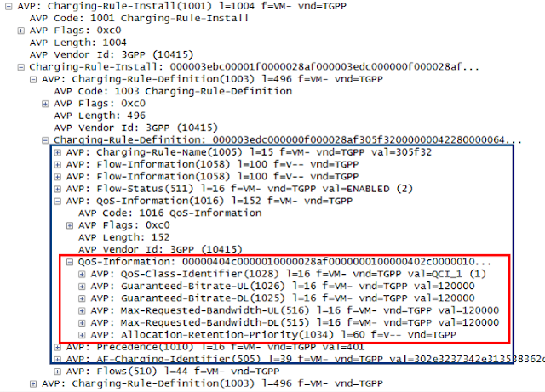](https://blogger.googleusercontent.com/img/b/R29vZ2xl/AVvXsEjid7lt943g2SPUt8t5slttdwrS8SQYX_WmAJA0HIw54Otkk9D8gJJHz-KKuSal15nrjbwHrODNvYP6FTnbq_MDxGyA2haV81WJuazoBBf5HDv3SgPs3jzt08BpJbzKo_39zTnpyFCoi38/s1600/pcap-pccrules.png)

* QCI(CoS Class Index): A level of QoS classified based on the required quality per service usages.
* GBR(Guaranteed Bit Rate) : The minimum bit rate to be guaranteed for the given bearer. A certain amount of bandwidth will be reserved for this bearer. The GBR bearer always takes up resources over the radio link, even if no traffic is sent.
* AMBR(Aggregated Maximum Bit Rate) : The total bit rate that is allowed to be used for all non-GBR bearers associated with a specific APN/UE.
* ARP(Allocation and Retention Priority) : Being used to indicate a priority for the allocation and retention of bearers. It’s typically used to decide whether a bearer establishment or modification can be accepted or needs to be rejected due to resource limitations..

**III. DSCP(Differentiated Services Code Point) marking**

The DSCP marking is an IP level QoS control for each IP packet to flow through the backhaul with a certain priority and the appropriate latency. As the IP packets from different PDN with different QCI values will be mixed inside the backhaul(e.g., VoLTE, internet), the DSCP marking at IP layer would be an important factor to be considered by switches and routers to guarantee the quality service for VoLTE. Without DSCP marking, IP packets can be delayed or dropped significantly when there is a burst of IP traffic at the same time within the IP network.

The DSCP marking shall be done by both end points of the backhaul for both uplink and downlink IP packets based on the QCI of the service traffic. The following shows a recommended DSCP mapping relations between the QCI and the DSCP values as specified in GSMA IR.34 "Inter-Service Provider IP backbone guidelines". For instance, the IP packets with QCI=1 and 2 for voice and video respectively is marked with the 2E, whereas the IP packets with QCI=5 for IMS signaling will be marked as 1A.

NOTE the DSCP-QCI mapping relation is a part of operator's policy. All the switches and routers aware of DSCP values needs to adjust itself to the correct behavior according to the agreed DSCP values as to handling the IP packets.

[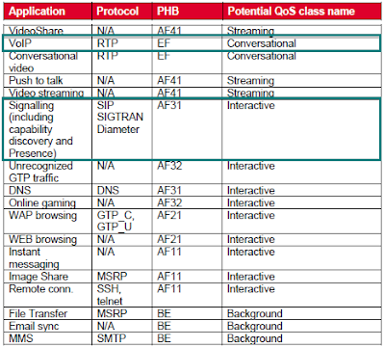](https://blogger.googleusercontent.com/img/b/R29vZ2xl/AVvXsEgVJJ7JbBCRCCfkW9Gr5JdJXn6YkBhoJ5vUFTn_PcGCerl2j6ouIoZGL_UWv_ISCV84I4sc3hRell6v7EDKGEpi2oKIZVW4YWP3vGhbz48VRhwbcDuJM8Mtuhaa3066ZJ1kCt2-nwFYwiI/s1600/app+mapping+into+DSCP.png)

[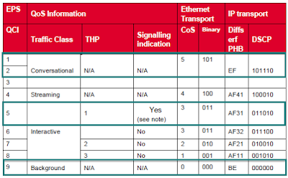](https://blogger.googleusercontent.com/img/b/R29vZ2xl/AVvXsEirar2nPw_EvP3wViJh3kP2TGWlIipkrftXobdxwRQSs82c-mVdi3V3vtVeOQZJnUrvqa50IIGTZLPoC1XF2vAWzfbNV2Ki6peqlMKIpN66ALsEeV-hnff2M_KNIlpEb53sMvIQpeo0HuE/s1600/DSCP-QCI+table.png)

The following shows an example of DSCP marking in the IP packet. In this example, the IP packet has been used to deliver the SIP INVITE and the IPv4 packet is wrapped by the IPv6 header at P-GW/S-GW. The 6-bit DS field in this IPv6 header is set to "2e"(i.e.,the Expedited Forwarding). This is a different value from the one specified in the above case

[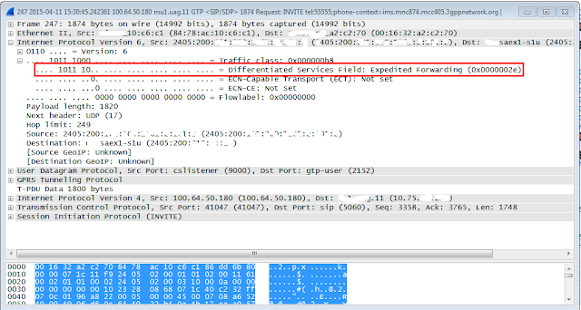](https://blogger.googleusercontent.com/img/b/R29vZ2xl/AVvXsEhK2cgHSEnUUwAHRJVL9-IS5dxb1SsPXrF9AetgGkt_W_UcgNNW2gnuz714VHisjtrf2EN8BX4LHc6rEetOclFojcJ0RmrOzD59kQ2gISNGtwZN7t5JajXCWnf_dpC331KXtfKHsEKI1As/s1600/DSCP+marking.png)

**VoLTE: QCI=1 setup failure when S1 handover is in progress**

In a mobile environment, by its nature, the handover may occur while the user is engaged in a VoLTE call session. The UE periodically reports measurements of various parameters to the eNB and the eNB determines whether the handover is required. Once it is determined by the eNB to trigger the handover, the eNB will decide whether to perform X2 handover or the S1 handover. When there is an existing X2AP connection towards the target eNB, the source eNB performs X2 handover. If there is no X2AP connection or the X2 handover attempt has failed for some reasons, the source eNB may trigger the S1 handover.

As to the PGW initiated bearer related requests(e.g., Create/Update/Delete Bearer request) there is no cause-id defined in the 3GPP TS29.274(r8),  Therefore, in this case, the MME may reject the request with the cause-id of reason unspecified. This cause-id will lead to the ripple effect towards the upstream forcing each node on the path to release the corresponding resources. This is shown in the following flow diagram.

[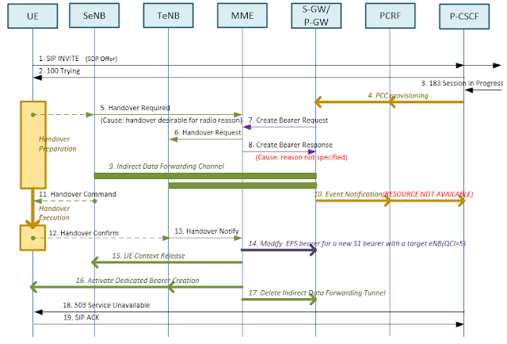](https://blogger.googleusercontent.com/img/b/R29vZ2xl/AVvXsEiON0tpXLWs6JA3RdDqBUk4LD-lj-EifGDB_vd1maesjO8D-SuK3wCcgxDJM9OgncDAUEpxtBKhRKgqqtp5g22HtglJn2NrdITRAqDIe9yl-ab6wrD6oJv_J2k_mdb50hDnTqEIQD1E_Zc/s1600/VoLTE+Setup+failure+and+handover+%2528flow%25231%2529.png)

Even though the handover is successful in this flow, the error cause of RESOURCE ALLOCATION FAILURE in the CCR over Gx will lead to the PCRF to send RAR(Re-Authentication Request) or ASR(Abort-Session-Request) over Rx with a cause-id of RESOURCE NOT AVAILABLE, and the process will end up with sending the 503 Service Unavailable by the P-CSCF. Upon receiving the 503 Service Unavailable, the UE releases all the resources for the call.  
  
In a circumstance where the eNB is not optimized, the handover might occur relatively often. If this racing condition is not handled properly, the result will lead to bad user experiences for VoLTE as the rejection of the bearer related request may often lead to the VoLTE setup failure for QCI=1 bearer for voice.

In the 3GPP TS29.274(r9), the 3GPP has specified the proper cause value of "Temporarily rejected due to handover in progress" and in the 3GPP TS29.274(r11), "Temporarily rejected due to handover/TAU/RAU procedure in progress". This cause-id value is used by the MME rejecting the bearer related request when the handover results in the relocation of the Serving GW and/or MME. The PDN GW which initiated the bearer related request will be able to consider this error cause value to handle the rejection.

The following flow shows one example of how to handle the rejected bearer related request. In this flow, the Create Bearer Request is rejected by the MME. The PDN GW may retry the Create Bearer Request based on the operator's policy.

[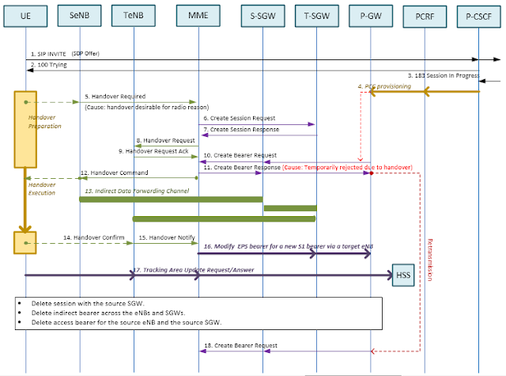](https://blogger.googleusercontent.com/img/b/R29vZ2xl/AVvXsEgvO2UqFI_r7AZrwUwqUtQJVPkPUhIcjh3qMgy5emBCGOUt9KoPuQ5xSC9MQgd2YMwYUrWBw-8A5eWBgn67xpMzcJNHrEW1XLLe38ZVPRjoNf5de-fBA5LyTheJ5wBUIMpJmzrG7wWprOc/s1600/VoLTE+Setup+failure+and+handover+%2528flow%25232%2529.png)

If there is no need of relocation of MME and/or Serving GW, the MME does not need to respond with the cause-id, rather it can perform store-and-forward way of message handling. In this case, the MME will temporarily store the message and wait for the handover to be completed and if it's done soon enough, the Create Bearer Request can be sent to the UE via the target eNB. How 'soon' is the 'soon enough' time is usually up to the operator's policy.

**VoLTE: Understanding of GTP TEID to use in LTE trouble shooting**

The GTP(GPRS Tunneling Protocol) is a communication protocol used by the LTE to deliver IP packets within the EPC. The GTP-C is used to deliver the controlling signals over S11 and S5, whereas the GTP-U is used to deliver application payload over S1 and S5.

[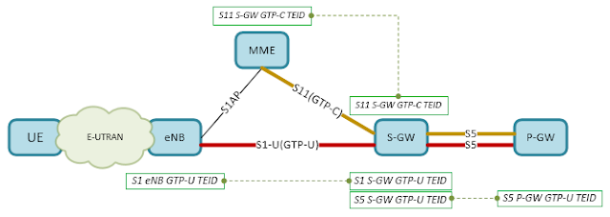](https://blogger.googleusercontent.com/img/b/R29vZ2xl/AVvXsEjO34zchtEeLlykjcwnYhg0fgAD8gyxtc3y2SJnMomJp56fq6nBVOtDpTsTRE4IJoXtndjR18GqBNZhDBYn0PoioXSnXudKw5giDZfsVzViHULlGFsOKOR-bcJVveJ18_5kEaUmGcGa8AU/s1600/architecture%2528fig%25231%2529.png)

**I. TEID exchanges**

The TEID(Tunnel Endpoint IDentifier) is generated by each node during the initial attach procedure. The Create Session Request includes the S11 MME DL TEID and the S5 SGW DL TEID, which are generated and included by MME and Serving GW respectively. The Create Session Response includes the S5 PGW UL TEID and the S11 SGW UL TEID, which are generated and included by PGW and Serving GW respectively.  
  
The following diagram shows the actual call flow and depicts how the TEID is exchanged between NEs. Upon receiving the Create Session Request, the Serving GW establishes the downlink GTP-C tunnel towards the MME using the received S11 MME DL TEID. In the same way the MME establishes the uplink GTP-C tunnel towards the Serving GW using the received S11 SGW UL TEID. The TEID for GTP-U is included in the body of bearer related messages (e.g., Create Bearer Request/Response, Modify Bearer Request/Response).

[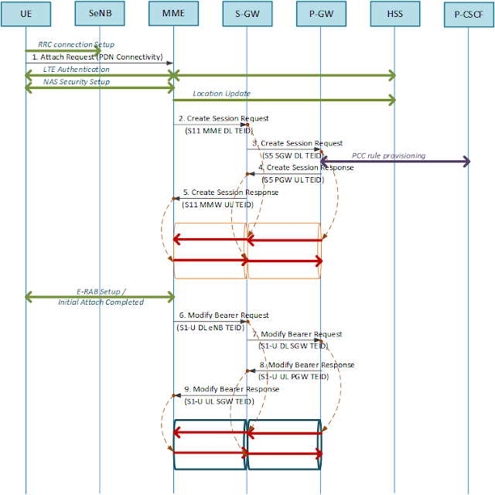](https://blogger.googleusercontent.com/img/b/R29vZ2xl/AVvXsEi96W7mRd8UrX8xN58ZSubB-0rLtOekKNHTeV0KfU1BsgscWclIWp6PYWdT6KOauBltEjmvIasWkxquIrbnfTujdJznMSOYAceBGd_7Uykso_ZVwTJWeZodGhsI9aQkw0F6r-4JHDrDsaw/s1600/TEID+exchange%2528fig%25232%2529.png)

The newly generated TEID is included in the body of each sending message and delivered to the peer node. The peer node perceives the end point of the GTP based on the received TEID. When the message goes through the existing GTP tunnel, the TEID of the peer node will be included in the GTP header of the sending message. The following example shows the TEID included in the Create Session Request being sent from the MME towards the Serving GW.

[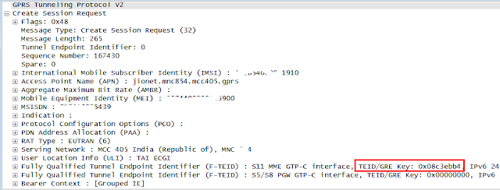](https://blogger.googleusercontent.com/img/b/R29vZ2xl/AVvXsEiNG5pSm7sdfrXUaTV1loSGMfIZP1gBGlTUz-13IeaIB3N6w3d9lWLoa-V3AC7Oo4sZL-OFWlBgH7ebxkvRdiBr5nr75A-5z1stKpAkBYxHcf7PVkJheVJksQ_iUR3K9rFPBaMkK5EnRkE/s1600/pcap-TEID-Create_Session_req%2528fig%25233%2529.png)

In the mean time, the following example shows the TEID included in Create Session Response, where the TEID received from the MME is used in the header and the newly generated TEID of Serving GW is included in the body.

[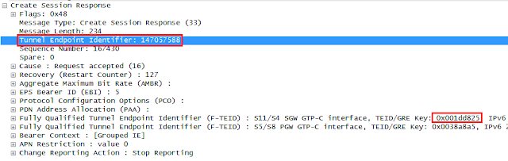](https://blogger.googleusercontent.com/img/b/R29vZ2xl/AVvXsEjd71ttsjHHwRicgxJHYWyQs9I82WUQkRKC0zo8zKhnKaQVdvqwh7jTzpgNHXdBlhSb-PvSCDYIoIzqF4x8v6sRo5WqhTuXpq8deqykqVKIYIoEATqggYv_u8c33AvM-WJS2ZbWOkugKl4/s1600/pcap-TEID-Create_Session_rsp%2528fig%25234%2529.png)

**II. TEID lifetime**  
  
The life time of the GTP-C session lasts along with the life time of the UE's IP-CAN connection. It starts when the UE attaches to network and ends when the UE detaches from the network. In case there are multiple PDNs , there is only one GTP-C session per UE. The following example shows the lifetime of the same GTP-C session, which is defined by same TEIDs. In this example, there are two Create Session Requests, each for different PDNs. Each Create Session Response is followed by the Modify Bearer Request for establishing default EPS bearers. Lastly, the Create Bearer Request is to establish dedicated EPS bearers.

[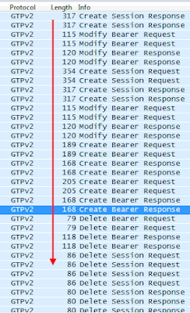](https://blogger.googleusercontent.com/img/b/R29vZ2xl/AVvXsEhLWinld7jhYUZoqIUjZLEURgQ24a9CFi7n9tLXFnP6aG7FZ_ITlfpJ4JlOL8P2u10whgRaQi7RNz5FJxrZlB0ghUwqyYiRdH3IctiFG4XquURz8f_h9mWoo2tCLvmTQtQNtWdFwn2v3lQ/s1600/TEID+lifetime%2528fig%25235%2529.png)

The lifetime of the GTP-U depends on the attributes of the EPS bearer. The GTP-U connection associated with the default EPS bearer has the same lifetime of that of GTP-C connection, whereas the GTP-U connection associated with the dedicated EPS bearer will be dynamically created and deleted within the lifetime of IP-CAN connection.

**III. TEID usage**  
  
When there are multiple EPS bearers established for the same APN and there needs to verify if  specific service data flow goes through the right EPS bearer, the TEID can be a useful tool to figure it out. The following example shows the GTP-U packet of the SIP REGISTER being sent from the UE towards the IMS Core. The TEID in the GTP header indicates "0x005b8422".

[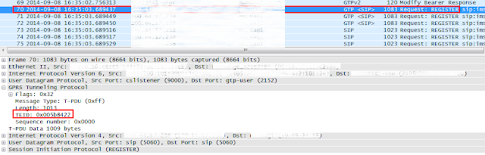](https://blogger.googleusercontent.com/img/b/R29vZ2xl/AVvXsEj-EoU73wPlA6EzMAEC1t3PPESery0E3849tftfUu6iZ_wIqf9KIheznnHRpLz4PkNFpANy723LQuNk7SniyrHHAF8ZrPsidMbhFkrE7es4_uph1-ulmNC9vyRay-W1ARnbqjOH7dxyfv0/s1600/REGISTER-teid%2528fig%25236%2529.png)

The following shows the same TEID appears in the body of a Modify Bearer Request. This Modify Bearer Request is for the EPS bearer of QCI=5.

[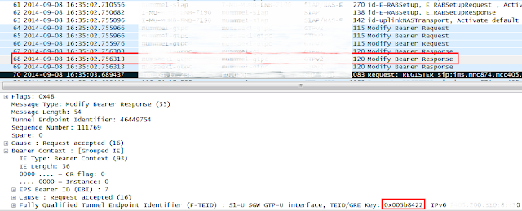](https://blogger.googleusercontent.com/img/b/R29vZ2xl/AVvXsEgKt6RJpIx71ujOCp7dNMx_vqBa7gGKTBvjNUwuJTGrFTeNOp5tuXbY90hmqHWv9v0u8FTYC_0Mo14lr8KEA4oOMk0FjZF0RaMXk_aIvOxWz5ZeJt35Wx_WH5qcVlgl_mQVKd0qFv4HSMk/s1600/pcap-ModifyBearerRequest%2528fig%25237%2529.png)

**VoLTE: E-RAB management vs Handover**

The 3GPP TS36.413 addresses the racing condition between UE handover and the E-RAB management procedures. The UE handover occurs based on the measurement parameters sent by the UE whereas the EPS bearer creation as a part of VoLTE call setup procedure in general. When these two independent events occur at the same time, there can be a collision at eNB, as the eNB is involved in both procedures. In this collision state, the eNB has two options to take as follows:  
  
  
**I. Terminating the E-RAB Setup and continues the UE S1 handover**

The following flow shows the eNB rejecting the E-RAB setup request and continues the handover procedure. Upon receiving the rejection to the E-RAB setup request with its cause id, e.g., "S1 intra system Handover Triggered", the MME continues the S1 handover procedure. In the meantime, the Create Bearer Request can be postponed temporarily until the handover is completed. If the Serving GW or MME is to be changed, the Create Bearer Request will be rejected with its cause id set to "Temporarily rejected due to handover" and the P-GW may retry the EPS bearer creation procedure after the S1 handover is completed(refer to <http://bit.ly/1H4Z7yr> for the detail).

[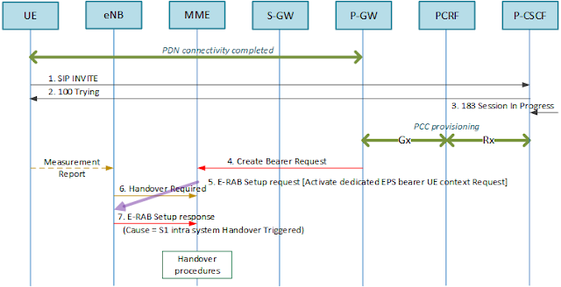](https://blogger.googleusercontent.com/img/b/R29vZ2xl/AVvXsEj8nab-QtCPZP_IGhQWz43i02U2rY9k0bi7jNfTeRRCHi3mEph4djeIoFrcej1BmRyvcAp2enPk0aOrLmagkNkFG-aB0EWKQR8R3J0ArVLRn-DPwNVxr24068aHzdFPjIzkX0e1Amdm8us/s1600/HO+continues%2528fig%25231%2529.png)

**II. Cancelling the UE handover and continues E-RAB Setup**

The following shows the eNB cancels the S1 handover towards the MME and continues the EPS bearer creation procedure. Upon receiving the Handover Cancel, the MME terminates ongoing Handover Preparation procedure and release any resources associated with the handover preparation. If the eNB does not receive the Handover Cancel Ack, it is assumed that the handover is terminated successfully.

[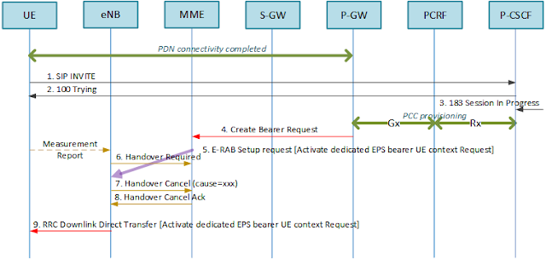](https://blogger.googleusercontent.com/img/b/R29vZ2xl/AVvXsEj8gg0iP6ldOmeeaN7L6NtQ3xGIwWxEGVkgZ726hrJlgGbKoSEM_6BhFpIjQL2rrhECIc997cIapoHCkqM9tBWQserr56LJQB1pNLS9WFaIeBkQk2UPGq6aSsH2Ck35Y1gA-4H3xmzJJnw/s1600/HO+cancel%2528fig%25232%2529.png)

The following shows the eNB cancels the X2 handover to continue the EPS bearer creation procedure according to 3GPP TS36.423. Upon receiving the Handover Cancel, the target eNB releases any resources reserved for the concerned UE context.

[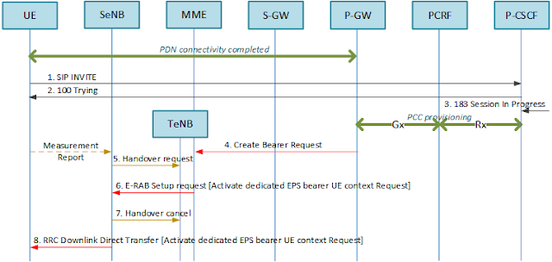](https://blogger.googleusercontent.com/img/b/R29vZ2xl/AVvXsEgxRuGym8P4aqamQgdJSWDlIR7w-2H4GBQLHnaUU6am6equrRSxgLLKfoIxBp_-2zv71vqiXPEIybh4GufIMCc4MnIH3S-uqPCvFr0NHCHwUisMH5TUnW4GsFdTS0sMraVoEDtvO0OJcGs/s1600/HO+cancel%2528fig%25233%2529.png)

**III. Service impact**  
The eNB shall be able to handle the racing condition between two independent events(i.e., E-RAB setup request and handover) either by cancelling the handover or by rejecting the E-RAB setup request. The MME also needs to be able to handle the racing condition either by rejecting the bearer related requests with a corresponding reason (e.g., Temporarily rejected due to handover) or by possibly providing pause-and-resume mechanism itself for bearer related requests in case the handover is in progress. If the bearer related request is rejected, the PGW may realize the retry mechanism(refer to <http://bit.ly/1H4Z7yr> for the detail). If this type of racing condition is not handled appropriately, there could be frequent call drops or call setup failures based on eNB optimization status resulting in bad user experiences of VoLTE user.

**VoLTE: Using TCP parameters in packet analysis**

The TCP is used to transfer a continuous stream of octets in each direction between users by packaging some number of octets into segments for transmission through the internet system[RFC793]. In SIP realm, the TCP is one of the most commonly used protocol along with UDP to transfer user data.

[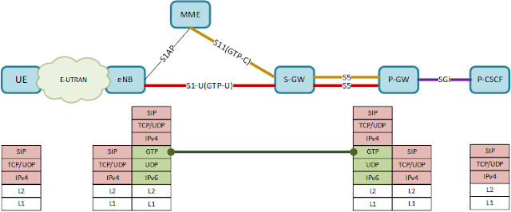](https://blogger.googleusercontent.com/img/b/R29vZ2xl/AVvXsEgUwxyo77Mf6gT1K8K8kKGnVgqHairG7WRAbWBamIlRdgxbinU7KnVGVGKDmFSHCyRUG9c2wx5iilh0IAjNdlTpM3x3UtRerizJyCadxI8mCuBYsL0wOdvj-NcojAyHbrPCjyNCgAV6CwI/s1600/architecture-fig%25231.png)

The above diagram shows an example of the protocol map for LTE user plane. The backhaul is placed between eNB and the EPC in the operator's network in general. The IPv4 packet sent by the UE over the air is wrapped by the eNB using GTP and IPv6 headers. The eNB sends the IPv6 packet through the GTP tunnel and the PGW at the end of GTP tunnel unwraps the IPv6 and GTP headers. The retrieved IPv4 packet at PGW is forwarded to the P-CSCF over SGi interface.  
  
**I. TCP header**  
  
The following shows the TCP headers and parameter descriptions as specified in RFC793

[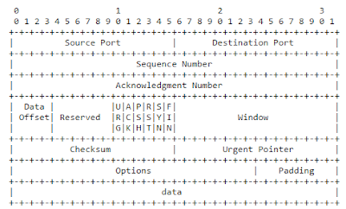](https://blogger.googleusercontent.com/img/b/R29vZ2xl/AVvXsEiqh5xMAfwYY8CJbVBSupdgigQAGkHJ6uterIJxAKv_6INtHpzXA2lZNZ4IY-lidj4aITL33eiwM0gSt-XN6Tcf32uUGEka2EMJNjxu1aX4I-JrTgL53LWokxCJk10I1Wilh_EzwW6s8g0/s1600/TCP_header-fig%25232.png)

* Sequence Number(32bits): The sequence number of the first data octet in this segment(except when SYN is present). If SYN is present, the sequence number is the initial sequence number(ISN) and the first data octet is ISN+1.
* Acknowledgment Number(32bits): If the ACK controls bit is set this field contains the value of the next sequence number the sender of the segment is expecting to receive. Once a connection is established this is always sent.
* Control bits(6bits)
  + URG: Urgent Pointer field significant
  + ACK: Acknowledgement field significant
  + PSH: Push Function
  + RST: Reset the connection
  + SYN: Synchronize sequence number
  + FIN: No more data from sender
* Checksum(16bits): The 16bit one's complement of the one's complement sum of all 16 bit words in the header and text. This is used to detect the corruption of data over TCP

**II. Usage of TCP headers in packet analysis**  
  
After successful initial attachment to the LTE network, the VoLTE UE(i.e., IMS UE) establishes a TCP connection with the P-CSCF in order to process the IMS registration. Once the TCP connection is established, the UE starts sending SIP messages(i.e., SIP REGISTER).  
  
TCP parameters can be useful when they are used to identify the identical packets between sending and the receiving node respectively. It is true in particular when the network(e.g., backhaul) is unstable where there can be a lot of packet delay, packet loss and packet re-transmissions, as it becomes far more difficult to analyze the packet flows.  
  
NOTE In the following snapshot, the yellow box depicts a UE side ip address and the green box a Core side ip address. All the detailed ip address is hidden for security purpose.  
  
The following snapshot shows the UE side trace log that was captured at UE. This example shows the normal SIP procedure that can occur when the call is requested by the user.

[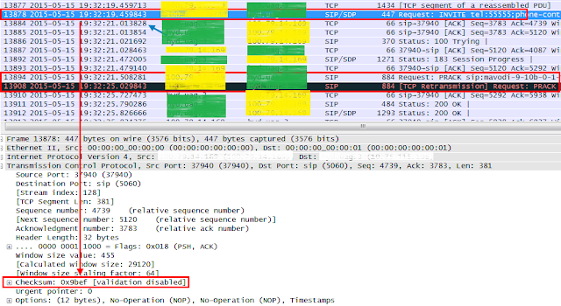](https://blogger.googleusercontent.com/img/b/R29vZ2xl/AVvXsEhgLPLWse4CxmaNEpqcZVcsmSw-nHncE-6vKCFXSS3bfKenB0pNg6Vm8uluRLwEdL4lz_xLLXIJFW8h37lp2Q4b68teqyCuligHQLJW23yH28HsrN_zauwl9XfGJ-pNlTrNUBtXESa6lPU/s1600/tcp_pcap-fig%25233.png)

The following snapshot shows the Core side trace log that was captured between backhaul and the  Serving GW. The procedure in this example is correlated with the above figure.

[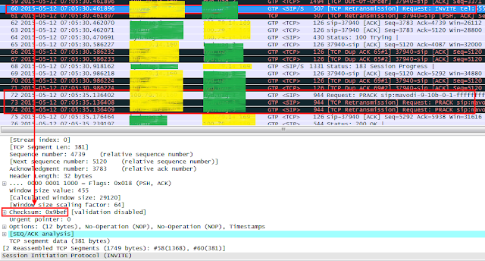](https://blogger.googleusercontent.com/img/b/R29vZ2xl/AVvXsEijhUUPjxI7NlNW00Ggv-rXsmtmLrMDLB9_x6PGINPrhW5ITlx3mXmhiiOCWUf0jEfIZHEwb9huvH2Sb485z_7hDHbDD7aYckJSvQ0Wh4-wzzxHHk3ouTqENXOlNWDErxGiaYhAPFnLvVE/s1600/tcp_pcap-fig%25234.png)

In order to find the matched transaction between the two nodes, the TCP checksum data can be used to identify the same packet. In this example, the same TCP packet for SIP INVITE can be found with its checksum value = 0x8bef. Note that it would be more usual to find the matched SIP transaction based on Call-Id in normal situation. However, when there are many packet re-transmissions and delays, the Call-Id wouldn't be enough to pinpoint the matched ones.  
  
On the other hand, taking a look at the SIP PRACK, the UE has sent two packets. As they are re-transmitted by the SIP layer, they will have different checksum value. (i.e., ox28e2, 0x2781)

[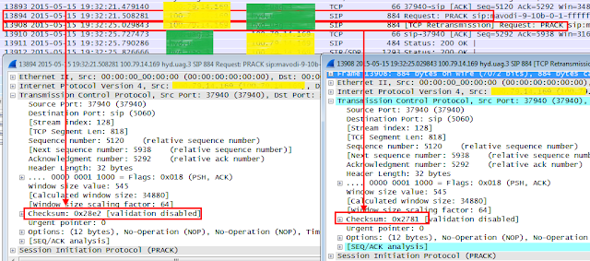](https://blogger.googleusercontent.com/img/b/R29vZ2xl/AVvXsEhig1rRu64lLT7dc4IaXYp5fRgrD8DE7MZgHYmi3ZJxejT-gzlbjqhRFBbZPdPCEdsiS07jIKIdZ1rSgto3b5IxT5JHKC0QzdY1rRJlX-1RrgH5P-fQc5sNYCTliZ82H7px3_pLt_RNmbY/s1600/tcp_pcap-fig%25235.png)

In the meantime, there are three SIP PRACKs appears in the core side and all of them has the same checksum value(0x2781). This checksum value indicates that they are matched only with second SIP PRACK sent by the UE. Therefore it can be reasoned that the first SIP PRACK sent by the UE has been lost somewhere between UE and the Serving GW.

[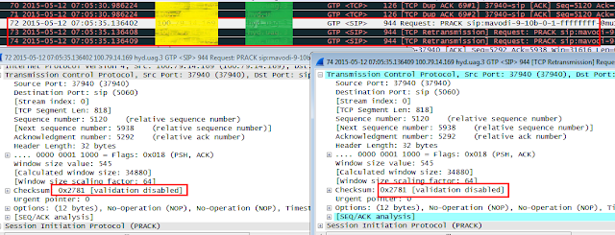](https://blogger.googleusercontent.com/img/b/R29vZ2xl/AVvXsEhwKe-SSRxZD203OTMrXxSTdy2f0KIkU67kA4Isbk55236OYEhVgO7fiI8UDq3NqYANzmagyxCdHBIOZwH8UdALQB5WZdaab2h6ytpcfG992aE08qaMSilxfqYHfWIR9YTgMM_goiSnIiA/s1600/tcp_pcap-fig%25236.png)

In the following core trace, it is observed that the TCP Ack for the SIP PRACK(TCP Syn) is sent only after 40 ms from the received SIP PRACK. The corresponding TCP Ack can be identified by mapping the TCP Acknowledge Seqnum of the TCP Syn with the Seqnum of the TCP Ack.

[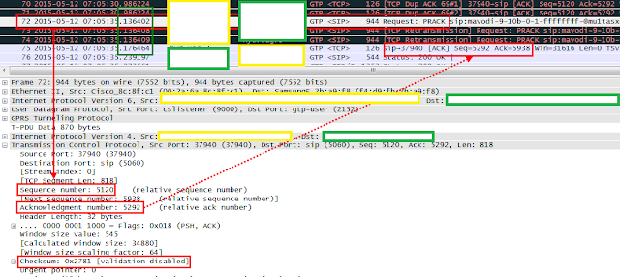](https://blogger.googleusercontent.com/img/b/R29vZ2xl/AVvXsEjVcLXDa37YYbkuTSu-aeTrGoD4r8wnkcECpTgxwIH349WiakSyZ_FK6rn_OahE7TbNe-F5wYUFkPETHmFvQicQeNkLE0q59_3I9qWHlPHZVWJ52SB8ox3v-_b8YmbKUAFBtcEWBvHl3Zo/s1600/tcp_pcap-fig%25237.png)

The same TCP Ack can also be found based on the checksum value. In this example, the UE received the TCP Ack for the SIP PRACK after 700 ms.

[](https://blogger.googleusercontent.com/img/b/R29vZ2xl/AVvXsEg0FWfONL9IYYshZjbymKtVrs8yqaPFyH35nkeESZKm5QTz2K1cKothpDiqwxfxBa_yOvCc5L4XG_VHmUet-i6Yg0bQoZrmWRdSlJyAKelAMOyByaNUuTZPtJYuWFfNFqaHMP3vEfbQWp4/s1600/tcp_pcap-fig%25238.png)

Given the relative time gap between the SIP PRACK(TCP Syn) and the corresponding TCP Ack at both ends, it can be reasoned that there has been a packet delay somewhere in a downlink between  Serving GW and the UE.

***

The TCP packet analysis can be used to correlate the packets between sending node and the receiving node. Measuring the relative time gap of sending and receiving packets also makes it easier to identify the problematic NEs or interfaces. As such, the TCP headers give useful information to engineers in analyzing the technical problems in VoLTE service. As the TCP packet delays and losses can more often than not lead to the IMS registration delay, IMS registration failure, call setup delay and call setup failure, it is directly related to the quality of user experiences. The TCP packet analysis becomes very useful way to realize the quality of VoLTE Service as it might also be in other services.

**VoLTE: Bearer binding and Session binding**

The LTE supports the PCC(Policy and Charging Control) architecture for QoS control applied to service data flow. In the PCC architecture, the PCRF(Policy and Charging Rules Function) takes the role of a central network component interacting with P-CSCF, SPR(Subscription Profile Repository) and the EPC. The PCRF is always involved in the activities of EPS bearer creation by generating the PCC(Policy and Charging Control) rules and provisioning them to PDN GW(i.e., PCEF). In order to generate PCC rules, the PCRF needs to gather service data flow information from the P-CSCF and possibly the subscription information from the SPR. As the PCC rule shall be applied from the access network to the EPC core with consistency, the PCRF needs to be able to maintain the relations of different sessions over different interfaces across the IP-CAN, EPS bearer and applications, in which the binding mechanism becomes a basic concept.  
  
NOTE In this article, it is assumed that the S5 between the SGW(Serving GW) and PGW(PDN GW) is using GTP, where the PGW becomes the end point of the GTP tunnel.  
  
  
**I. Session binding**  
  
The session binding is an association of the AF session information to one and only one IP-CAN session [TS23.203]. Th AF(Application Focus) session is defined as a service level session such as IMS service session that is established by the application level signaling protocol offered by the AF that requires a session-setup with explicit session description before the use of the service[TS29.214].

[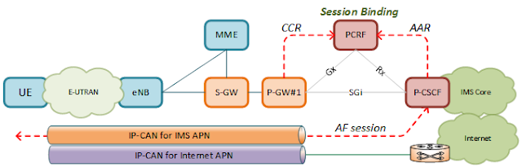](https://blogger.googleusercontent.com/img/b/R29vZ2xl/AVvXsEg2hj9QIeQmDZv42nUCCzpzAaf7LegNRiBmX9ItR9qBOF0dsVg7IiD7Q841RUPTZLhIMXLj6DNWTke_BVC7IiwmyXiOIRIEQDf_dJ3ILTQV8C-P-BtdmAMJXNSjjKN1dpZ6LDGrgsZCGZE/s1600/fig%25231-session_binding.png)

The IP-CAN session information is obtained by the PCRF during the UE initial attach procedure.  
When the UE performs the initial attach to the LTE network, the PGW triggers the *CCR-I* towards the PCRF. The *CCR-I* contains the IP-CAN related AVPs such as Framed-IP-Address, IP-CAN-Type, RAT-Type, Called-Station-Id, AN-GW-Address. The following is an example of *CCR-I* captured over Gx.

[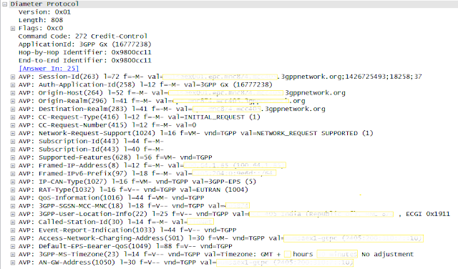](https://blogger.googleusercontent.com/img/b/R29vZ2xl/AVvXsEjfKKrFKr5keE4CZW3Rx-T7Q2kZUTnxSHxf5VijnCXFp6nd8UX-hdBIIKCB37696JSeMH7qI49x-BGxHlA-FBbwWzjltd7r91A5hfjw7D3NO28XjZd_pJqft6UJ4Ud5FrrXO29pusigTV4/s1600/fig%25232-pcap-CCR.png)

* Framed-IP-Address: The valid routable IPv4 address that is applicable for the IP Flows towards the UE at the PCEF. The PCRF shall use this address to identify the correct IP-CAN session binding[TS29.214].
* Freamed-IPv6-Prefix: A valid full IPv6 address that is applicable to an IP flow or IP flows towards the UE at the PCEF. The PCRF shall use this address to identify the correct IP-CAN session binding[RFC4005,RFC3162].
* IP-CAN-Type: Type of Connectivity Access Network in which the user is connected[TS29.212].
* RAT-Type: The Radio Access Technology that is currently serving the UE[TS29.212].
* Called-Station-Id: APN [TS29.212].

The service data flow information is obtained while the service session is set up. Upon UE request for VoLTE call setup, the *SIP INVITE* is delivered to the P-CSCF(i.e., AF) with an SDP offer. The SDP offer includes media session information such as 5-tuples(source ip address, destination ip address, source port, destination port and protocol), codec information, etc. Upon receiving the *SIP INVITE*, the P-CSCF interprets the received SDP contents into diameter AVPs and triggers the AAR towards the PCRF. The following shows an example of SDP contents included in the *SIP INVITE*.  
  
NOTE It would be possible for the P-CSCF to trigger *AAR*once when the *183 Session In Progress* is received(SDP answer) in order to reduce diameter traffic.

[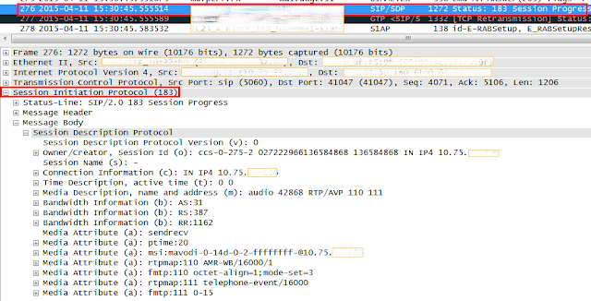](https://blogger.googleusercontent.com/img/b/R29vZ2xl/AVvXsEht4fuT0ya-Jh62EQhEJjWf8KrcXp7jKK5qMVmQ2R7hDKRL18q8-l54h3zvcX1fwTV6KAV5yWXSQrmG2HV65lRBbEJblynzAN31QUreGK7aKbU1_C7VcjR2zQVVRLXkDwnc826jRErvJXw/s1600/fig%25233-pcap-SDP.png)

The following is an example of diameter *AAR*over Rx which includes the service data flow information.

[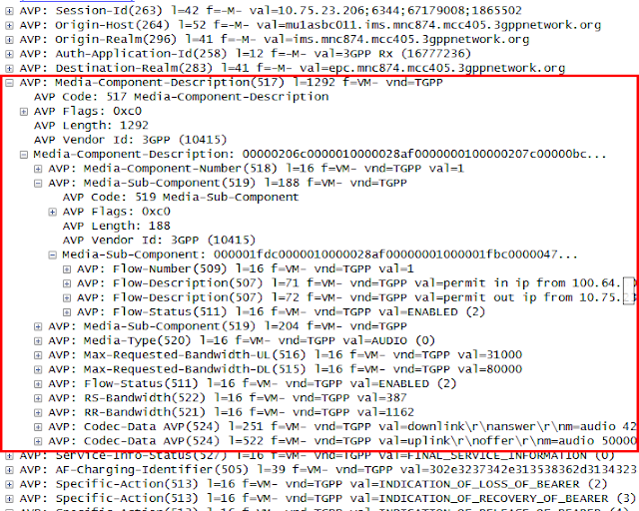](https://blogger.googleusercontent.com/img/b/R29vZ2xl/AVvXsEh_WP9yF_fH2BEBoCDvmUyuQOVZe80a8lHZFvs6ywYsgBCQ-uxjUTIB4cUXlV7zwLFUwrwtJoVK401vAbbgNMQpvecbvLIibNe8_m_ZoNgyWPgJEi-npvA6XW80pC3rEe4suy4mcG_t9Ms/s1600/fig%25234-pcap-AAR.png)

* Media-Sub-Component: contains the requested bitrate and filters for the set of IP flows identified by their common Flow-Identifier[TS29.212].
* Flow-Description: defines a packet filter for an IP flow with the following information[TS29.212].
* Flow-Status: describes whether the IP flow(s) are enabled or disabled[TS29.214].
* Max-Requested-Bandwidth-UL/DL: Indicates the maximum requested bandwidth in bits per second for an uplink/downlink IP flow[TS29.214].
* RS-Bandwidth: indicates the maximum required bandwidth in bits per second for RTCP sender reports within the session component[TS29.214].
* Codec-Data: contain codec related information known at the AF[TS29.214].

Upon receiving the *AAR*, the PCRF binds the service data flow information received from the P-CSCF to a specific IP-CAN session received from the PGW.  
  
  
**II. Bearer Binding**  
  
The bearer binding is the association of the PCC rule and the QoS rule (if applicable) to an IP-CAN bearer within that IP-CAN[TS23.203]. Upon user's request for voice call, the SIP signals will flow through the EPS bearer of QCI=5 and there will be additional EPS bearer newly established to transfer voice traffic. In the same way as described in the previous section, the PCC rules are generated and provisioned to the PGW by the PCRF. The PGW enforces PCC rules accordingly by performing gating control over service data flow.

[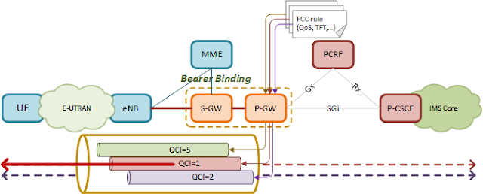](https://blogger.googleusercontent.com/img/b/R29vZ2xl/AVvXsEi3Wb_KbrLtAlmbwbGo6bSX9-ttThBYgqyYuZBkZaz9o75u-BpGdC9-S5Avn2UIgugNZ7qVWxje_ntj05r11CXOeVsNQ6fe7XA76nvqlU0vV7y3iDwVZgG3-Jj6fdDQsVHnWj1gmp7w7dg/s1600/fig%25236-bearer_binding.png)

The PCC rule contains various parameters that can be used to control service data flow such as Flow-Information, Flow-Status, QoS, etc. The following snapshot shows an example of PCC rule contained in the diameter RAR over Gx for voice traffic.

[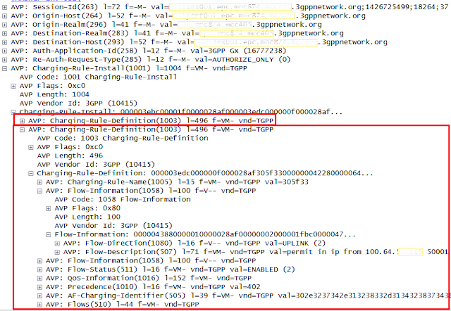](https://blogger.googleusercontent.com/img/b/R29vZ2xl/AVvXsEhCg1yfHzpfKgs9hXvJHo4J-Q9WkCykJAMC6BGHxCh4-9r1EhcuDhbklGqGKzvOyPxzJoUJtJZ70pydjiJW3HzCqy1eqjmsN46M4I0zTGEf1kLEtbXeiWYkntnxbcu-7tYY_rZ27akPGqk/s1600/fig%25237-pcap-rar.png)

Upon receiving the *RAR*, the PGW triggers the EPS bearer creation procedure by sending the *Create Bearer Request* to the MME. The *Create Bearer Request* contains the TEID for GTP-U created by the PGW and QoS parameters(QCI, MBR, GMBR) as well. In return, the corresponding response from the MME, *Create Bearer Response*, contains the allocated EBI(EPS Bearer ID) and the TEID for GTP-U created by the eNB. As an end point of the GTP Tunnel, the PGW shall maintain the relations between EPS bearers and PCC rules. The following is an example of *Create Bearer Response* captured over GTPv2.

[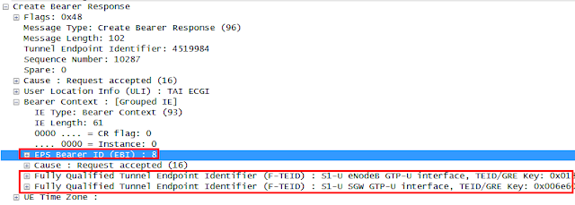](https://blogger.googleusercontent.com/img/b/R29vZ2xl/AVvXsEgoRMZIZYoiBtLUk1Oyxsx6endYQ2j2gJE2NLMnM2dhJIbKTik45LUo7Oo10irr4Hnm8Q5dNOxz-IYbgxWkR_e6Lf2T7PpH_N1MbtN8aSW50lIZ_-qqTmKiXe5dXa7m-Gg-MOT1XGxDJzQ/s1600/fig%25238-create_bearer_resp.png)

***

The session binding and the bearer binding are basic concepts to understand how different type of sessions are related with each other over different interfaces within the PCC architecture. The IP-CAN session to which the UE is attached is bound with the AF session by the PCRF and the service data flow for that AF session is used to generate the PCC rules. These PCC rules are used to map the specific service data flow to a certain EPS bearer which belongs to that IP-CAN session.  
  
Thanks to this binding relations, one event at one place makes a ripple effect to the other, thereby the LTE core can maintain the consistent status for the same UE. If the UE releases an AF session, the corresponding PCC rules for the service data flow belonging to that AF session are removed and in turn, the EPS bearer for that PCC rules will also be released. If the UE detaches from the network, the IP-CAN session will be released and in turn, all the AF session and EPS bearers belonging to the same IP-CAN will also be released.

**VoLTE: PDN connectivity request vs handover**

The PDN connectivity procedure is to request the setup of a default EPS bearer  to a PDN[TS24.301]. The PDN can either be the default PDN or an additional PDN. When it is the default PDN, the UE establishes the default EPS bearer as a part of the process of initial attach. If it is a subsequent PDN, this procedure will establish additional default EPS bearer with that PDN. As such the UE supports multiple default EPS bearers in multiple PDNs.  
  
When the PDN connectivity procedure does collide with the handover procedure, the EPS shall be able to handle the situation based on the principle of best effort. The MME may pause the bearer creation procedure and resume when the handover is completed or the MME shall reattempt the *E-RAB setup request* after the handover is completed[TS23.401].  
  
The following is the case where the PDN connectivity procedure collides with the X2 handover.

[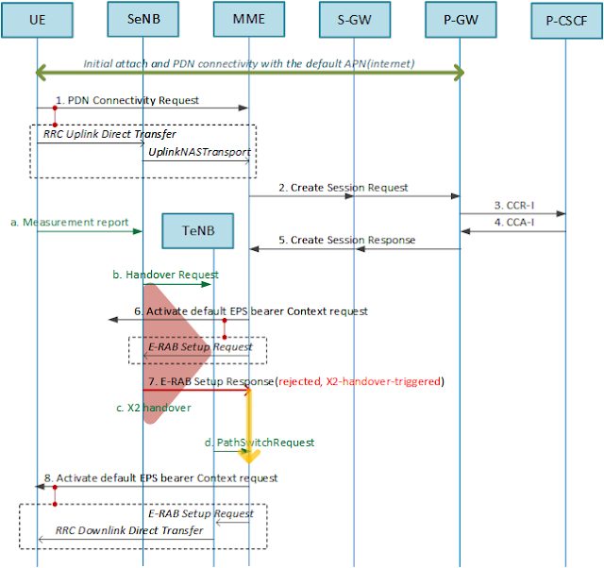](https://blogger.googleusercontent.com/img/b/R29vZ2xl/AVvXsEjrapxc1vYQ6_-BFvg7PjBWKxAOX9m-vW7WwaFNhl6Shq0acLWugnUdsgTNXk3qNJhAQF8A9yvg5rwVvcC5Fh9wilH1GGom4dYTio7niqaaTntQYWmIoCLkjMXZSSjwhTiK-fFL_Khu0IU/s1600/fig%25231-x2_ho+vs+PDN_connectivity.png)

The above is the case the *PDN connectivity request* is sent for the second PDN. In this example, the MME proceeds the activation of the default EPS bearer by sending the *Activate default EPS bearer Context request* over S1AP while the X2 handover is in progress at the eNB. The eNB rejects the *E-RAB Setup request* with its cause value set to "X2-handover-triggered". Upon receiving the rejection to the *E-RAB Setup request*, the MME shall wait until the X2 handover is completed. Once it is completed, the MME re-attempts the activation of the default EPS bearer request. The following shows the S1AP procedure where the *E-RAB setup request* is rejected while subsequent PDN connectivity procedure.

[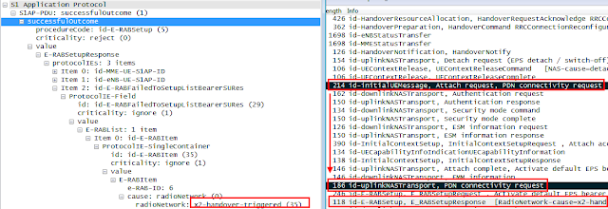](https://blogger.googleusercontent.com/img/b/R29vZ2xl/AVvXsEhracoKAT0HEN4oXbisxp5SnmtcdgaPR95NhX2i88lTt5Fnm8ipMWteOttGIhtHoNrrZlC9168PoqDFLdQhzhGnm0w4xdlWZLGOeIcHIxI5b7mxxkSEvOtO-qUvTq3PE3S5ZPHAUgGEsOw/s1600/fig%25232-x2_ho+vs+PDN_connectivity-pcap.png)

The same mechanism is also applied to the S1 handover case as shown below.

[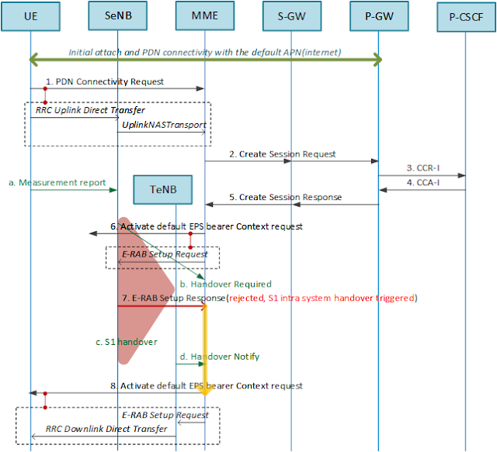](https://blogger.googleusercontent.com/img/b/R29vZ2xl/AVvXsEi06dL7jWwrtXu6dJul8mLzhuDThM-_9r6IdUWQc7gMBRZANAj3CxMOhodKpB0oXRzKKT2xjtu6FlYsKt2xtfAZcYnY1XYVvxBI_MIiS9jyd-6nXQorZ8P4t1Eacl5ikrVG26oGnRfIbhQ/s1600/fig%25232-s1_ho+vs+PDN_connectivity.png)

In this case, the MME requests activation of the default EPS bearer as a normal procedure before receiving the *Handover Required* while the eNB already sent the *Handover Required* and subsequently receives the *Activate default EPS bearer Context request*. If the handover is only in preparation stage, the eNB may be able to cancel the handover and continues the E-RAB setup procedure. Instead, in this example, the eNB rejects the *E-RAB setup request* with its cause value set to "S1 intra system handover triggered". Upon rejection, the MME hold the state until the S1 handover is completed and resumes by reattempting the activation of the default EPS bearer.  
  
NOTE the MME may pause between the step #b and the setp #6  as it is already aware of the S1 handover in progress. However, from implementation point of view, it looks better to pause after the setp #6 as it is a common place both for S1 and X2 handover.  
  
If the timer at MME expires and the PDN connectivity couldn't be completed, it is expected that the UE reattempts the PDN connectivity procedure. In order to request connectivity to an additional PDN, the UE shall start timer T3482 after sending *PDN connectivity request* and enter the state of PROCEDURE TRANSACTION PENDING[TS24.301]. The T3482 stops when the UE receives the *Activate default EPS bearer Context request* or if expires, the UE reattempts the PDN connectivity procedure.

**VoLTE: Traffic Flow Templates**

The service data flow template is a set of packet filters applied to IP packets to identify the service data flow belonging to a specific application. The packet filters typically consist of IP 5-tuples, i.e., source IP address, destination IP address, source port, destination port, protocol type. The service data flow template is delivered to the PGW contained in the PCC rules. The PGW identifies the service data flow based on the service data flow template applied in the order of filtering priorities. Once the service data flow is identified, the corresponding QoS parameters are applied to relate the service data flow to a certain EPS bearer.  
  
**I. TFT filter**  
Once the bearer binding is completed, that is, the PGW builds mapping relations between EPS bearers and the corresponding PCC rules, the PGW requests the creation of the EPS bearer (i.e., *Create Bearer Request*) towards the MME in which the set of IP 5-tuples are interpreted as a bearer level Traffic Flow Template (TFT). The TFT can be defined either separately for uplink and downlink or for both uplink and downlink. The TFT for the downlink is used by the network element whereas the TFT for the uplink is used by the UE. The following diagram shows the TFT structure when the TFT operation is add, create or replace [TS24.008].

[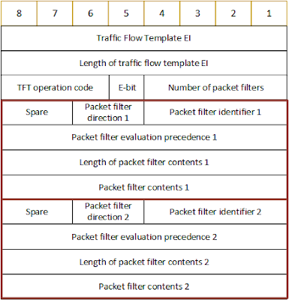](https://blogger.googleusercontent.com/img/b/R29vZ2xl/AVvXsEghznz5fEbjaByYbsLipOtcJoU41eAVA6LXbl6B0mpsS0J3Erkpfkp5O3_lw87gRMBOiTz16xPujrqwBTaMK4M3sft_j6Kgos2-_RyFV7AfbaOsigb2IbcjPXA-nFBpNd72EUwPDPYAuPc/s1600/fig%25231-TFT+structure.png)

* TFT operation code : the action to be taken to the TFT and/or packet filter list e.g., create, delete, add, replace, etc.
* Number of packet filters : the number of packet filters. In case the operation code is "Delete existing TFT" or "no operation code", the number of filters will be 0. Otherwise, the maximum number of packet filters is 15.
* Packet filter direction: the direction of the traffic, i.e., uplink only, downlink only, bidirectional
* Packet filter identifier: the unique number to identify the packet filter
* Packet filter evaluation precedence: the precedence for the packet filter among all the packet filters in all TFTs associated with the PDP address.
* Packet filter contents: variable components with variable size such as remote/local IPv4/IPv6 address, protocol identifier, remote/local port, etc.

The following snapshot shows the TFT included in the *Create Bearer Request*(PGW/SGW->MME) captured over S11. The TFT operation code is to "Create a new TFT" and the direction of the IP flow to which this TFT is applied is an "uplink only" as this TFT is supposed to be used by the UE. The precedence value indicates the priority for this filter among other filters to be applied to the IP flow. Therefore this priority value must be locally unique in the UE. In this example, the IPv4 remote address indicates the P-CSCF address.

[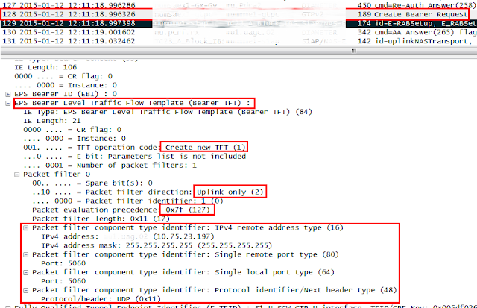](https://blogger.googleusercontent.com/img/b/R29vZ2xl/AVvXsEjPPKsnruvzwYzfnFsjvNl5O-25ZxQFm6oDuHWbDJzNzEF4u2c-02d8unCsJkB82WattnSkUUSGgQqlfvprblT1SmRSZTm_3ZTfa3deh5UYCffFallVBOlcJJb-ahLMjGKg-vpZr8YbRaA/s1600/fig%25232-Create+Bearer+Request.png)

The following snapshot shows the TFT included in the *Activate dedicated EPS bearer* (MME ->eNB) captured over S1AP. As the TFT is included in the NAS message, it is delivered to the UE transparently so it can be used by the UE.

[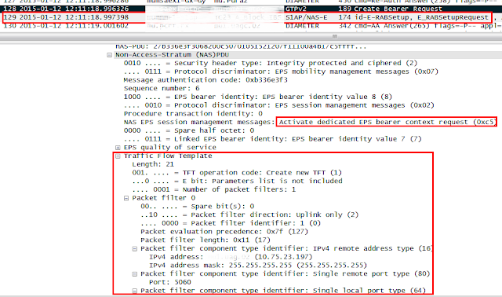](https://blogger.googleusercontent.com/img/b/R29vZ2xl/AVvXsEiXvdpxQanl1btbo8aXrwfrjsCBm0L5Lcddxp8rCGpfmZ1KM-gKzVp8LiMkJEvkCZOL8VmTS4RXw_hpRBvoXjD7mnrBxFOBWew9UScqZtHmMJ6aMNYiArG1pTp4x9HUmLSWJDuptcvl80c/s1600/fig%25233-Activate+EPS+bearer+context+request.png)

In a nutshell, the uplink-only TFT is created by the PGW based on the received PCC rules and sent to the UE so the UE can utilize it to filter and map the outgoing IP packets with the corresponding uplink EPS bearer.  
  
  
**II. TFT errors**  
The TFT is delivered from the MME to UE or vice versa contained in a NAS message over S1AP and the RRC interfaces. The TFT errors indicate operational inconsistencies from semantics or syntax perspectives between TFT operations, packet filters and NAS messages and once detected, it leads to the failure of EPS bearer level operations. The 3GPP TS24.301 has specified four types of TFT related errors as below:  
  
(1) Semantic error in the TFT operation is more likely the case when there is a contextual inconsistency in the TFT operation. The following shows example cases:  
   - The TFT operation of other than "Create a new TFT" in the *Activate dedicated EPS bearer context request*.  
   - The TFT operation of "Delete packet filters from existing TFT" when the deletion will result in the empty TFT.  
(2) Syntactical error in TFT operations is more likely the case when there is a logical inconsistency between TFT operation and the packet filters. The following shows example cases:  
   - The TFT operation of "Create a new TFT" and the empty packet filter list in the TFT IE.  
   - The TFT operation of "Add packet filters in existing TFT" and the empty packet filter list in the TFT IE.  
   - The TFT operation of "Delete packet filters from existing TFT" when there is no corresponding packet filter in the existing TFT.  
(3) Semantic error(s) in packet filter(s) is more likely the case when a packet filter consists of conflicting packet filter component which would render the packet filter ineffective.  
(4) Syntactical error(s) in packet filters(s) is more likely the case when two or more packet filters in the resultant TFT would have component(s) with identical values such as the same packet filter identifiers, the same packet filter precedence values, etc.  
  
Each of the above error cause can appear in the following NAS messages as an ESM cause:  
  
(1) The *Activate dedicated EPS bearer context reject* (UE-->MME) as a failure to create the dedicated EPS bearer.  
(2) The *Modify EPS bearer context reject* (UE-->MME) as a failure to modify the dedicated EPS bearer.  
(3) The *Bearer Resource Allocation reject* (MME-->UE) as a failure to initiate the activation of the dedicated EPS bearer.  
(4) The *Bearer Resource Modification reject* (MME-->UE) as a failure to initiate the update of the dedicated EPS bearer.  
  
  
**III. Case study**  
The following snapshot has been captured while testing the conference call scenario. Having been sorted out based on the MME-UE-S1AP-ID, it shows the lifetime of the EPS bearer from when it is created until it is released due to the "semantic error in the TFT operation". In the meantime, there are five times of EPS bearer modifications occurred.  
  
NOTE The MME-UE-S1AP-ID is assigned by the MME to identify the UE over S1AP. In the same way, the eNB also identifies the UE by assigning the ENB-UE-S1AP-ID.

[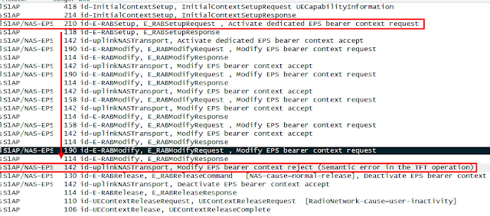](https://blogger.googleusercontent.com/img/b/R29vZ2xl/AVvXsEg30p065AJ4O9xuUyPyHmyfSQpYGBwnhoj2CcggpzOYqEb_EoNnuY7LEsZtPBACRrLBRS4RS7dACZiH4eFcRVB0wMLu0Y7mTeKFstpt8rYB8PK6AVUDQVCurth1KgahXtUgqY_Fg84rT3s/s1600/fig%25234-semantics+error+in+the+TFT+operation.png)

The following snapshot shows the TFT in the *Activate dedicated EPS bearer context request*. Please note that there are two packet filters, one for the RTP and the other one for the RTCP. The TFT operation has to be "Create a new TFT". The packet filter identifiers are 1 and 2 and the precedence values are 223 and 191, respectively.  
  
NOTE the detail of the second packet filter is not shown in this snapshot.

[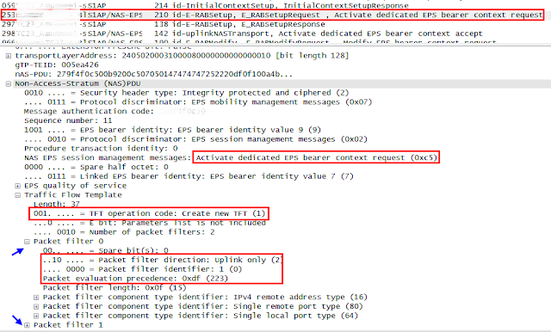](https://blogger.googleusercontent.com/img/b/R29vZ2xl/AVvXsEhv-XRq69wInebTN8fThljEzSLD4Tr31q7rj1xFt_bzv9atOBPMA6PlFo6y1mn276FEtWBqjCydHo2Ppvd2LcE2KPTCYIcmuHWLyx_cbsjvWc-KanoubuARU43Pl_lW8-SbuvxM3Q1oH8I/s1600/fig%25235-Activate+EPS+bearer+context+request.png)

The following snapshot shows the TFT in the first *Modify EPS bearer context request*. The TFT operation is "Add packet filters to existing TFT". The packet filter identifiers are 3 and 4 and the packet precedence values are 247 and 239, respectively.  
  
NOTE the detail of the second packet filter is not shown in this snapshot.

[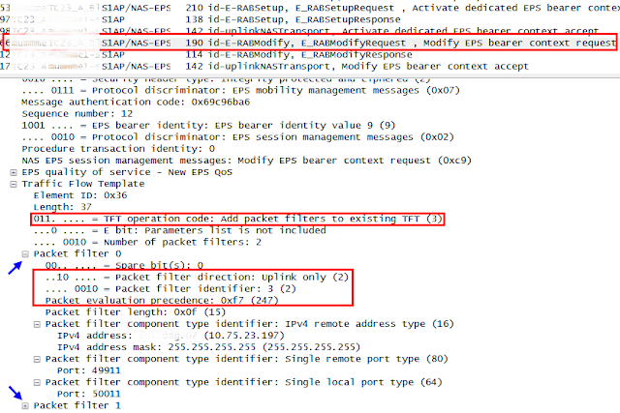](https://blogger.googleusercontent.com/img/b/R29vZ2xl/AVvXsEg2qv04xGYrxEL4kjhEhxZydzHSzeFFRTOeWpUAyhFvto1mySBrQldWl1hRu0i2b9UY8HqOHSHqo2DehMyHUgj2HzVQsFcx6FtoSncGWaWhEEn3oiTb8d1Ec-OsT6jGC7GxM16aArwIGmk/s1600/fig%25236-Modify+EPS+bearer+context+request.png)

All the history of packet filters for the rest of operations can also be analyzed following the same way. The following table shows the resulting analysis of the details for all the packet filters during the lifetime of the EPS bearer.

[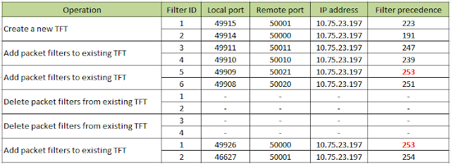](https://blogger.googleusercontent.com/img/b/R29vZ2xl/AVvXsEhKhSfPG1y4_oPtJ7s3DYg64iKA_4lSBCZ57JzIkOWVtF0IvfJ8RofNrZDKW0afDOuDvfARJF8-__FVJHHSSTkuaS9_OAaHSEpcfNQk0AL4mPFrtvEkQQFZEbrrYuBLRrY_XDG3DvCqN4o/s1600/fig%25237-table.png)

In this example, the last TFT "Add packet filters to existing TFT" operation which is sent in the *Modify EPS bearer context request*has the same packet precedence value with the existing packet filter #5. Therefore, the UE responds with the ESM cause = "semantic error in the TFT operation" in the *Modify EPS bearer context reject*.  
  
NOTE The UE seems to have a glitch sending the wrong ESM cause in this test case. The duplicated packet precedence value will lead to the ESM cause of "Syntactical errors in packet filter(s)" according to the 3GPP TS24.301.

**VoLTE: Tracking Area Update and combined attach**

A telecommunication network provides the way of identifying and tracking the location of the UE to maintain the UE mobility. The UE registers its location first time when it attaches the LTE network. Once the UE location is registered in the network, the UE may either periodically or per event initiate the tracking area update procedure. In case the tracking area update procedure has failed, the UE retries the same procedure based on the retry scheme. If the UE loses the connection and/or falls into the idle state, the UE needs to re-register its location as soon as it comes back to connected state. Without location report, the network may assume that the UE stays at the last visited tracking area and if not, the network will have a strategy to get to know the UE location based on the paging scheme.  
  
NOTE Refer to the section 5.3.3 "*Tracking Area Update procedures*" of 3GPP TS23.401 for the detailed cases where the UE triggers the Tracking Area Update (TAU) procedure.

**I. Identifying UE location**

The location of the UE is identified by the combination of several identifiers and it is subject to the configuration of the physical and logical network topology. The following shows the conceptual diagram of the radio network.

|  |
| --- |
|  |
| Fig 1. UE location and Tracking Area |

* Cell-ID : locally unique identifier of a cell with the eNB
* eNB-ID : locally unique identifier of an eNB within the PLMN
* E-UTRAN Cell ID(ECI): locally unique identifier of a cell within a PLMN [eNB ID + Cell ID]
* E-UTRAN CGI (ECGI): globally unique identifier of a cell [PLMN ID + ECI]
* Tracking Area Code (TAC): locally unique identifier of the tracking area within a PLMN
* Tracking Area Id (TAI): globally unique identifier of a tracking area [PLMN ID + TAC]
* PLMN ID: globally unique identifier of a PLMN [MCC + MNC]

**II. Tracking Area Update procedure and combined attach**

The tracking area update procedure is initiated by the UE to register its own location to the network and it can occur when the UE is either in an idle state (i.e., ECM-IDLE) or in an active state (i.e., ECM-CONNECT bearer before release it sends *TAU* request. The UE uses the LAI and the ECGI to represent its own location. The UE may request the combined attach for both EPS services and non-EPS services. In this case, the EPS will need to interwork with the legacy network. The failure of such interworking will lead to retrials of tracking area update procedure. The following flow shows a normal procedure of the UE registering its location and updating its tracking area.

|  |
| --- |
|  |
| Fig 2. Initial attach and Tracking Area Update procedure |

[1] After RRC connection has been completed, the UE attaches to LTE network by sending *Attach Request* to MME*.* The S1AP *InitialUEMessage*that delivers the *Attach Request*contains TAI and ECGI to inform the network of its location. Upon receiving the *Attach Request*, the MME performs the LTE authentication and Security measurement with the UE.

[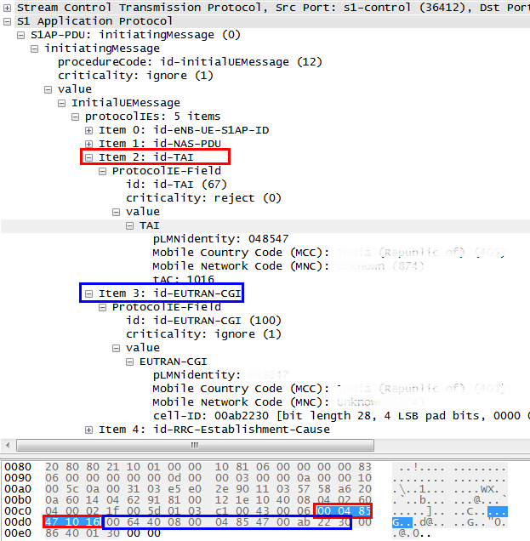](https://blogger.googleusercontent.com/img/b/R29vZ2xl/AVvXsEgElq4E_tNA7bsYUAqxMZY4-1YxIQBqZ3gWdSpj1T8_1Ym-czIX6HFXBc66bpg7ei3yHvwrA4BYJuS_dcvWlsUuJwjvEvxnYQvPnz_eXfDUmMeCl5uQmTEMMy98PAqLGvyQgxeAERNstI0/s1600/fig%25233-Attach+Request.png)

In this example, the UE requested the combined attach with its EPS attach type set to "Combined EPS/IMSI attach", which indicates that the UE wants to attach for both EPS and non-EPS services. The voice domain preference and UE usage has been set to "IMS PS voice preferred, CS voice as secondary". Given these, the UE may be able to attempt the VoLTE and if it is not available it will perform CS fallback (CSFB) procedure.

[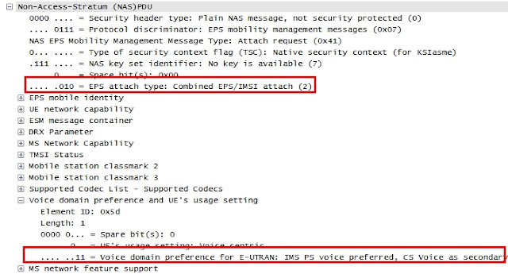](https://blogger.googleusercontent.com/img/b/R29vZ2xl/AVvXsEjAmbp6MqvPgSun_1VambX4UqAoVy3y6tmvNWZiG7VS4Nsls4C9hfEwoX51adx5lmVk04reI4GvKFfqwJc0WO0qTVgWy-RgTR103yCOGGKHXctTaSNmdYEGuGPAfXP-dDj0RZNZFqgkOy8/s1600/fig%25234-combined+attach.jpg)

[2-3] The MME update the location of the UE to the HSS by sending *Update Location Request* that contains the visited PLMN identifier (i.e., MCC and MNC).  
  
[4-7] The MME creates a GTP-C session with the SGW/PGW by sending the *Create Session Request*and the PGW triggers the *Credit-Control-Request (CCR)* to the PCRF. The *Create Session Request* contains the Serving-Network IE for the PLMN ID and the User Location Info IE for TAI and ECGI. The *CCR* contains the 3GPP-User-Location-Info AVP to accommodate the TAI and ECGI.  
  
[8] Upon receiving the Create Session Response from the SGW/PGW, the MME responds with the *Attach Accept* towards the UE. The Attach Request contains the Tracking Area List (TAL), which is the list of TAIs to which UE is implicitly registered by the network. Henceforth, the UE does not need to update its location when it moves within the given TAL, thereby the intention is to reduce the traffic regarding the TAU.

[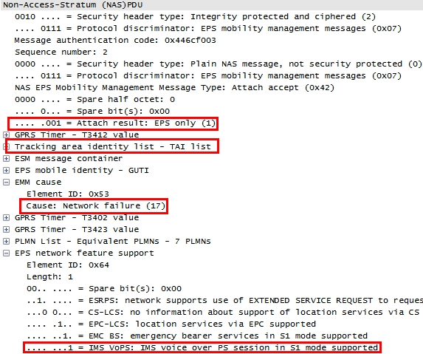](https://blogger.googleusercontent.com/img/b/R29vZ2xl/AVvXsEhIl2RLMs3PzyFjY9ZmNe59aHOCJmfvD3wl8ogEq5-I7CrnbR3kONgfM4MNX7EtvOg_4fFANEgwJ0Zl06Z4W9KGNQyfajtMLnis2YIIMXyXnnAUwID9n269kAEmrJp6N8z_stGFCm8g-GA/s1600/fig%25235-Attach+accept.jpg)

In this example, the combined attach has been accepted with its attach result set to "EPS only" and supports the IMS Voice over PS session in S1 mode. The "EPS only" indicates that the EPS service has been successful but attach for non-EPS has failed[3].  
  
[9-11] The UE establishes the E-RAB with the eNB and sends the *Accept Complete* to the MME. The MME requests the SGW/PGW to establish the S1 bearer by sending *Modify EPS bearer request*.  
  
[12-13] The UE may trigger the TAU procedure by sending the *TAU request* following the criteria as defined in TS23.401. The *TAU*contains the UE's current TAI and the ECGI. The voice domain preference has been set to "IMS PS voice preferred, CS voice as secondary" indicating that the VoLTE is preferred but if it's not available, the UE will perform CS fallback. The EPS update type has been set to "Combined TA/LA updating with IMSI attach" indicating that the UE wants to perform an attach for non-EPS services while it is attached for EPS services. The last visited TAI is included if the UE has a valid TAI of the last visited tracking area and used by the MME to make a good list of TAI (i.e., TAL) for the UE. The TAL is contained in the *TAU Accept*.

[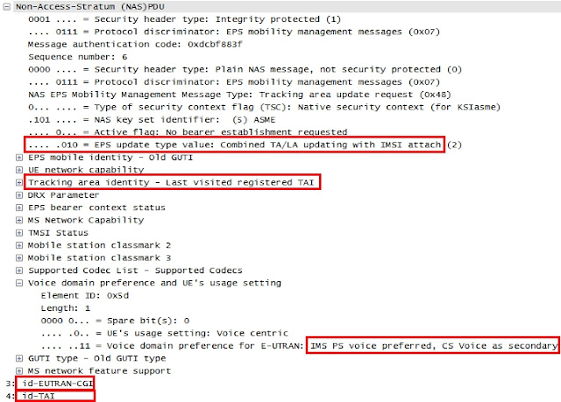](https://blogger.googleusercontent.com/img/b/R29vZ2xl/AVvXsEjclz6Yz2LtZytQabr2CBas88O3oT6sRd4whD0IRP2eB7vBxsKnj4PoeQ_wnPXcYRy6prFgSEq5no9AxLejyNjvfVjVjKYG3zIuVxvRw4m-eQ4jC_uk1StAn-5IdqjHFF478ah4bTOgKs8/s1600/fig%25236-TAU+request.jpg)

**III. Periodic TAU and retrying scheme**  
  
The timer, T3402 and T3411, specifies the time interval after which the tracking area update procedure takes place. Upon expiry of T3402 or T3411, the UE sends *TAU*with its EPS update type set to "Combined TA/LA updating with IMSI attach". The timer value is set by the network and sent to the UE being contained in the *Attach Accept*and every *TAU* response.  
  
When the UE receives the "Network Failure" in the *TAU* response for combined attach, the UE starts the T3411 and retries the *TAU* procedure up to 5 times. If it has already retried 5 times, the UE starts the T3420 for the next retry cycle. The T3411 is recommended to be set to 10 seconds and the T3420 to 12 minutes according to 3GPP TS24.301.  
  
The following shows the *TAU* retries history when the UE receives the Network Failure error for combined update. There are only 4-times of retrial in the first cycle as the first request in the *Attach Request* has not been counted.

[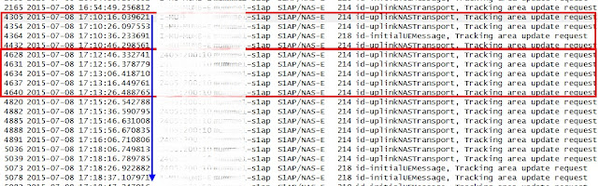](https://blogger.googleusercontent.com/img/b/R29vZ2xl/AVvXsEi9v0gUs4J3YnI-8Te4TnY3e-dBdmNMvO13G7MAGSKBqU7bJIUGwCTz18igK-6FLOR2RRhDOVRjiZpdvEKRdYmB55JadCnLCpH38AxgXrik82_UG0sho8ng88uWPMlmmltz_bWlHB0LBUg/s1600/fig%25237-TAU+retry.jpg)

NOTE The TAU procedure can also take place when the UE receives the RRC connection release with its reason set to "load balancing TAU required" for MME offloading or when the UE moves into the LTE from 3G network. This will be discussed later under the different subject.

**\*\*\***

In summary, the UE triggers the TAU procedure periodically and whenever it looks the UE location has changed or needs to be updated at MME. The detailed cases have been specified in 3GPP TS24.301 though, the operators may need to optimize the TAU traffic in a way not to cause a traffic overload. The traffic can be possibly controlled by finding out appropriate timer values or by optimizing the list of TAIs in a TAL.

***Red Mouse***

REFERENCES  
  
[1] 3GPP TS23.003, "Numbering, Addressing and Identification", v11.0.0, Dec 2011  
[2] 3GPP TS23.401, "General Packet Radio Service(GPRS) enhancements for Evolved Universal Traversal Radio Access Network(E-UTRAN) access", v12.4.0, Mar 2014

[3] 3GPP TS24.301, "Non-Access-Stratum(NAS) protocol for Evolved Packet System(EPS); stage3", v12.4.0, Mar 2014

[4] 3GPP TS36.300, "Evolved Universal Traversal Radio Access (E-UTRA) and Evolved Universal Traversal Radio Access Network(E-UTRAN); Overall description; stage2", v10.0.0, Jun 2010  
[5] 3GPP TS36.331, "Evolved Universal Traversal Radio Access (E-UTRA); Radio Resource Control(RRC); Protocol specification", v12.6.0, Jun 2015  
[6] Netmanias, "LTE Identification

**E2E VoLTE call setup(1/4) : Initial attach and default EPS bearercreation**

|  |
| --- |
| When the UE is turned on, it establishes a PDN connection with a default APN. In this test for VoLTE call setup, the operator provides two APNs, i.e., “Internet” APN and the “IMS” APN. The default APN is an “Internet” APN that is used for internet data traffic and its default EPS bearer has a QCI value of ‘9’. After the PDN connection is established with the internet APN, the UE attempts additional PDN connection with the IMS well known APN, i.e., “IMS APN”. The IMS APN is preconfigured in the UE and its default EPS bearer has a QCI value of ‘5’ being used for SIP signaling. Once the PDN connection with the IMS APN is completed and the default EPS bearer is successfully created, the UE is able to communicate with the IMS Core for VoLTE call service. |

**Introduction**

The UE's initial attach procedure consists of two routines. One is to establish a signaling path on RRC, S1AP and GTP-C interfaces and the other one is to establish the bearer path including Data Radio Bearer (DRB) and GTP-U (i.e., S1 and S5 bearer). The following diagram show overall LTE architecture and different signaling and media paths with multiple PDNs.

NOTE In this diagram, the S5 interface between the SGW and the PGW has been omitted for simplicity.

|  |
| --- |
|  |
| Figure 1. PDN Connectivity |

The signaling connection procedure involves LTE authentication, NAS security procedure and the UE's location update procedure. Therefore, when the signaling connection is completed, the UE comes to have a secured connection to communicate with the network and the network becomes aware of the UE's context as to its location, subscriber's information, QoS requirements, etc. Along with the signaling connection, there comes a default EPS bearer established from the UE to the PGW, which covers the DRB, S1 bearer and S5 bearer.

**I. Initial attachment**

A UE establishes an RRC connection with an eNB and the eNB creates an S1AP session with an MME for signaling. The NAS messages are exchanged between UE and the MME once the RRC and S1AP connection is established and it is composed of two layers, i.e., EPS Session Management (ESM) layer and EPS Mobility Management (EMM) layer. The ESM message is used to control PDN connectivity, bearer resource allocation/modification, activation/deactivation of a default/dedicated EPS bearer. The EMM message is used to maintain the mobility of the UE using e.g., Attach, Detach, Tracking Area Update (TAU). The NAS message transparently goes through the eNB contained in RRC and S1AP messages.

|  |
| --- |
|  |
| Figure 2. Initial Attach flow |

[1-2] The UE in idle mode requests the eNB to establish a signaling connection by sending *RRC Connection request*. The eNB allocates the network resource based on the received radio configuration and initiates an RRC connection towards the UE by sending *RRC Connection Setup*.

[3] The UE configures a radio bearer and transport channel based on predefined parameters identified by a received predefined configuration identity and confirms RRC connection by sending the *RRC Connection Setup Complete* to the eNB. Meanwhile, the NAS messages (i.e., *Attach Request*at EMM layer and*the PDN Connectivity Request*at ESM layer) is transparently delivered to the MME via eNB being contained in the RRC and S1AP messages (i.e., *RRC Connection Setup Complete* and *InitialUEMessage*, respectively).

The following snapshot shows the NAS part of *InitialUEMessage* captured on S1AP interface.

|  |
| --- |
|  |
| Figure 3. InitialUEMessage |

In case the UE wants to use both LTE and non-LTE, the *EPS Attach type* will be set to "Combined EPS/IMSI attach" and the *Voice domain preference* set to "IMS PS voice preferred, CS voice as secondary".

* EPS Attach Type : EPS attach/combined EPS/IMSI attach/EPS emergency attach
* Voice domain preference : a preferred network for voice call

The Protocol Configuration Option (PCO) is used by the UE to request a certain information like UE IP address, DNS IP address, etc.

The following snapshot shows an example of *PCO* configuration included in the *initialUEMessage*.

|  |
| --- |
|  |
| Figure 4. PCO for initial attachment |

The following snapshot shows other parameters of *initialUEMessage*, which contains the UE's location information (i.e., Tracking Area Identifier, E-UTRAN Cell Global Identity) and RRC establishment cause.

|  |
| --- |
|  |
| Figure 5. Parameters in initialUEMessage |

[4-5] Upon receiving the *Attach Request*, the MME requests the authentication vector to HSS by sending *Authentication Information Request* (AIR) to authenticate the subscriber.

[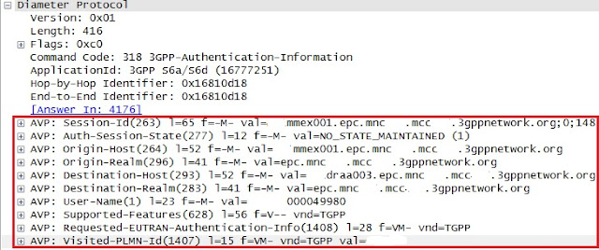](https://blogger.googleusercontent.com/img/b/R29vZ2xl/AVvXsEj2tk6DDWz7DPF_wCXXpa0grdFP6sAl-DWjRGTfob0NcvDEeExrXKEwFie-HbDGldonIeMfXppfGXQMJ3yZh1m3bB_7z3Jj45SlE4LF77393_YOIcXb1DDORuVkSSkoR1JPozXK3eLdtfA/s1600/Fig%25236+-+snapshot%25234173_AIR.jpg)

Figure 6. Authentication Information Request

The HSS responds with the Authentication Vector in the *Authentication Information Response* (AIA) as shown in the following snapshot.

[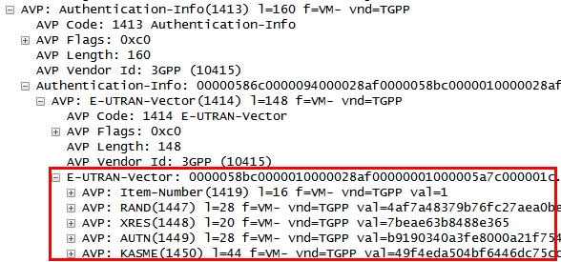](https://blogger.googleusercontent.com/img/b/R29vZ2xl/AVvXsEiSHcKuh3i-WwpfkWnCvKN8Yd3JCM2GG9srXfO51jyCsBnn_f53yQGhzQ1B3NG8FuNi1vKcDqEj5sjgNub6aVIqjIk9bUiHUz9hyzKlRrmrj1dYm5Aj2aTMx7g0ihGabuD5dUn9wWKnvP0/s1600/Fig%25237+-+snapshot%25234175_AIA.jpg)

Figure 7. Authentication Information in AIA

The following diagram shows a conceptual data flow of LTE-AKA authentication. The MME delivers the AUTN and RAND to the UE among the received parameters. (2) The UE authenticates the network by running the authentication algorithm which uses the received RAND and local parameters as input and then (3) verifies if the output of the calculation is matched with the received AUTN. The UE sends the RES which is another output of the authentication algorithm to the MME so that (4) MME can verify the RES by comparing it with the XRES received from the HSS in (1).

[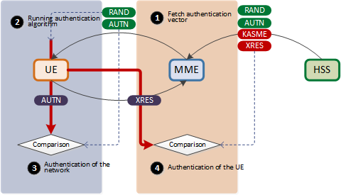](https://blogger.googleusercontent.com/img/b/R29vZ2xl/AVvXsEgwwBDv7VhMlpggSGERRO60pgRKnUox_c1CHY4H2sDeqgWEtS-pblbN-h76ogus1e1DEjqAGxagv2ldEDsYMl9FV_4ONDmShbx8jaQMNi9ulYHT1eVtFUxUPdeIp6aey8A2vJphVwS-CV0/s1600/fig%25238+-+LTE+auth.png)

|  |
| --- |
| Figure 8. LTE authentication |

As such the UE and LTE network performs the mutual authentication. After successful authentication, there comes the NAS security establishment procedure between the UE and the LTE network in order to provide a secured data transfer and data integrity.

**II. Location update and GTP-C session creation**

In this part of the flow, the MME updates the UE's location information stored in the HSS and creates GTP-C session with the SGW. The GTP-C session is used to control GTP-U (i.e., S1 and S5 bearers) media session belonging to the same APN.

[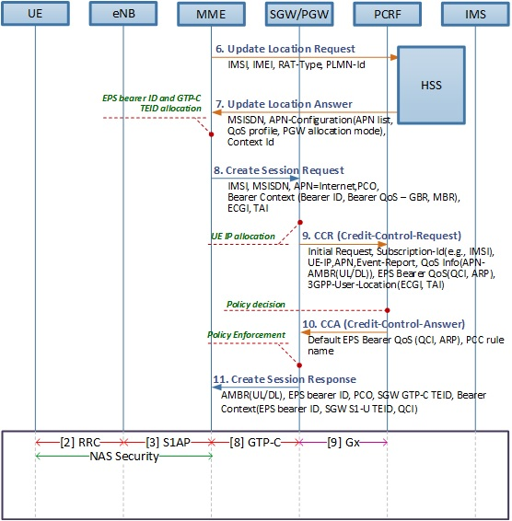](https://blogger.googleusercontent.com/img/b/R29vZ2xl/AVvXsEi38JkXL6uDDINPFAYY5USeHtVoMs1Jg__WuZGuOyCZ20GAqUEs6-cMuIVoEd4y0k6DLGEomc7ZhKJAGPoME1AF-lzwmig6_4g5hdTT_e-S4cZm04sfFBnlHmOQHszLey5WuRwFdjdwFFM/s1600/Fig%25239.+GTP_C+creation+flow.jpg)

|  |
| --- |
| Figure 9. Location update and GTP-C session creation flow |
|  |

[6-7] The MME registers the UE's location to the network by sending *Update Location Request* to the HSS. The following lists some of parameters as shown in the snapshot.

* User-Name AVP: IMSI
* Terminal Information AVP: IMEI, Software version
* Visited PLMN-Id AVP: MCC and MNC of a visited network
* RAT-Type AVP: EUTRAN

[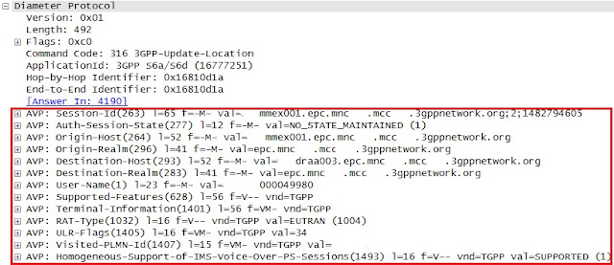](https://blogger.googleusercontent.com/img/b/R29vZ2xl/AVvXsEhMqWkI-y_FKcPjKRnvbSX62AqqeU4xZR6exh6ZQcL6hDdC7T9OhMnL4ZAcfa_pPg8IpKscC-akjCcBlgrzCquQMWTZKA-_jtv60PFwxkZW7KzV5p4eSUTGQ55pd2kb5EAP_u8PwldxVo8/s1600/Fig%252310+-+snapshot%25234187_ULR.jpg)

Figure 10. Update Location Request

In return, the MME receives the *Update Location Answer*from the HSS and it containsthe APN list as shown in the snapshot below.

[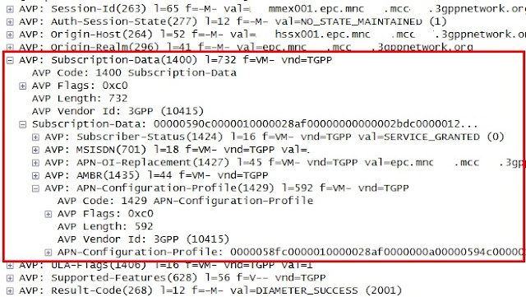](https://blogger.googleusercontent.com/img/b/R29vZ2xl/AVvXsEiPtHoCqjD_ccrmYXXBfE8rN6fmJayQ8t-MEcBTmHLrZmg2FFnNTZcwbCmBBkgwf0uKDtLlwx4BodWgAD4KQK8yjKsJbNZuZGmpjXX7Re8i37GJfSVYhG7Zx3-Yr6373LELg1Hkq32VqsU/s1600/Fig%252311+-+snapshot%25234189_ULA.jpg)

Figure 11. Update Location Answer

Upon receiving the list of APN in the *Update Location Answer (ULA)*, MME determines the default APN. In this example, there are two APNs received as shown in the following snapshot.

[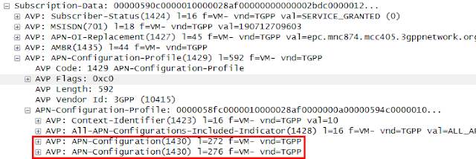](https://blogger.googleusercontent.com/img/b/R29vZ2xl/AVvXsEhOVcgRvhOMONqhYqRE7mo5hzPH2dZ525Jgbo8AjTE6w3T3-So1y-Y8KVU8HfNfycpcg0QVVFRF5OAqhsTqebLdOkUPNMw20_ogr5Ra1Wk6lNpOsz68doszVMl_m-ofy0zNI_N1GIpzL6k/s1600/Fig%252312+-+snapshot%25234189_ULA-APN_list.png)

Figure 12. APN list

The following snapshot shows the detailed APN configuration. One of APNs (bottom one) is an "Internet" APN as indicated by Service-Selection AVP. The other APN (upper one) is an “IMS” APN. The default APN is determined by comparing the Context-Identifier AVP under the APN-Configuration-Profile AVP with another Context-Identifier AVP in the APN-Configuration AVP. In this case, the context identifier value of "10" in the APN-Configuration AVP for “Internet” is matched with the context identifier value in the upper layer. Given this, the MME will select the “Internet” APN as a default APN.

[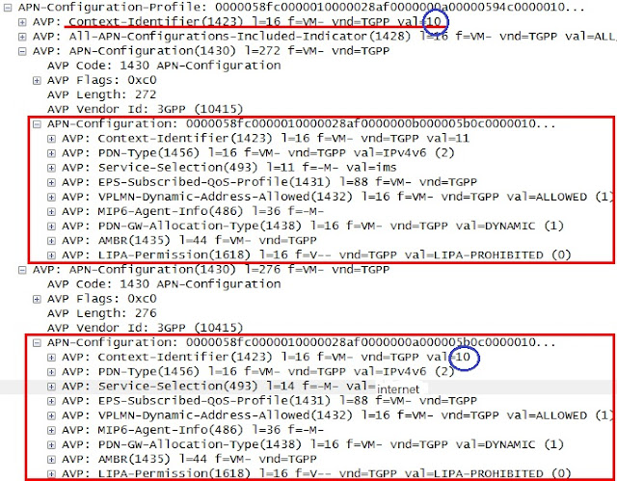](https://blogger.googleusercontent.com/img/b/R29vZ2xl/AVvXsEhpl96KXTEfcV6v-6gpQA_pLuVo8o5VXiA2KB67vWi1lndyyXvwdwMquEFTlBMMv_l4KqQGKT4fA6Drq24G5ZbgmxO1Xeq9VNixyVdRSiibA9l-lG5zgHmf8-VBImHZ5VAOqGt5QqTBrQ4/s1600/Fig%252313+-+snapshot%25234189_ULA_APN_Configurations.jpg)

Figure 13. APN Configuration Profile

[8] The MME requests S11 (GTP-C) session creation by sending the *Create Session Request* to the SGW. The *Create Session Request* contains the following parameters along with subscriber's information like MSISDN, IMEI and IMSI.

* APN : the access point name to which the GTP-C session is to be established.
* PDN Address Allocation (PAA) : UE IP address. It is empty at this moment in time as no IP address has been allocated for the UE.
* Serving Network : the MCC and MNC of the serving network which the UE is attached to.
* User Location Info: TAI, ECGI
* MME GTP-C TEID : Identifier of the MME as an end point of the GTP-C tunnel
* EPS Bearer ID (EBI) of the default EPS bearer
* QoS Class Identifier (QCI) : ‘9’

In this case the QCI value of “9” for the default EPS bearer has been allocated as this is a PDN connection with the “internet” APN.

NOTE The UE can have up to 11 EPS bearers in total and assign the same amount of EPS Bearer Id (EBI) from 5 to 15.

NOTE The SGW will also establish the GTP-C session with the PGW on S5 interface which is not shown in this flow.

[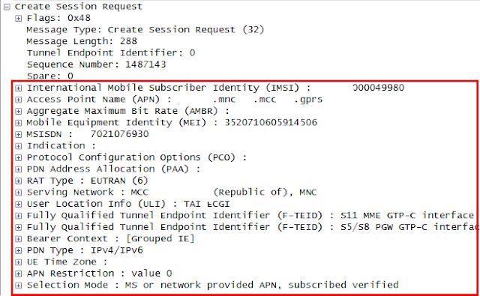](https://blogger.googleusercontent.com/img/b/R29vZ2xl/AVvXsEgh1hbN9LlfGXcHsxZTZTuRlNkisBBSMEEi5O3u_R8w8uQZdrbmlKa941KOu8JYhCTEFU2u57CY67XiIO4S_K-2t2UYGIaDgVKNVCMgNRehmYovKxPU9l3Kk9fwsSodnSpay-sS5uOVRnQ/s1600/Fig%252314+-+snapshot%25234191_Create_Session_Req.png)

Figure 14. Create Session Request

[9] Upon receiving the *Create Session Request*, the PGW assigns an IP address for the UE from an IP pool. The PGW sends the *Credit-Control-Request*(CCR) to the PCRF indicating that this is an initial request and requests the PCC rule for the default EPS bearer. The *Credit-Control-Request*(*CCR)* contains the following parameters in this example.

* CC-Request-Type AVP: “INITIAL REQUEST”
* Subscription-Id AVP: IMSI, MSISDN
* Framed-IP-address AVP: the allocated UE IP address
* QoS-Information AVP: APN-AMBR (UL/DL)
* 3GPP-User-Location-Info AVP: TAI, ECGI
* Call-Station-Id AVP: APN (Internet)
* Default-EPS-Bearer-QoS AVP: QCI, ARP

The following snapshot shows the *CCR* captured on Gx interface.

[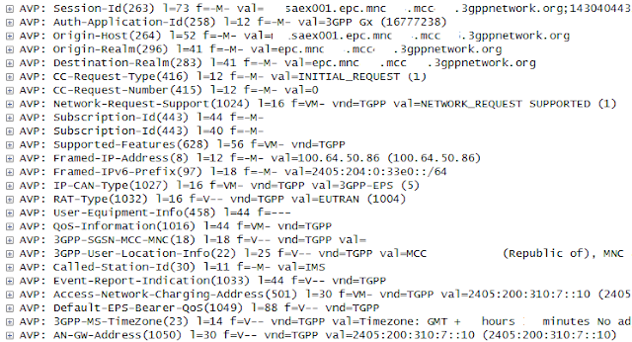](https://blogger.googleusercontent.com/img/b/R29vZ2xl/AVvXsEjnjJRx9d5mZ8kqB-mrYtJsbOkZ8aJTEnke8PJ___ReX8KqQT9Pm29bdpG-gBhCK9lhxnj-1Q6e86E0LYkZy8vXIuvNkuJTAXUs63Qax1on0iAq1S8J4ENCCenDRWsC_VCGBTolHfLopTg/s1600/Fig%252315+-+snapshot%25234193-CCR.png)

Figure 15. Credit Control Request

[10] Upon receiving the *CCR*, the PCRF determines the PCC rule based on the received subscriber's information and responds with *Credit-Control-Answer (CCA)*including a PCC rule(s). When it comes to a default bearer, the PCRF may include only a PCC rule name which indicates the predefined PCC rule locally stored in the PGW. Henceforth, the PCC rule is applied to all the traffic by the PGW.

[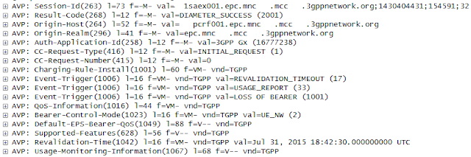](https://blogger.googleusercontent.com/img/b/R29vZ2xl/AVvXsEg7WVR-00ruJ6WYmIrDkdvQhqAyoE9O6KQZHvltdX8dmLJFYoF20EnQMcR_qKIEBZRnfEW1HIQXSG_1yAk-b4sFePzSghxwFxG5UAcviW54QDUhfdErKxKe6peo0mKIQF60HB-4_Kgt1hk/s1600/Fig%252316+-+snapshot%25234195-CCA.png)

Figure 16. Credit Control Answer

[11] The SGW/PGW completes the GTP-C session creation procedure by sending the *Create Session Response*. The *Create Session Response* contains the following parameters:

* AMBR : Aggregated maximum bit rate that is allowed for this APN
* EPS Bearer ID : 5
* Protocol Configuration Options (PCO) : P-CSCF IP address, DNS IP address, etc, based on the requested configuration information by the UE in the *Attach Request*
* PDN Address Allocation (PAA): UE’s IP address
* SGW GTP-C TEID : Identifier of the SGW as the end point of the GTP-C tunnel
* Bearer Context: the information of the S1-U default EPS bearer to be created, which contains EBI, SGW GTP-U TEID, QCI, etc

[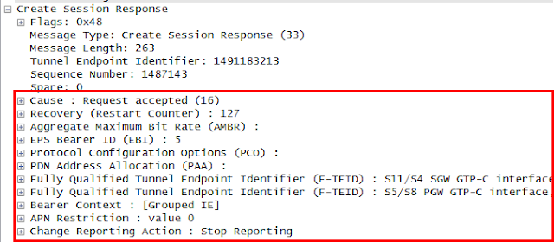](https://blogger.googleusercontent.com/img/b/R29vZ2xl/AVvXsEh9M_Gu5sh2Ql-bItC0fWTC9FPOaXSGowIqZ0g4BzuMbQsl1lWJwi014uW_ovbxuPP6aGaalcBJY1Rz9UZZtS6JdQ7WYx9fiV77r1LEdY0QNXNMgZI0jOBEfkem88yxhBbHtfuYueNAwDc/s1600/Fig%252317+-+snapshot%25234197-Create_Session_Response.png)

Figure 17. Create Session Response

**III. Default EPS bearer creation**

Once the signaling path is successfully set up, the MME requests the eNB to activate the default EPS bearer with the SGW and the UE. The eNB establishes S1 bearer towards SGW and the Data Radio Bearer (DRB) towards the UE. The SGW will also establish the S5 bearer with the PGW, which is not shown in this flow.

[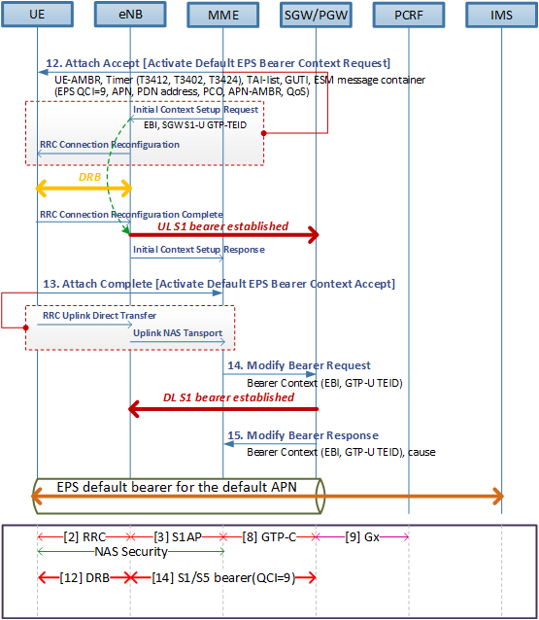](https://blogger.googleusercontent.com/img/b/R29vZ2xl/AVvXsEhuYREkDl44eO0GW-3lIRXYYHr7zdTT_YziGXpILxdj2_x_UfEwLGud7dyBMenzfIQWuhSqjFYzq_UYnvantz_Qk-eUHYntLXe3kBrNjA0mJ8oQRGtBDUbulo7LydFl7eD9nL7SdiBBmWY/s1600/Fig%252318+-+default+EPS+bearer+creation+flow.png)

Figure 18. Default EPS bearer creation flow

[12] The MME accepts the initial attach request by sending the *Attach Accept* and requests to activate the default EPS bearer to the UE which contains *Activate default EPS bearer context request* in the ESM message container. The NAS message (i.e., *Attach Accept*in EMM layer*, Activate default EPS bearer context request* in ESM layer) contains the following parameters.

* TAI list : the list of Tracking Area Identity within which the UE doesn't need to send *Tracking Area Update* (TAU)
* EPS QoS : QCI (9)
* Access Point Name (APN) : Internet APN
* PDN address: the allocated UE IP address
* APN-AMBR: the maximum aggregated bit rate allowed for this APN
* Protocol Configuration Options (PCO) : DNS IP address, etc, based on the requested configuration information by the UE in the *Attach Request*

[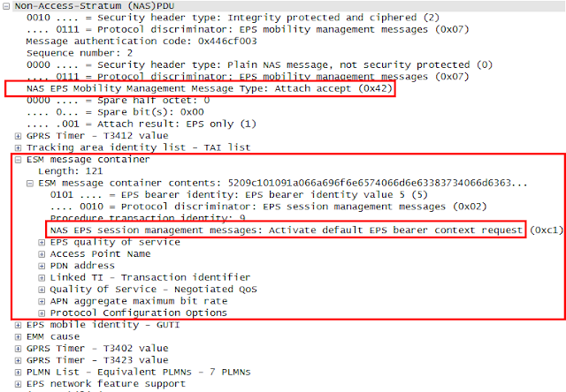](https://blogger.googleusercontent.com/img/b/R29vZ2xl/AVvXsEgF5p1A6JwJCdQxHrOjF7zcmzmfa6TU1eqnxb6vXzikZFiMe27ZcMq-DXY92k1s2KVdKkBglt73svIhA5s26lcu3dtR5GEUQ9VntvB5m7zr7gUbCKheFn7LQIpuEdm5gFNhOK6SyqIknpM/s1600/Fig%252319+-+snapshot%25234199-AttachAccept.png)

Figure 19. Attach Accept (Activate default EPS bearer context request)

The above NAS message is contained in the *Initial Context Setup Request* message on S1AP interface. Other than the NAS message, it also contains the following parameters.

* UE-AMBR : Aggregated maximum bit rates for the UE (UL/DL)
* E-RAB ID : identifier of the radio access bearer towards the eNB
* SGW GTP-U TEID : identifier of SGW as an end point of the GTP-U tunnel which was delivered in *Create Session Response* (step#11).

[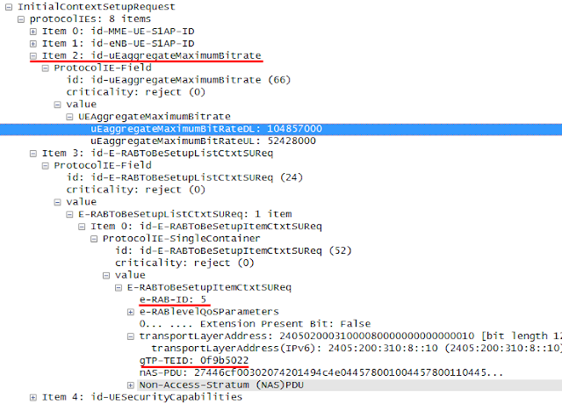](https://blogger.googleusercontent.com/img/b/R29vZ2xl/AVvXsEj1XaagXzX6OnkbSses1QVoc3up-vB_FQ3klS9RJ7qBS2m_YbGltYseZFYJ7F2OaWCUJ9QQHzG02Mr7hGQ1gl41ydSoKV-6EvBGel27fGMaRDQFVRg29Mbx1mBdw8lBt5in3TiGQpkavmc/s1600/Fig%252320+-+snapshot%25234199-initialContextSetupReq.png)

Figure 20. Initial UE Context Request

Upon receiving the *Attach Accept*and *RRC Connection Reconfiguration*, the UE establishes a DRB with the eNB and responds with *RRC Connection Reconfiguration Complete* to the eNB.

The eNB establishes the uplink S1-U bearer with the SGW. After successful GTP-U establishment, the eNB responds with the *initial UE Context Response* to the MME. In this response, the eNB contains the eNB GTP-U TEID, which will be routed to the SGW via the MME and used to identify the eNB as an end point of the GTP-U by the SGW.

NOTE The SGW GTP-U TEID is generated by the SGW and transparently routed to the eNB via the MME contained in *Create Session Response* and *Initial Context Setup Request* on S11 and S1AP, respectively. In the same way, the eNB GTP-U TEID is generated by the eNB and transparently routed to the SGW via the MME contained in the *Initial Context Setup Response* and *Modify Bearer Request*at step#14.

[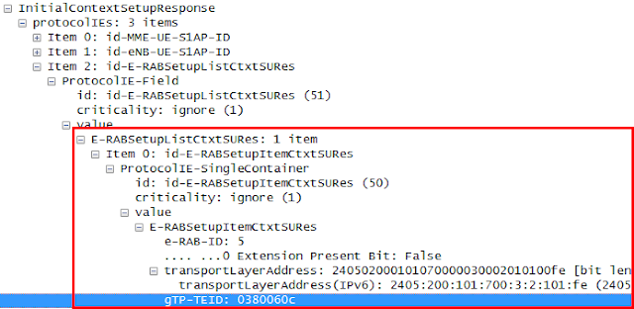](https://blogger.googleusercontent.com/img/b/R29vZ2xl/AVvXsEiiOXovC9JXp5JRs3iDnq-cExHuttWpThCqYVxRo6fuQ6SfXyxrUXvXI2pi_Td8d6DhBFw5bg3OELAzybtTxHpcivgYw8W1qIkWpYkO0hPYf3oS16X3wp06oRUxf8ePYRh_qt5_hqRcMkA/s1600/Fig%252321+-+snapshot%25234201-initialContextSetupResponse.png)

Figure 21. Initial UE Context Response

[13] The UE confirms the *Attach Accept* and informs the MME of the fact that the default EPS bearer has been activated by sending the *Attach Complete,* which contains the *Activate Default EPS Bearer Context Accept* as a response to a corresponding request.

[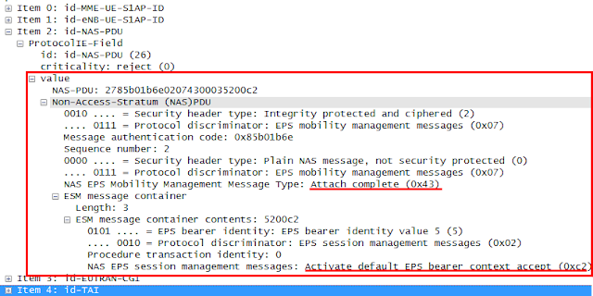](https://blogger.googleusercontent.com/img/b/R29vZ2xl/AVvXsEizaykzDNQ6NxYj7BJ2_-23nadEMUiKvBrjk4kslEJfH1y5WjInrIhWABlf3SBKV1QzsnyHNtu6uTBdKk_NXr8TDyVSgyoVqJOc9fzLnDi3pWIcMblYNox4MnUHNu0r8z97p3vvd7VCwqY/s1600/Fig%252322+-+snapshot%25234202-AttachComplete.png)

Figure 22. Attach Complete (Activate default EPS bearer context accept)

[14] The MME sends the *Modify EPS Bearer Request* requesting the SGW to establish the downlink S1 bearer towards the eNB. The *Modify EPS Bearer Request* contains the following parameters:

* EPS Bearer ID : identifier of a default EPS bearer (5)
* eNB GTP-U TEID : identifier of the eNB as an end point of the GTP-U tunnel

[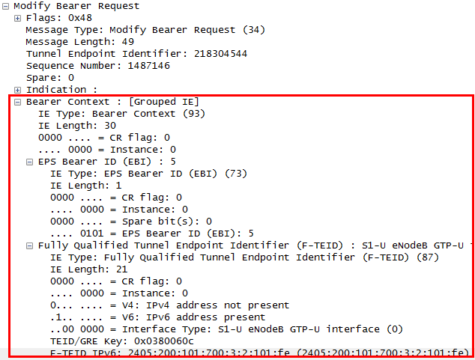](https://blogger.googleusercontent.com/img/b/R29vZ2xl/AVvXsEiAY2KidYwZtXfN0iQW1OCmJ01DIlysKJDxzgS4pWZuVSl3FzFa8OPSPZJzX8XCSN0nUU7wRK1W_K-e6iQPEo1jM0CqEg7Je-pToEYeRuHAZAUfOBGdqR2ncT3bOGUbvzRrqUeyOMny5CQ/s1600/Fig%252323+-+snapshot%25234204-ModifyEPSbearer.png)

Figure 23. Modify EPS bearer request

Upon receiving the *Modify EPS Bearer Request*, the SGW establishes the S1 bearer towards the eNB.

[15] The SGW responds with the *Modify EPS Bearer Response*.

[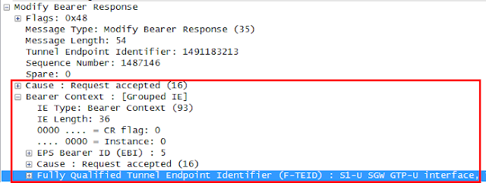](https://blogger.googleusercontent.com/img/b/R29vZ2xl/AVvXsEgykH4Tig-ZJuugxmRBs5XjnhbmTvWm_cctk0LE3KicXV0XoB_mBfRjtu0P65HXcxMYni3cyI7pDCmevTCKR8ER-axiNytiL-KyCroYERftekwp0vE5LMI9OOGouXqtspppWMc0ox2mixk/s1600/Fig%252324+-+snapshot%25234206-ModifyEPSbearerResponse.png)

Figure 24. Modify EPS bearer response

**IV. PDN Connection to IMS APN**

So far, the UE has performed the initial attachment procedure with the LTE network and as a result, the PDN connection has been established between the UE and the default APN, i.e., internet APN. After successful PDN connection with the default APN, if the default APN is not an IMS APN, the VoLTE UE initiates an additional PDN connection procedure with the “IMS” APN.

[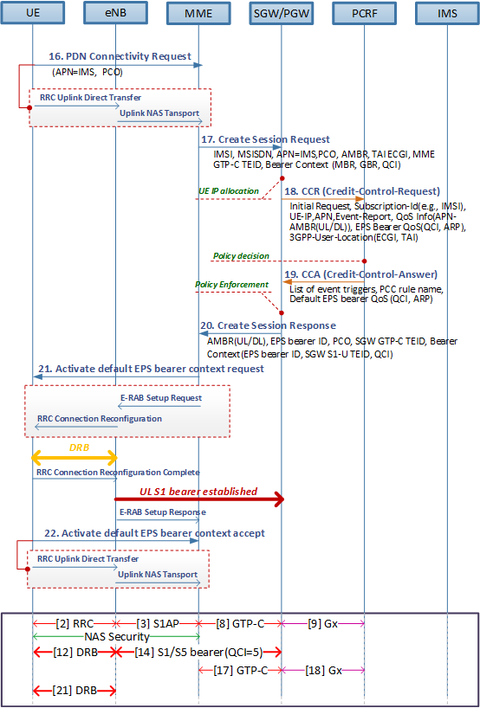](https://blogger.googleusercontent.com/img/b/R29vZ2xl/AVvXsEhYR0sMZ-TuPVMdDk4mxgsYufrq6Fa7Kb_ZYplobvl2DHqqxc8iZRjq4oMVjrkBK4soRGZrUOcn0fOHPk3QmccN7yPPgp95CO61JSzSIp8amt7NKuJgkkpAzCalCIGOhG9cl2lt6YpHi9g/s1600/Fig%252325+-+IMS+APN+connection+flow.png)

Figure 25. PDN connection with IMS APN flow

[16] The UE requests to establish an additional PDN connection with the IMS APN, which is typically used for VoLTE. There is no need of establishing RRC connection at this stage as it was already established at step#3. In this message, the Access Point Name (APN) is set to “IMS” and the UE may request the P-CSCF address and it is indicated by the Protocol Configuration Option (PCO) parameter. The following snapshot shows an example of *PDN Connectivity Request* which is contained by the *uplinkNASTransport* S1AP message.

[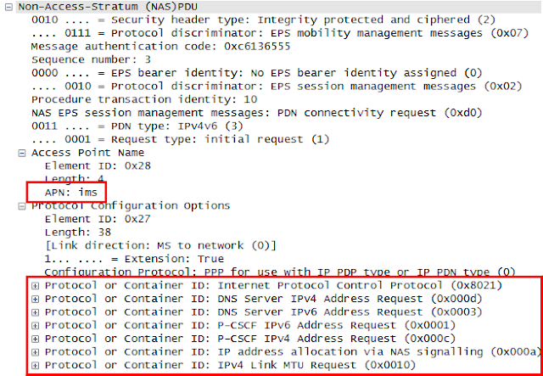](https://blogger.googleusercontent.com/img/b/R29vZ2xl/AVvXsEhm5wuBknckaumdihfPY-Tc1gNFOLucJoT8SxmN3VdKLQ_wV7HjdZcenRNbn5C7vOkYRAw-zJCMxk8Zu3-CRFXv9z6WobaZerDrGcfaxbWOABmUtABN0qAPTukTUkFqcgo4GV3V4J0Xm1s/s1600/Fig%252326+-+snapshot%25234208-PDNConnectivity%2528IMS%2529.png)

Figure 26. PDN connectivity request for IMS APN

[17] Upon receiving the *PDN Connectivity Request*, the MME sends *Create Session Request* to the SGW. Refer to step #8 for overall description.

* APN : “IMS”
* MME GTP-C TEID: the same TEID that was allocated at step #8. The MME and the SGW use the same TEID for different PDNs.
* EPS Bearer ID (EBI): ‘6’ in this case as the EBI ‘5’ was already used in step#8. The EBI will be incremented along with a new EPS bearer.
* QoS Class Identifier (QCI): ‘5’ for IMS signaling.

[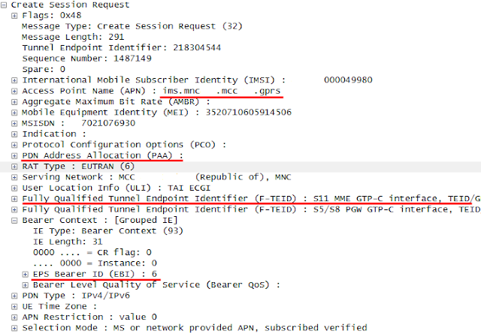](https://blogger.googleusercontent.com/img/b/R29vZ2xl/AVvXsEh2PnmZTIZXx1l3oyO81bwK3ULA3Mi9ebaBnw9YoabfNiH5MG9TU9dvuaoDUK48OqKwkOsxdi7b8PlInE-V_OtbarhVrEzHgKtzAWK32FI8cyGDh8vfyuk-bsbrP1tpmxerYyW913xmjy0/s1600/Fig%252327+-+snapshot%25234209-CreateSessionRequest%2528IMS%2529.png)

Figure 27. Create Session Request

[18] Upon receiving the *Create Session Request*, the MME sends *CCR* to the PCRF. Refer to step #9 for overall description.

[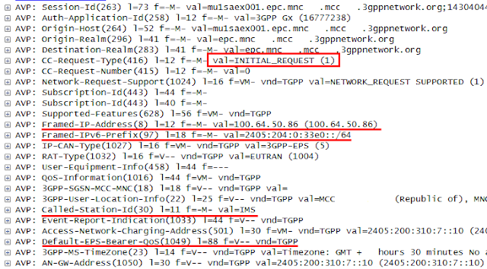](https://blogger.googleusercontent.com/img/b/R29vZ2xl/AVvXsEixOzDT_ykUq-NTpdB15QTYEuB3WPxtojbFaNYLunaSyUMAQKxjs3dr2asDx4IfPuz9xgb_1DkWfnJfkFlRISmhrVB-qSECTVeTGraHv8tJA5yScjNXfTwLqeRIhWwvEOgKXVODVg-AlYI/s1600/Fig%252328+-+snapshot%25234211-CCR%2528IMS%2529.png)

Figure 28. Credit-Control-Request

* CC-Request-Type AVP: “INITIAL REQUEST”
* Framed-IP-address AVP: The UE IP address is different from what was allocated at step #9. The UE is allocated with different IP address per PDN.
* Call-Station-Id AVP: IMS APN
* Default-EPS-Bearer-QoS AVP: In case of IMS APN, the default EPS bearer has a QCI=5.

[19] Upon receiving the *CCR*, the PCRF responds with *CCA* containing the PCC rule of the default EPS bearer for IMS APN. Refer to step #10 for overall description.

[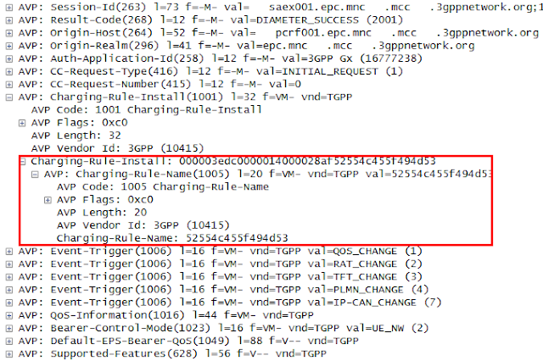](https://blogger.googleusercontent.com/img/b/R29vZ2xl/AVvXsEisIiIfNHlVWK6-oQwvNF-mwyKSG9Wgo0QHgaGS5lttSY8OnZiJoz6dLMuRUeRBSqXL9eDfcCFs9kaa7RdWT28Fw-YrvBcJS5z8DeNkNlM4pR8aT0YvdCGOhJOJXxkwgXr6zRvYmu7suC8/s1600/Fig%252329+-+snapshot%25234213-CCA%2528IMS%2529.png)

Figure 29. Credit-Control-Answer

[20] Upon receiving the *CCA*, the MME responds with *Create Session Response* containing the PCC rule of the default EPS bearer for IMS APN. Refer to step #11 for overall description.

* EPS Bearer ID: ‘6’
* Protocol Configuration Options (PCO) contains P-CSCF IP address and will be delivered to the UE.
* PDN Address Allocation (PAA): UE’s IP address and will be delivered to the UE.
* SGW GTP-C TEID: The same TEID that was allocated at step #11. The MME and the SGW use the same TEID for different PDNs.
* Bearer Context contains the SGW GTP-U TEID for the default EPS bearer which is different from what was used in step #11.

[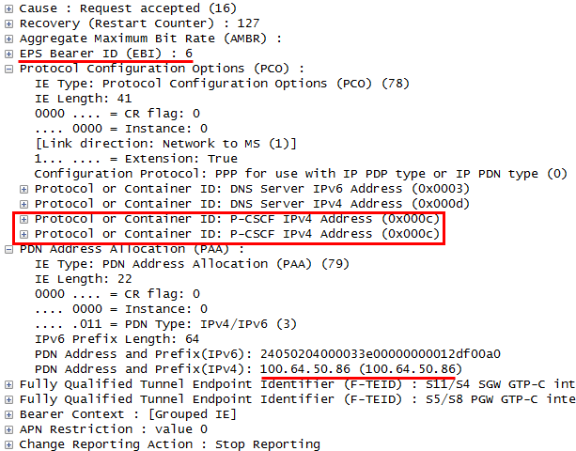](https://blogger.googleusercontent.com/img/b/R29vZ2xl/AVvXsEhlvcBFq6TLvw00LgHkmTgoIKRwhRQrZPz_yltz2dQjc0V31Rx73Y2sWOapmGokUZRy1aarw-fF5GnVX7j7uoGzA_il3NkPovsY-J-9JZrmz04fOi6J9f14gjRl8sa9dbxp_Jh8Cf0z8k8/s1600/Fig%252330+-+snapshot%25234215-CreateSessionResponse%2528IMS%2529.png)

Figure 30. Create Session Response

[21] Upon receiving the *Create Session Response*, the MME requests to activate the default EPS bearer by sending *Activate default EPS bearer context request* towards the UE, which is contained in *E-RAB Setup Request* on S1AP interface. The *E-RAB Setup Request* is used to assign resources on Uu (i.e., air interface between UE and the eNB) and S1 for one or several E-RABs. The following shows parameters contained in the *E-RAB Setup Request*.

* UE-AMBR (UL/DL): The aggregated maximum bit rate of the UE associated with the same PDN.
* E-RAB to be setup parameters contains E-RAB ID=6 and SGW GTP-U TEID which was delivered at step #20.

The following shows parameters contained in the *Activate default EPS bearer context request*:

* EPS QoS QCI = 5
* Access Point Name (APN): “IMS”
* PDN address: The newly allocated UE IP address
* Protocol Configuration Options (PCO) contains the P-CSCF address which was delivered in step #20.
* APN-AMBR: aggregated maximum bit rate for the same APN.

[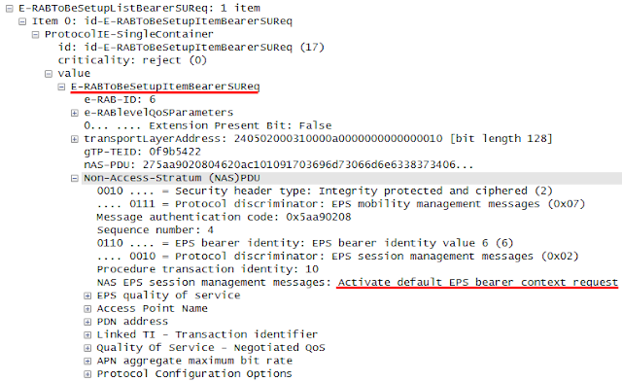](https://blogger.googleusercontent.com/img/b/R29vZ2xl/AVvXsEgoB0Rw36IXhJE3QBPYNCdc2tfjlSKXwGKCcY_qw1_LWuJzjrf7XHzTZWELJE_2EUdFNLDsSFs3-0LK8Uh6HGA3vN-6pLoBzPbTGh4ZefbTQ4SNNnL3n8Td8hKy9P7EuC9hKQYYEkBFWdc/s1600/Fig%252331+-+snapshot%25234217-ERABSetupRequest%2528IMS%2529.png)

Figure 31. E-RAB Setup Request (Activate default EPS bearer context request)

The eNB delivers the *Activate default EPS bearer context request* transparently to the UE, which is contained in *RRC Connection Reconfiguration*. Refer to step #12 for UE behavior after receiving *RRC Connection Reconfiguration*.

[22] ] The UE informs the MME of the fact that the default EPS bearer has been activated by sending the *Activate Default EPS Bearer Context Accept* as a response to a corresponding request.

[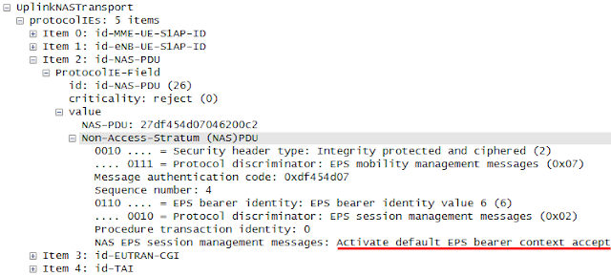](https://blogger.googleusercontent.com/img/b/R29vZ2xl/AVvXsEii_fiSuXSCgrDcLE8224Nv-rFOk9aM8BFhsxh_RU0xcUNYm0hC8uK02OpQ2XqDWDvhJz2wLBajVTtqgTbZb_bT0aKHuEEjoMNlgnyer1DxOVrgr1qx_NWDivTaHo-iblckSnbaB_7tpTU/s1600/Fig%252332+-+snapshot%25234219-ActivateRsp%2528IMS%2529.png)

Figure 32. Activate default EPS bearer context request

[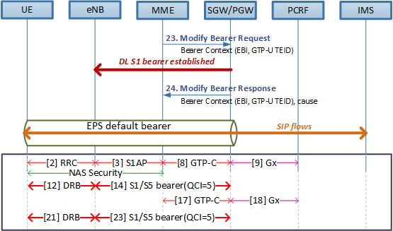](https://blogger.googleusercontent.com/img/b/R29vZ2xl/AVvXsEh02SjMES8VXE4UGQnT0TDX0pj21541SNbNpoj7YayU4G1evCr93F7KlDO5rBuWUJRAuAH4HK4ZSAH0n4N_FMbTCpmaNhod6Mq2ZMPfXeMnRgLATTPICBNmU0zIC4i1sZB-p3d1XYPiCE4/s1600/Fig%252333+-+EPS+bearer+creation+flow+%2528IMS%2529.png)

Figure 33. EPS bearer creation flow

[23] The MME sends the *Modify Bearer Request* requesting the SGW to establish the downlink S1 bearer towards the eNB. Refer to step #14 for overall description. The message contains eNB GTP-U TEID that shall be used by the SGW to identity the end point of the GTP-U of default EPS bearer.

[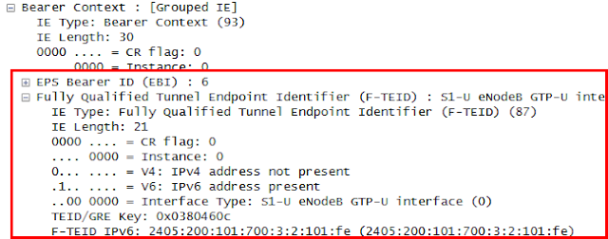](https://blogger.googleusercontent.com/img/b/R29vZ2xl/AVvXsEjdoG2a2pCtKYNt7lX-mM9Bb-f3WZkNn0vFdrnS-ZxR511OsMpJltBNds4r8LbX-mOX7GaSiJXKI_XdguF_cdUH0nkE59m_UmzbwyQ4qGeozvk_CCRQKIrut5FuxPf_VcnnbUjibn490uU/s1600/Fig%252334+-+snapshot%25234220+-+ModifyBearerReq%2528IMS%2529.png)

Figure 34. Modify Bearer Request

[24] Upon receiving the *Modify Bearer Request*, the SGW establishes a downlink S1 bearer and responds with *Modify Bearer Response*.

**[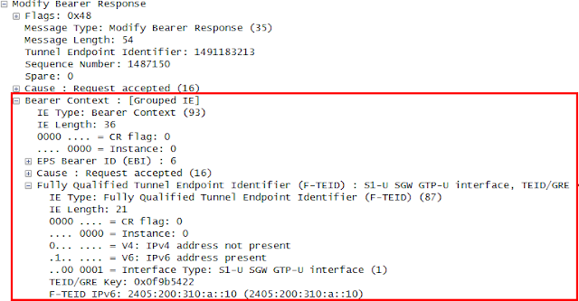](https://blogger.googleusercontent.com/img/b/R29vZ2xl/AVvXsEhFlbuhg_SCN_b5yZHuooS-aZ9ANtWxLMXcVHayzESjr6gTVjZcvuXw1e7CgfO7b0Kq9QcagXstrqTDFWeDb8VOktFM2CzD71-Nj28i2oa_IHGT4YsBn_rDD9k3yMxYHBJB7ImTyP-ZLDQ/s1600/Fig%252335+-+snapshot%25234222+-+ModifyBearerRsp%2528IMS%2529.png)**

Figure 35. Modify Bearer Response

Consequently, the default EPS bearer with QCI value of ‘5’ between the UE and the IMS APN is established. Hereafter all the SIP traffic goes through the default EPS bearer.

***Red Mouse***

**REFERENCES**

[1] 3GPP TS25.331, "Radio Resource Control (RRC); protocol specification", v12.3.0, Sep 2014

[2] 3GPP TS24.301, "Non-Access-Stratum (NAS) protocol for Evolved Packet System (EPS); stage3", v12.4.0, Mar 2014

[3] 3GPP TS36.413, "Non-Access-Stratum (NAS) protocol for Evolved Packet System (EPS); stage3", v12.4.0, Mar 2014

[4] Red Mouse, "[Tracking Area Update and Combined Attach](http://bit.ly/1MNWcsl)", Jul, 2015

[5] Red Mouse, "[Understanding of GTP TEID to use it in LTE troubleshooting](http://bit.ly/1HPM3dv)", Jun, 2015

[6] Netmanias, "LTE Security II: NAS and AS security", Aug 5th 2013

[7] Netmanias, "LTE IP Address Allocation Schemes I: Basic", Feb 13th 2015

**E2E VoLTE call setup(2/4) : IMS registration**

|  |
| --- |
| Once the UE attaches to the LTE network and the default EPS bearer is created successfully with the IMS APN, the UE registers to the IP Multimedia Subsystem (IMS) network before accessing the VoLTE service. The IMS registration procedure includes the IMS authentication, e.g., IMS-AKA, and security negotiation between UE and IMS network. After successful IMS registration, the IMS network becomes aware of UE context such as subscription profile, registration status, etc. After the initial IMS registration, the UE shall refresh the IMS registration status by periodically sending re-Registration. |

**Introduction**

It is assumed that the UE has established a PDN connection to the IMS APN with the QCI value of its default EPS bearer set to ‘5’. The IMS registration signal goes through the default EPS bearer and gets inside the IMS core via the P-CSCF. The P-CSCF, I-CSCF and the S-CSCF consists the IMS core and they controls SIP signaling for VoLTE. The I-CSCF and the S-CSCF interworks with the HSS via Diameter Routing Agent (DRA) to retrieve subscriber’s profile, authentication vector, etc. At the front of the P-CSCF lies the Session Border Controller (SBC). The SBC provides a security function like IPSec, topology hiding, media controlling, etc. It can either be co-deployed with the P-CSCF or separated from the IMS Core.

NOTE the DRA between Diameter clients and Diameter servers (i.e., PCRF, HSS) is omitted in the diagram to clarify the reference points.

[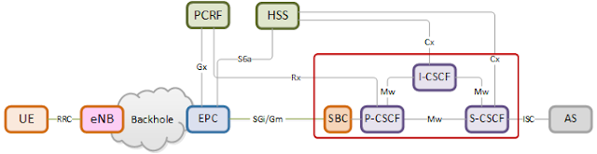](https://blogger.googleusercontent.com/img/b/R29vZ2xl/AVvXsEglPqJPWa-71E6ODfLEXB6vM1LSqZOZeBc3_gF1LQ9WMM7_qd5qERCQthf9VP3MRiydo78ECzwKyRb70o0hX7KshNTOiVaN1BegUT9B7zLzxh1ITQEa77vz4tqIuUzBFVe0ZHrPtuxKpqw/s1600/Fig%25231.+overall+architecture.png)

Figure 1. Overall architecture

**I. IMS Authentication and Key Agreement (AKA) during IMS registration**

The IMS AKA is a mutual authentication methodology used by the IMS network to authenticate a UE. In this authentication procedure, both server and client runs the same authentication algorithm using the same secret key and several public parameters. The secret key is known to both UE and the IMS network. It can be stored in IP Multimedia Services Identity Module (ISIM) and at the same time, be provisioned to the Home Subscriber Server (HSS) in advance. After running the authentication algorithm, the server and the client exchanges their outcome with each other and authenticate the peer by comparing the received authentication parameter with the outcome of their own. The following is the conceptual diagram of the IMS AKA mechanism.

[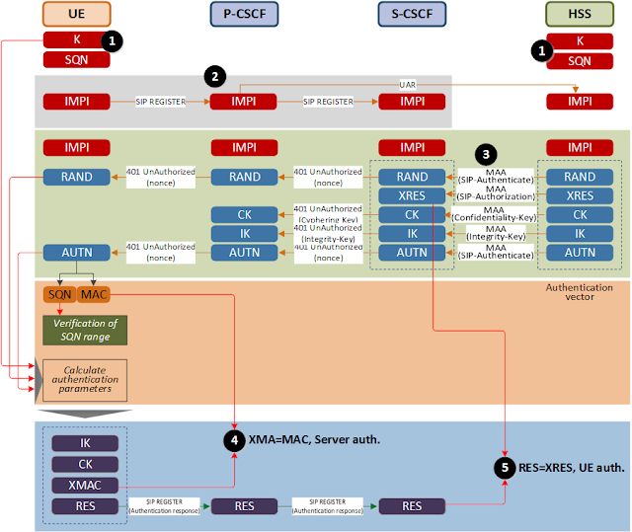](https://blogger.googleusercontent.com/img/b/R29vZ2xl/AVvXsEhTHxeqVuj55Yvfxax4_lsGf5gxdRb0iDqrML8OBDV6MITTtw60x2ZFdAMma4npVghiO9bgBuPKkAP2jkGmG7HGW5kVA2ustFym8XDgC6BN6tUA5xTrmrBoRhqgJeO2j2FX6kkuEUesp-Q/s1600/Fig%25232.+IMS+AKA.png)

Figure 2. IMS AKA

(1)   The secret-key K and the sequence number SQN are commonly stored in both server and client.

(2)   The UE sends the initial registration with the user identifier towards the IMS Core.

(3)   The S-CSCF (i.e., registrar) queries the HSS for the authentication vector of that subscriber. The HSS generates the random number RAND using the SQN. The HSS uses K, SQN and RAND parameters as input to the authentication algorithm and as a result, obtains a set of authentication parameters, i.e., the authentication vector (AV), as listed below:

* AUTN : Authentication token represented as a concatenation of MAC and SQN and used by the client to authenticate the server.
* XRES: Expected correct result of running authentication algorithm and used by the server to authenticate the client.
* CK: Cipher Key (Optional)
* IK: Integration Key

The S-CSCF returns AV (i.e., RAND, AUTN, CK, IK) to the P-CSCF and the P-CSCF delivers RAND and AUTN in the response to the initial registration request (see the step#31 for the detail). XRES is stored in the S-CSCF for later use. The CK and IK is used for integrity and security check by the P-CSCF (or SBC).

(4)   The UE extracts MAC and SQN from the received AUTN. The UE verifies the range of SQN and uses AUTN, K and RAND as input to the authentication algorithm. The UE compares the resulting parameter, XMAC with the received MAC. As such, the UE authenticates the server.

(5)   The resulting RES is sent back to the server. The S-CSCF authenticates the client by comparing the received RES with the XRES.

**II. IMS registration procedure**

Right after the default EPS bearer is established, comes IMS registration procedure. The IMS registration is the procedure for a VoLTE client to register its contact information to the IMS network and it is performed through the existing EPS bearer of QCI=5 in general. The IMS registration procedure is composed of two transactions, that is, the first one is for the UE to obtain the authentication challenge and the other one is to be authenticated using the received authentication challenge.

In case it is a re-registration, the first transaction may not be necessary. The UE will include challenge parameters received in the previous registration procedure so the network is able to authenticate the UE as long as the challenge parameters are still valid. During the registration, the VoLTE client and the IMS network authenticate each other based on the agreed authentication algorithm and in the meantime, negotiate a security algorithm for IP layer transactions.

[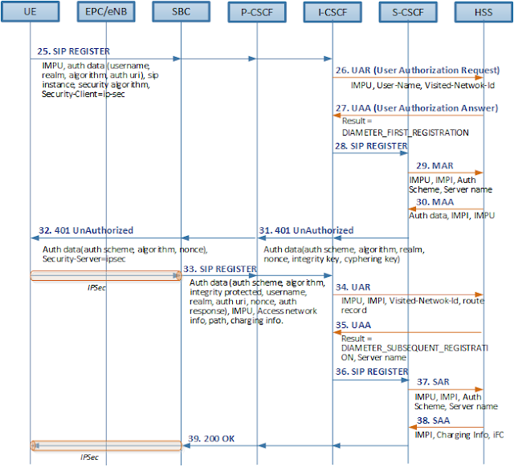](https://blogger.googleusercontent.com/img/b/R29vZ2xl/AVvXsEg4UGazhrIDSBul4a0UGuEqPSVPEklXxY1Mh40834-aixhDhlv0k9PtHiZLtCCqnm2cbRwsEX1FVFyBHC7XJtR4mIc4GM8NWs_hjCaMI8UEW1r2hKcATlZVujba8pUHO9fnecBX42Y5zns/s1600/Fig%25233.+IMS+registration+flow.png)

|  |
| --- |
|  |
| Fig 3. IMS registration flow |

[25] The UE initiates the IMS registration by sending the SIP *REGISTER*towards the P-CSCF.

* Authorization: Authentication information e.g., authentication scheme, nonce, realm, authentication algorithm, etc. The nonce value is empty as this is the first registration.
* Expires: The validity time of this registration. The UE is supposed to perform re-registration before the timer is expired. It is usual for the UE to re-register after 1/2*(timer value) seconds. When the UE is connected to the LTE network, the value of this header would be 3600 seconds and when it is connected to the Wi-Fi, it would be 60 seconds typically.
* Security-Client: A list of supported security algorithm by the UE.
* Contact: UE IP address, device capabilities and various feature tags.

The following snapshot shows an example of SIP *REGISTER*.

[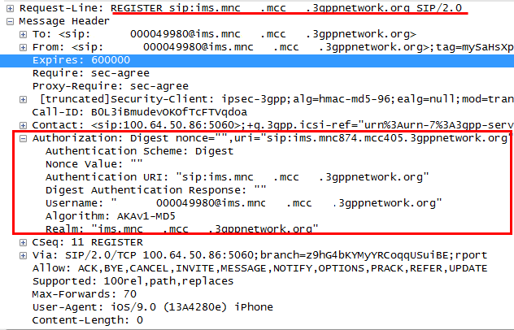](https://blogger.googleusercontent.com/img/b/R29vZ2xl/AVvXsEjhpQjsT4tRb_w9nDPlYEbjle6ZcTbhuoUslN6OiJ3l6-9EZ5sFFXLTOSJR0Tp12ZF38eGk3jO0KuSWkwUQ4frtblC7FEneXcjLfKE6Uv3t8v5FFOQRJ4BcT5JmACd24WwmjoSJ3xQHlnI/s1600/Fig%25234.+snapshot+%25234224+-+REGI..png)

|  |
| --- |
| Fig 4. SIP REGISTER |

The P-CSCF routes the SIP *REGISTER* to the I-CSCF as the P-CSCF does not know at this moment as to which S-CSCF is going to serve this UE yet.

[26] Upon receiving the SIP *REGISTER*, the I-CSCF performs user registration status query by sending *User-Authorization-Request* (UAR) to the HSS.

* User-Name AVP: IMS Private User Identity (IMPI) of the user and used to authenticate the user based on the username part of the value.
* Public-Identity AVP: IMS Public User Identity, which is either SIP URI or TEL URI of the user.
* Visited-Network-Identifier AVP: The domain of the visited PLMN

The following snapshot shows an example of *UAR*.

[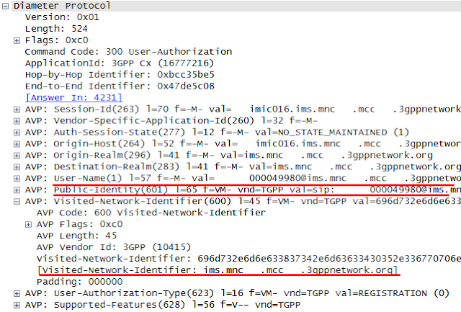](https://blogger.googleusercontent.com/img/b/R29vZ2xl/AVvXsEjKfNGpaK9xETC3LoETIaAautZsju3oDpfwziAqLku-InYcksqyiNMqAnfeth14Cd2iIpXCaibI-MtnE9SzlftQsX6RTEd708CetHptn_xaGlwBDcpZenjv3ucOODfEm-XIvoOPLT-Mme4/s1600/Fig%25235.+snapshot+%25234228+-+UAR.png)

|  |
| --- |
| Fig 5. User Authorization Request (UAR) |

[27] The HSS authorizes the user for IMS service (i.e., verifying the user’s IMPI and IMPU) and if successful, returns with the S-CSCF address for this user in the response, *User-Authorization-Answer* (UAA).

* Server-Name AVP: The S-CSCF address assigned for the IMS subscriber.
* Experimental-Result: DIAMETER_FIRST_REGISTRATION if it is the first time IMS access for the user and there is no S-CSCF assigned yet. If there is already assigned S-CSCF for the user, it will be set to DIAMETER_SUBSEQUENT_REGISTRATION and the Server-Name AVP will be provided.

The following snapshot shows the case where there is already assigned S-CSCF for the user, in which case the I-CSCF does not have to assign a new S-CSCF. If there is no assigned S-CSCF for the subscriber, the HSS returns a set of S-CSCF capabilities and the I-CSCF shall assign a new one based on the received capabilities.

[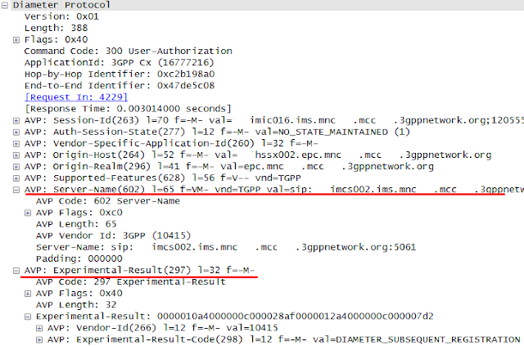](https://blogger.googleusercontent.com/img/b/R29vZ2xl/AVvXsEgrmpB5guSYzHDHJnN8icvsih5tm0hEs_V15WNGhGFDJeu6WDYA1BFbkA695HOgKc6G5vz6pu5PATE8vUJBDwahvkxqNImaFh1bmKxY511QqvkrOAa1SSxaZq_zD14MKSZa1z-cSf7Sl08/s1600/Fig%25236.+snapshot+%25234230+-+UAA.png)

Fig 6. User Authorization Answer (UAA)

[28] The I-CSCF forwards the *SIP REGISTER* towards the indicated S-CSCF.

[29] The S-CSCF sends the *Multimedia-Auth-Request* (MAR) to the HSS requesting the authentication information.

* User-Name AVP: IMS Private User Identity (IMPI) of the user and used to authenticate the user based on the username part of the value.
* Public-Identity AVP: IMS Public User Identity, which is either SIP URI or TEL URI of the user.
* SIP-Auth-Data-Item AVP: The authentication algorithm set to “Digest-AKAv1-MD5” in this example.
* SIP-Number-Auth-Items AVP: The number of authentication vectors.

[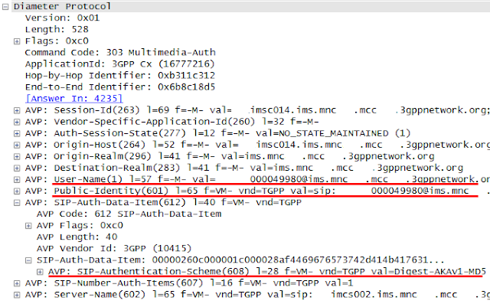](https://blogger.googleusercontent.com/img/b/R29vZ2xl/AVvXsEg3J-GZi8DFnwYnbFI0fdm54OKtka5xJfXCRR7rjfkDPuk2PyQwuvpV135H9bigzJv-ozodOa4LgKCynjpPtNmOalnJQ-6zW64j1cG5fOBbvw0KG3jVCddzxdKJLNsxiD0SltG82aBK5JE/s1600/Fig%25237.+snapshot+%25234232+-+MAR.png)

Fig 7. Multimedia Auth Request (MAR)

[30] The HSS responds with the *Multimedia-Auth-Answer* (MAA) containing the authentication information.

* SIP-Authorization AVP: XRES, which is one of output obtained after running the authentication algorithm (e.g., AKAv1-MD5).
* SIP-Authenticate AVP: The concatenation of RAND and AUTN to be used for authentication.

[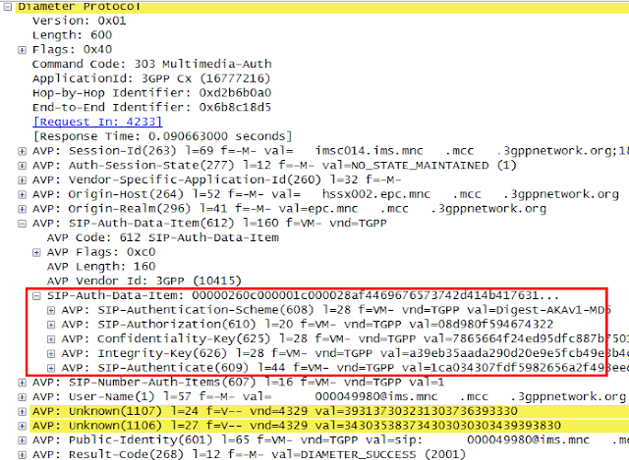](https://blogger.googleusercontent.com/img/b/R29vZ2xl/AVvXsEjTpurRrk7CGkhBxUpZBPntlbRvf-z5LzJeI5GU_iOWtIIw7LRyGqAyCOUGaIfo7qSSThpxOWr15XxLBIfZkpTYyY4Vdh5mKLFx8T1d3Vdi5wt3a60nDIgCMZmppFlvRtPeGhEx04hOCoI/s1600/Fig%25238.+snapshot+%25234234+-+MAA.png)

Fig 8. Multimedia Auth Answer (MAA)

[31] The S-CSCF responds with the *401 UnAuthorized* to the P-CSCF. The WWW-Authenticate header includes nonce parameter (i.e., a concatenation of RAND and AUTN), IK and CK. The AUTN is a concatenation of the MAC and SQN.

* WWW-Authenticate: Authentication challenge needed for mutual authentication.

[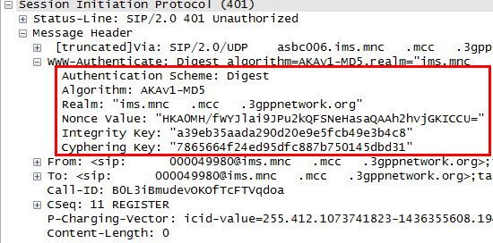](https://blogger.googleusercontent.com/img/b/R29vZ2xl/AVvXsEjbLKOboUPTc9g8Gm3PXhSZDGyRAktCKF812qDekb31BPeLo_tIBUGG049tQuLJ1-UrthwY7xOrjkIgbbfILf10xc1dMGgbyyjEXmRRxJI3RYChCUIo_UvlifvClz-mlp3-QVvgFKPQU0g/s1600/Fig%25239.+snapshot+%25234236+-+401.png)

Fig 9. 401 UnAthorized

[32] The P-CSCF responds with the *401 UnAuorized* towards the UE. The WWW-Authenticate header includes nonce value. The IK and CK is stored in the P-CSCF and removed from the WWW-Authenticate header. As the UE and the P-CSCF negotiated the security method to use IPsec during the initial SIP registration, the subsequent registration and the call related signals like INVITE, 200 OK, PRACK, BYE, etc. are secured based on IPsec.

* Security-Server: a list of supported security algorithm by the server.

NOTE In this field test, the SBC takes over security functions of P-CSCF. Therefore the security negotiation and maintaining security parameters like IK and CK are done by the SBC.

[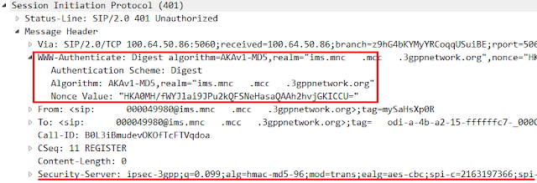](https://blogger.googleusercontent.com/img/b/R29vZ2xl/AVvXsEholstrdhXzYo6r6yXPDjqQqW4reYSMR9kWYSlNXrV7uH3N3iRYlK2cWXj3u974OTpTPOrBPKfFNBXPuUSUOXCEQuA1ky5858zMv0xUdQittcEqxmFGKTiUJND0r7MIEM4L64gXnhiniFA/s1600/Fig%252310.+snapshot+%25234237+-+401.png)

Fig 10. 401 UnAthorized

Upon receiving the *401 UnAuthorized*, the UE extracts the MAC and the SQN from the AUTN, calculates its own XMAC and checks if the XMAC is the same as the received MAC and if the SQN is in a correct range, thereby the UE authenticates the server. The UE also obtains the RES, IK and CK as a result of running the authentication algorithm.

[33] The UE sends the subsequent SIP *REGISTER*towards the P-CSCF and the P-CSCF to the I-CSCF.

* Authorization header: The response to the authentication challenge along with the private user identity, realm, nonce, URI and RES.
* P-Access-Network-Info: The radio access technology and radio cell identity.

[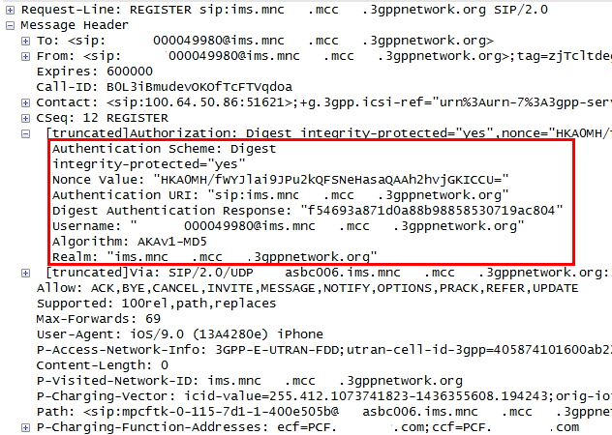](https://blogger.googleusercontent.com/img/b/R29vZ2xl/AVvXsEi9XpVyCnvX9D2aOaNGTLE_XJzyodjxeDPioBB6bApTQidLwS_VraeWLfV7-rB0JMxkhM0bFX1-PgDUrdu07k12In1F6fbuOCt4ygI4qhHMEB9WXiGADO_MwD2jzoFzc5HL2Z-e2uWCge0/s1600/Fig%252311.+snapshot+%25234239+-+SIP+REGI.png)

Fig 11. Subsequent SIP Registration

NOTE the above snapshot has been captured between SBC and P-CSCF as the packet on SGi/Gm interface has been secured using IPsec as a result of security negotiation and it couldn’t be decoded by the wireshark in this test. In order to complete the security negotiation, the UE must have included the Security-Verify header in the subsequent REGISTER indicating IPsec, which is not shown in this snapshot as the SBC removes the header before forwarding the message to the IMS core.

[34] Upon receiving the SIP *REGISTER*, the I-CSCF performs user registration status query by sending *User-Authorization-Request* (UAR) to the HSS.

[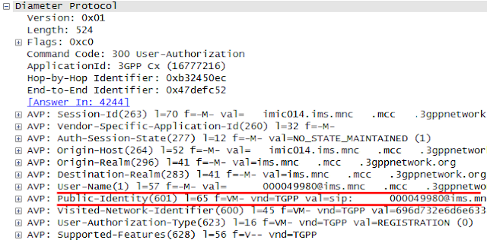](https://blogger.googleusercontent.com/img/b/R29vZ2xl/AVvXsEhDmBjuxE45cJPPmTzP5F8btK4q3-de-FEa3rPG9afTt6iMAWY4Obxb0iAj5tyh_fh2u7AUaJ0odoF7J4hfRg5a8RbFB4vtpDIE1DUD_2ou0kwZFcoM4G1LcnonRFKDWllgohnTCGJW0gc/s1600/Fig%252312.+snapshot+%25234241+-+UAR.png)

Fig 12. User Auth Request (UAR)

[35] The HSS authorizes the user for IMS service (i.e., verifying the user’s IMPI and IMPU) and if successful, returns with the S-CSCF address for this user in the response, *User-Authorization-Answer* (UAA).

[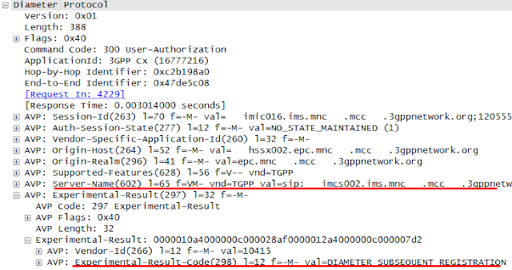](https://blogger.googleusercontent.com/img/b/R29vZ2xl/AVvXsEjYfQTKEBwUH3akKYXdhWGQalMEh9EC83EgSj4xYGM67c7SU4IEG2bF2DGqnwHop-50iy0WdfnDXXKpf8MQJNd4HIz3SOS8NeZTUFgSD8QG5bnl2p_J-xa2MR7qT0IcudpTUWme_dR7u9I/s1600/Fig%252313.+snapshot+%25234243+-+UAA.png)

Fig 13. User Auth Answer (UAA)

[36] The I-CSCF forwards the SIP *REGISTER*towards the indicated S-CSCF. Upon receiving the subsequent SIP REGISTER, the S-CSCF compares the stored XRES with the received RES (i.e., Digest Authentication response parameter). If they are identical and successfully authenticated, the public user identity is registered in the S-CSCF.

[37] The S-CSCF informs the HSS that the user has been registered by sending *Server Assignment Request (SAR)*. Upon receiving the *SAR*, the HSS stores the mapping relation between the S-CSCF and the corresponding IMS subscriber.

* User-Data-Already-Available AVP: Indicator of whether or not the sending S-CSCF has user profile information which is required to service the user. If it is set to USER_DATA_NOT_AVAILABLE, the HSS is expected to provide the user data in the response.

[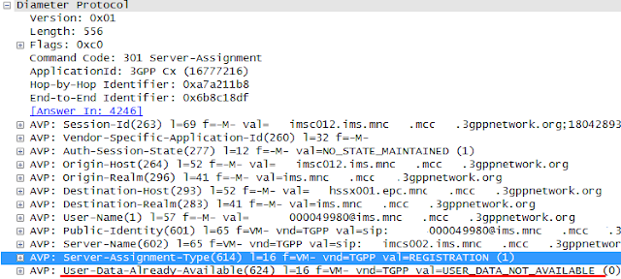](https://blogger.googleusercontent.com/img/b/R29vZ2xl/AVvXsEimZHKBQ0jqNqYn2rQeXPQkHKvIIRUAIZVK6dO18JumBj6pyYVeAKIHKqnGHAj1HBMIQ6_RYblkmvVy9-schESwKs2BEc6foHT9Tkb7A8dJit5QIQC7oX-DGcaHM4ITZSqvuVIF6mME1bY/s1600/Fig%252314.+snapshot+%25234245+-+SAR.png)

Fig 14. Server Assignment Request (SAR)

[38] The HSS responds with the*Server Assignment Answer* (SAA) to the S-CSCF. As it was indicated in the *SAR* that the S-CSCF does not have user profile, the HSS includes the User-Data AVP in the response.

[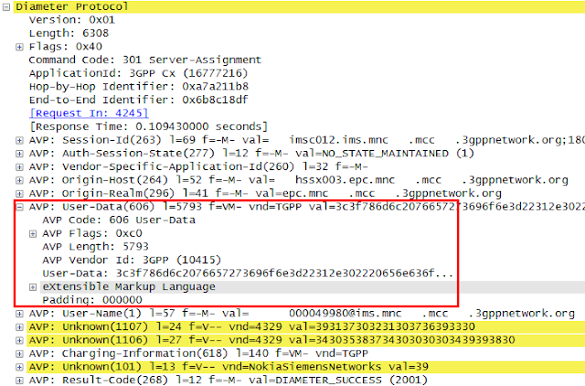](https://blogger.googleusercontent.com/img/b/R29vZ2xl/AVvXsEgRsxuOTcZOO1nzQ37Rva5bweL-E_o_gL1oVLroKuTh-D3u6XvvnGNrfUsRfhRY9HuO3amVGZjmGnKIYXnFW3vEV_izlistf38f6m3xOhAD_-E1rsj8_tnioPNa6ubqeIesvMw4q1ZZ-tE/s1600/Fig%252315.+snapshot+%25234246+-+SAA.png)

Fig 15. Server Assignment Request (SAA)

The User-Data AVP may contain the following items as is shown below:

* Private Id
* Service Profile
* Public Identity
* a list of initial Filter Criteria (iFC)

[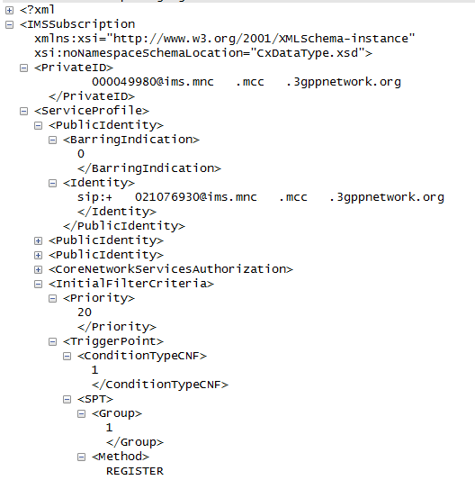](https://blogger.googleusercontent.com/img/b/R29vZ2xl/AVvXsEinZIrIXdawhAodKYFFOT6yfteRUWs4Tr6zJLA4yci6LmmcyyYwMj76OU_LL1274eLIb0J3HcGm9pe8A4QphLZKKDASLEacjR1G1aDaGnWL1oyzAJsT1t8skcb8kUSawvxy9SP9pCpC-AY/s1600/Fig%252316.+snapshot+%25234246+-+UserData.png)

Fig 16. User Data in SAA

[39] The 200 OK for the SIP *REGISTER*is sent back towards the UE following the reverse signaling path.

[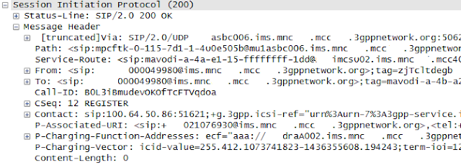](https://blogger.googleusercontent.com/img/b/R29vZ2xl/AVvXsEjCiJiaeIUygQL5IcbLNPweh273-8qO2ibJdzCNLwPjfAKdRi58t3e6XLGQNlfXxWcQMa38dJ9nMExY6SgyZ9q9AhIlMaMZv-WZMbONbfD4RmhYlON7D5A1tH84hmubq1xajTRmvA-U2Ds/s1600/Fig%252317.+snapshot+%25234247+-+200OK.png)

Fig 17. 200 OK to SIP EGISTER

NOTE the above message has been captured on the interface between SBC and P-CSCF as the 200 OK on SGi/Gm interface has been secured using IPsec.

After successful IMS registration, the UE subscribes to the reg event package for the public user identity registered at the S-CSCF. The UE will get notified of a registration status of public identities belonging to the same user.

[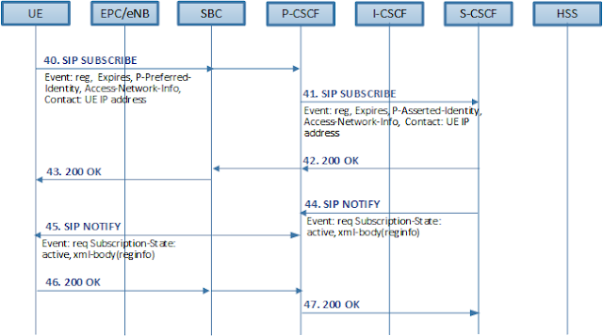](https://blogger.googleusercontent.com/img/b/R29vZ2xl/AVvXsEgMaw-aPcRaZZMEhoX9fNB4lom3etX_S0GOQ5rqX2R4zY6tr4Wo9dnrgdPCxykhcW40CW_B8AvuK1XyTlA7dgponjalG4rZJF7MF5s3imoUwD6r1m4qoq9KyKpDKJ5Sh21TQTLpisOyzGo/s1600/Fig%252318.+Subscription+flow.png)

Fig 18. Subscription for reg event package

[40] The UE subscribes to the reg event package by sending *SIP SUBSCRIBE* towards the S-CSCF.

* Event: “reg” indicating this is the subscription to the reg event package
* Expires: Validity time period during which this subscription session is valid..

[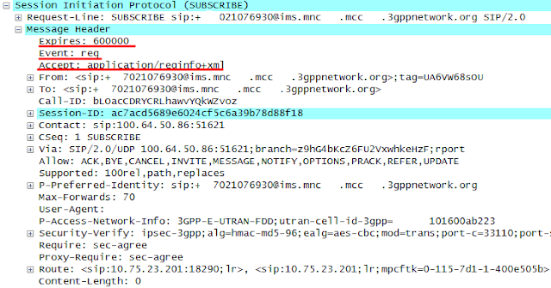](https://blogger.googleusercontent.com/img/b/R29vZ2xl/AVvXsEgEMPcMb20odWed-xECyBSb1b8UOx6lqj9eFGB872t0QpJmjzCLYon3ydJEcQZy-STtaKhRNRjBoAeEHaxmWMJ12t-vXm8Tvb7DizMpWRXBddfDHC-JI2PESNSigN-vZUFxvoR8CuHd9p4/s1600/Fig%252319.+snapshot+%25234259+-+SUBSCRIBE.png)

Fig 19. SIP SUBSCRIBE

[41] The P-CSCF forwards the SIP SUBSRIBE to the S-CSCF which is known to P-CSCF during the registration procedure.

[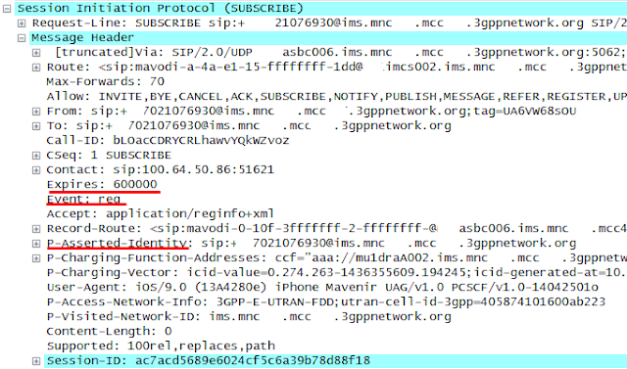](https://blogger.googleusercontent.com/img/b/R29vZ2xl/AVvXsEgmo_S_zIZDnkrtc3NNYU6yJn3ArYcZi-2NVbOyry-KIFvRCqcarMA1K2p7wI3mUam2XhhqcaYfiTGZF-Pe855A2jd1TntuYhQ0CeRCOOmZ4Koik5WnLTb9_mvhPODncXKj05om89Tq0Uw/s1600/Fig%252320.+snapshot+%25234280+-+SUBSCRIBE.png)

Fig 20. SIP SUBSCRIBE

[42-43] The S-CSCF returns with the 200 OK response and it is forwarded to the UE following the signaling path.

[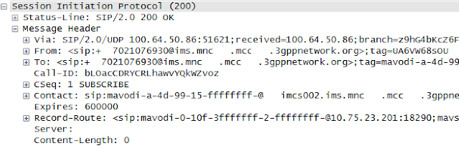](https://blogger.googleusercontent.com/img/b/R29vZ2xl/AVvXsEhJkbxD9kE0l8Y-4pSHRpo6BS29Re5OJeeEiFo0f3gQgPKKtqvXPeCkvkgVOcm0Zi9lkzpsKRZoR9Gc7O4hQoRdnnXROD0id1sMsKI7jmqfZTnp42v4S8mZJI8_trLjuYVnbQdTHEpZS2M/s1600/Fig%252321.+snapshot+%25234287+-+200+OK.png)

Fig 21. 200 OK response to SIP SUBSCRIBE

[44-45] The S-CSCF notifies the UE of its current registration status by sending SIP NOTIFY, which is forwarded to the UE

[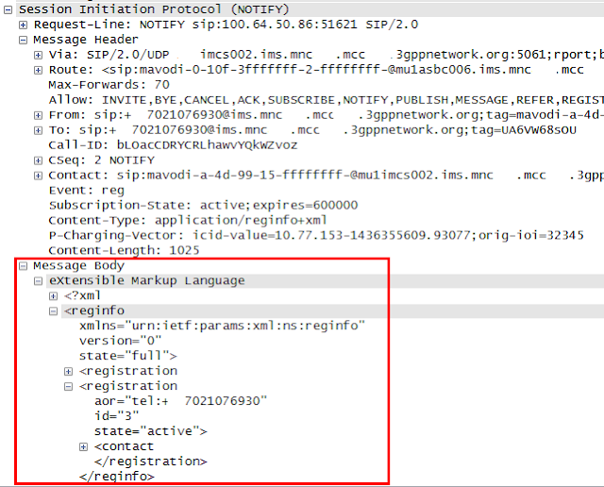](https://blogger.googleusercontent.com/img/b/R29vZ2xl/AVvXsEj1LhDVW8C9Q2oq3NFL8iefyK-BqSOaD199rqsrTfvwoY48D22y8c-wF5I06n7R31VfcMy6QngqMBp3xZq_jFbOz7yoRNQzFfpjrIltaD94Gf68hcQWtoHNvrosqaZMRKr8mlAUlO6Yfc4/s1600/Fig%252322.+snapshot+%25234290+-+NOTIFY.png)

Fig 22. SIP NOTIFY

[46-47] The UE responds with 200 OK response towards the S-CSCF.

[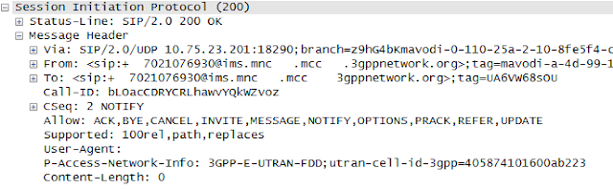](https://blogger.googleusercontent.com/img/b/R29vZ2xl/AVvXsEgWFoPDSIK3DtL9mKzO6a6DMuSDjdRnoE8R6ahcBtpPtgtjvmMYQnQoTr43uC0VbTOmCcM33iCDzajMsgAVw8TK0fsASn_H4pfTUHWcz8nDLX9WdGxsSjNflK-RT3a-Qa1rJNZu16GDjqI/s1600/Fig%252323.+snapshot+%25234295+-+NOTIFY.png)

Fig 23. 200 OK response to SIP NOTIFY

**REFERENCE**

[1] IETF RFC4740, "Diameter Session Initiation Protocol (SIP) Application", Nov 2006

[2] IETF RFC3310, "Hypertext Transfer Protocol (HTTP) Digest Authentication Using Authentication and Key Agreement (AKA)", Sep 2002

[3] IETF RFC7315, "Private Header (P-Header) Extension to the Session Initiation Protocol (SIP) for the 3GPP", July 2014

[4] IETF RFC3329, "Security Mechanism Agreement for the Session Initiation Protocol (SIP)", Jan 2003

[5] 3GPP TS 29.228, "IP Multimedia (IM) Subsystem Cx and Dx interfaces; Signaling flows and message contents", v12.3.0, Sep 2014

[6] 3GPP TS 29.229, "Cx and Dx interfaces based on the Diameter protocol; Protocol details", v12.6.0, Jun 2015

[7] 3GPP TS 24.228, "Signaling flow for the IP multimedia call control based on Session Initiation Protocol (SIP) and Session Description Protocol (SDP)", v5.15.0, Sep 2006

[8] 3GPP TS 33.203, "3G Security; Access security for IP-based services", v12.5.0, Mar 2014

**E2E VoLTE call setup(3/4) - Voice call setup**

|  |
| --- |
| Once the IMS registration is successfully done between the UE and the IMS network, the user can make a VoLTE call. Upon request for voice call from the user, the VoLTE UE starts SIP signaling with the IMS core. The SIP messages are routed based on initial Filter Criteria (iFC) in the IMS Core and delivers SDP offer and answer to establish media session along with various SIP headers. As a consequence of the SIP signaling, a new dedicated EPS bearer is established between the UE and the SGW/PGW which is used to transfer voice media. The QoS of this new dedicated EPS bearer is defined by the PCC rules generated by the PCRF. |

**Introduction**

While the SIP messages go through the default EPS bearer (QCI=5) towards the IMS core, the voice media path is established at the front-end NEs taking the role of IMS Application Level Gateway (IMS-ALG) and IM Access Gateway based on SDP negotiation. The following diagram shows the conceptual diagram of IMS-ALG and IMS Access Gateway model specified in 3GPP TS23.228. The IMS-ALG controls media resources and gating functions of the IM Access Gateway over Iq interface. It acts as a B2BUA and can modify the SDP and SIP headers of SIP messages if necessary. The IM Access Gateway executes the allocation and release of transport addresses, IP versioning and the media gating function under the control of the IMS-ALG.

|  |
| --- |
|  |
| Fig 1. IMS-ALG and IMS Access Gateway model |

The following diagram shows how the media path is established. Upon request from the user for voice call setup, the UE sends VoLTE call setup request (i.e., SIP INVITE) to the IMS core with an SDP offer, which contains the allocated media information of the originating UE [A]. The IMS-ALG allocates media resource in the IM Access Gateway to which the originating VoLTE UE can access. The allocated media information at IM Access Gateway is sent back to the UE in the response as an SDP answer [a]. The IMS-ALG allocates additional media resource for the upstream, includes it in the SDP offer and sends it towards the remote IMS-ALG [B]. The IMS-ALG in the remote IMS network responds with the SDP answer containing the media access point of IM Access Gateway in the same network [b]. The IMS-ALG in the remote network also allocates another media resources and sends it to the UE as an SDP offer [C]. In turn, the UE will also send back the response including SDP answer of its own [c].

NOTE the gray arrow indicates the signaling path and the rest indicate the media path and its direction.

[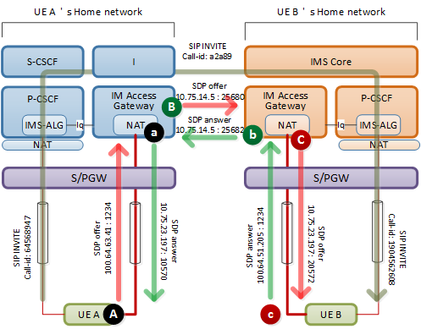](https://blogger.googleusercontent.com/img/b/R29vZ2xl/AVvXsEgTkSZr7_MEY3Mq4qoUHekyZUBe76Fj-a-i7nZiH5D8E2PFwEk8BsE1qzaYRH2xVcpcSjkvDMTnNTj0offVGYHs1DU2PJuFVJuW5XmxbvGEADf2Sk6CZFj2-jm-72pWB_hKMd7IPt4QIFA/s1600/Fig%25232.+Media+path+establishment.png)

|  |
| --- |
| Fig 2. Media path establishment |

NOTE The IM Access Gateway functionality is typically provided by Service Border Controller (SBC).

**II. VoLTE call setup procedure**

Upon request from the user for VoLTE call setup, the UE initiates SIP signaling with the IMS core. The P-CSCF address is informed to the UE when the UE attaches to the network. The signaling path beyond the P-CSCF is determined based on a routing mechanism of IMS core. The SDP negotiation is performed along with the SIP signaling and determines the media path for voice call setup.

Upon receiving call setup request (i.e., *SIP INVITE*), the P-CSCF informs the PCRF of the service data flow information. The PCRF triggers the Evolved Packet Core (EPC) to create a dedicated EPS bearer of QCI=1 for voice media by generating and provisioning PCC rules to the SGW/PGW. The PCC rules include QoS parameters and rules to be applied to service data flows based on which the SGW/PGW establishes mapping relations between service data flows and the EPS bearers.

NOTE Based on GSMA IR.92, the UE is strongly recommended to support the precondition framework for VoLTE. Please note that, in the following practice, the precondition procedure has been disabled before testing. Please refer to [FCM.01](http://www.gsma.com/network2020/wp-content/uploads/2014/10/FCM.01-VoLTE-Service-Description-and-Implementation-Guidelines-Version-2.0.pdf), [IR.92](http://www.gsma.com/newsroom/wp-content/uploads/IR.92-v9.0.pdf) and 3GPP [TS 24.229](http://www.3gpp.org/DynaReport/24229.htm) for the detail.

NOTE While the following procedure shows the only originating side, the same procedure and principles can also be applied to the terminating side. The signaling procedure handled within the IMS core has not been described to avoid complexities as it can vary based on the deployment architecture as per IMS vendor.

[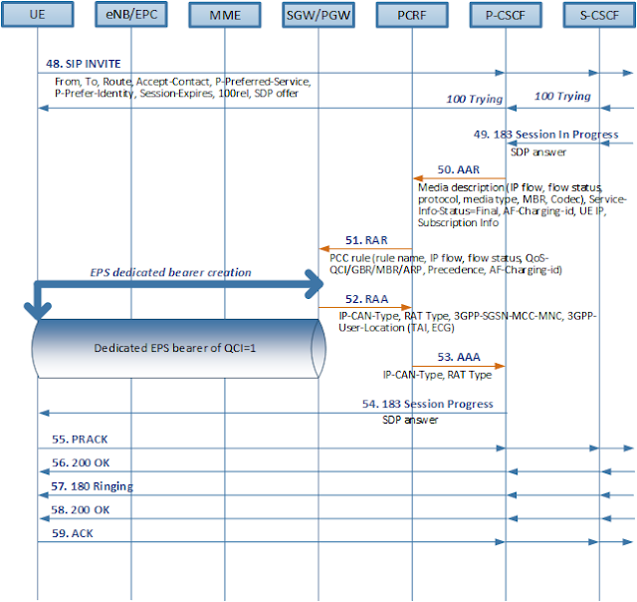](https://blogger.googleusercontent.com/img/b/R29vZ2xl/AVvXsEijrG_1xAW3xoQyvUNM5zzb6Kl0zCqsLwPQ0pUyQhHBYpB8UHoMJIjW2KvQ9oZncOQimaEqQaMpc-MjvKqGuXiovvcMlqR8dRvft4Gtt2ItL6kFKIsM7Qpnj_q-6m0tk5ozCHslX7uJko8/s1600/Fig%25233.+VoLTE+call+setup+%25283%2529+flow.png)

|  |
| --- |
|  |
| Fig 3. VoLTE setup call flow |
|  |

[48] Upon request from the user to make a voice call, the originating UE sends the SIP *INVITE*towards the P-CSCF.

* Supported header: a list of option tags indicating supporting features. In this example, the "timer" and "100rel" indicate support of session timer and a reliable delivery of the provisional response (i.e., 183 Session In Progress), respectively.
* P-Early-Media header: indicator of whether the UE supports the early media mode.
* Allow header: a list of SIP methods that is supported by the UE.
* P-Preferred-Identity header: the originating user's identity that is preferred by the originating user to be used. This header is replaced with the P-Asserted-Identity header by the P-CSCF in the IMS network. If the SIP message is sent towards untrusted IMS core, the P-Asserted-Identity header shall be removed.
* User-Agent header: VoLTE client information
* Privacy header: preference of sending UE indicating that any sensitive information shall be hidden from any parties that do not need to know it.
* Accept-Contact header: a list of features of target UE preferred by the sending UE
* P-Access-Network-Info header: the radio access technology and cell identity.
* Session-Expires header: a valid period of time of this SIP INVITE session. The parameter “uac” indicates that the sending UE will refresh the session before the timer is expired.
* P-Preferred-Service header: service identification user wishes to be used. This header is replaced with the P-Asserted-Service header by the P-CSCF.
* Content-Type: media type of the message-body sent to the recipient.
* Route header: a list of IP addresses of intermediary nodes which the SIP request will go through. This would a copy of Service-Route header returned in 200 OK response to SIP REGISTER, which is inserted by the S-CSCF. The Service-Route header indicates the intermediary node associated with that S-CSCF.
* From header: sending user’s SIP URI or TEL URI
* To header: recipient’s SIP URI or TEL URI
* Call-ID header: a globally unique identifier of the SIP session. All the SIP messages of the same session must have the same Call-ID value.
* CSeq header: sequence of the same SIP method. The sequence number is incremented as the same SIP method is being sent.
* Max-Forwards header: maximum number of hops that the message can go through.
* Contact header: the contact address, device capabilities, feature-tags, etc. of the sending UE.
* Via header: a list of SIP addresses of intermediary nodes. The entry is inserted by each node that wants to stay in the signaling path for the SIP response. The response message for this request (e.g., *183 session in progress, 100 Trying, 200 OK,* etc) will be transferred to the originating UE following the reverse path listed in this header.
* Content-Length: body length in bytes.

[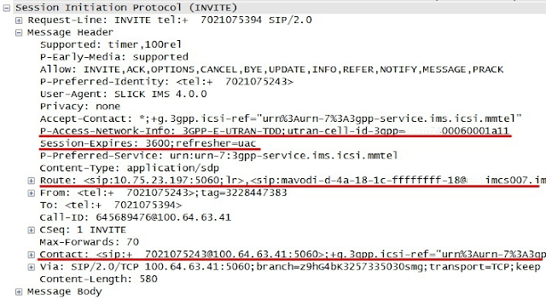](https://blogger.googleusercontent.com/img/b/R29vZ2xl/AVvXsEh6QTCv5BMWbFkxRnGtgBTtwwibXwz1AAYiOozTzRYf0qm-wFuGoq9JxyudC7Cg8oNhVeRnUiIc1eLv62FSugN9f3c2etDuTUai8fqCUBu6ByRk7UhEIXnh4dZXehar7WyMWerz_jqcS0I/s1600/Fig%25234.+snapshot%252397-invite.png)

|  |
| --- |
| Fig 4. headers in SIP INVITE |

The SIP *INVITE*contains an SDP offer. The SDP defines media information of the sending node which contains the contact ip address, port number and a list of supporting codec information. The following shows descriptions of each parameters used in SDP.

* ‘o’ (originator and session identifier): <username><session-id><network type><address type><ip address>
* ‘s’ (session name): any textual session name
* ‘c’ (connection data): <network type><address type><connection address>
* ‘t’ (timing): <start time><stop time>
* ‘m’ (media description): <media type><port><protocol><fmt: media format description>
* ‘b’ (bandwidth): AS (application specific) – maximum RTP session bandwidth (kbytes), RS – sending RTCP bandwidth (bytes), RR – receiving RTCP bandwidth (bytes)
* ‘a=rtpmap’ (attributes): <payload type><encoding name><clock rate><encoding parameters>
* ‘a=fmtp’(attributes): format specific parameters related with the corresponding media
* ‘a=ptime’(attributes): length of time represented by the media in a packet (ms)
* ‘a=maxptime’(attributes): maximum amount of media that can be encapsulated in each packet(ms)

The following is an SDP example included in the SIP *INVITE* captured on the Gm interface. The UE’s IP address is “100.64.63.41” and port number for audio is “1234”, which is depicted as [A] in Fig2.

[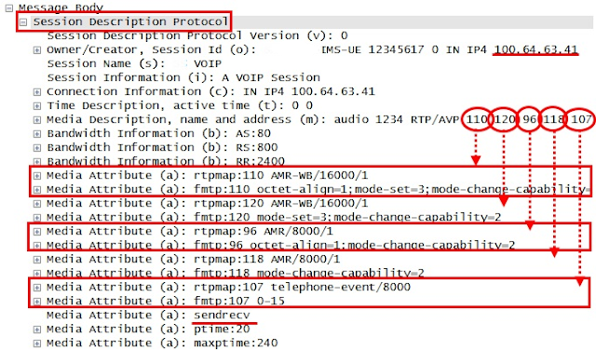](https://blogger.googleusercontent.com/img/b/R29vZ2xl/AVvXsEi3rVAXcuDWD3fz68Vyz6dWaaIIPH6XX9JJCD6Y_sm56aWgJ6_7Cua43tfNM3K8Ib1Ofj5Xufb-vSdNXrVJcKf8CPDQi1KN-XeEGGHYiuPYQboqwDWYxRM_gbBhwYjVzWZxZ5e050UVUdw/s1600/Fig%25235.+snapshot%252397-sdp.png)

Fig 5. Attributes in Session Description Protocol (SDP) offer

NOTE Upon receiving the SIP *INVITE* with an SDP offer, the P-CSCF may send service data information to the PCRF of which flow-status AVP set to ‘DISABLED’. In this case, the P-CSCF will send additional service data information when it receives the *183 Session In Progress* with SDP answer. In the following example, the service data information is sent only once when the P-CSCF obtains SDP offer and answer all together at step #48.

The P-CSCF responds with a *100 Trying* provisional response. The provisional response is a one-way response sent back to the originating side used as informative. It is not necessarily guaranteed for its safe arrival.

[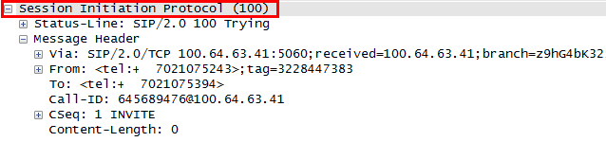](https://blogger.googleusercontent.com/img/b/R29vZ2xl/AVvXsEgTGHI-07uKlj0WhGMQ-IB7YbW-gQCLwC7__-JhYn5JxOSUOsbNMQDsaiNd1b8OPF2uJH7qf_D2TKfZdNJVOmMlkooQZw0FM9-wjX6hKHHLjc_ZWBwFLo59Q35oM3EFkyPH7qpVprDTHtQ/s1600/Fig%25236.+snapshot%252398-100Trying.png)

Fig 6. Parameters in 100 Trying

[49] The terminating UE locally allocates resources, generates the *183 Session In Progress* along with SDP answer and sends it back towards the originating UE. The *183 Session In Progress* arrives the originating S-CSCF following the reverse path of the SIP messages. The S-CSCF forwards it to the P-CSCF.

* Record-Route header: a list of IP addresses that is copied from the Route header by the terminating UE in the received SIP *INVITE*. The value of this header will be reused by the originating UE when it composes Route header upon sending subsequent SIP request.
* Require header: a list of option tags indicating features that needs to be supported by the recipient (i.e., the originating UE) of this message. In this case, the "100rel" indicates the originating UE shall support the reliable delivery of provisional response.

NOTE the provisional response, 1xx, is an informative response therefore it does not usually require the reliable delivery. However, *183 Session In Progress* would be an exception as it contains the SDP answer.

* RSeq header: the sequence number of this response. The value of this header is copied to the CSeq header in the following *SIP PRACK* sent by the originating UE.
* P-Asserted-Identity header : the authorized user's identity of the sending user of this message (i.e., the terminating user)
* P-Charging-Vector header: a collection of charging information, which consists of IMS Charging Identity (ICID) value, the address of the SIP proxy that creates the ICID value and the Inter Operator Identifiers (IOI). The ICID indicates a globally unique charging value that identifies a dialog, the IOI identifies both the originating and terminating networks involved in a SIP dialog. In the following example, the full text for the header is as follow:

|  |
| --- |
| icid-value=0.274.195-1418282284.647;term-ioi=32345;term-ioi=22345;icid-generated-at=10.75.0.5;term-ioi=Type3Term;orig-ioi=32345 |

[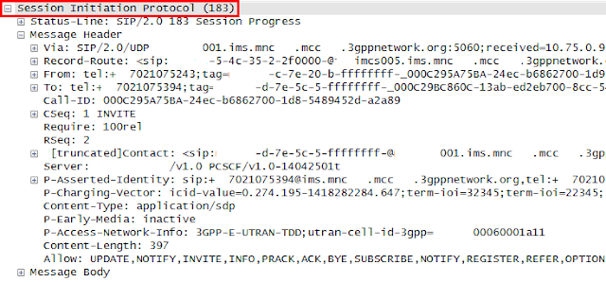](https://blogger.googleusercontent.com/img/b/R29vZ2xl/AVvXsEjc-h7dw_KpNC3ccIAyPqkAFMBtz0qiDd35pD2LHLuQnEq984CCXROu4_ctKLCjqcXeUgP9xDEjghCnLfQ8HPaJ09I-niEVw0yAQtxyjj4qvnyKEBqy0jZisWrAFMyfgTc3BpYxXbOWFyQ/s1600/Fig%25237.+snapshot%2523122-183SessionProgress.png)

Fig 7. Headers in *183 Session In Progress*

[50] Upon receiving the*183 Session In Progress*, the P-CSCF triggers the *Authentication and Authorization Request*(AAR) towards the PCRF to inform the fact that there is a new Application Focus (AF) session being created. The PCRF performs [session binding](http://hongjoo71-e.blogspot.in/2015/06/volte-bearer-binding-and-session-binding.html) between the AF session and the corresponding IP-CAN session.

NOTE AF indicates an element offering applications that require the Policy and Charging control of the user plane resources. In this context, it indicates the P-CSCF.

* Session-Id AVP: identifier of Rx session for this application. It lasts until this application (i.e., VoLTE session) does exist.
* AF-Application-Identifier AVP: identifier of the VoLTE call session assigned by the P-CSCF.
* Media-Component-Description AVP: media information of the service data flow
* Service-Info-Status AVP: the status of the service information that the P-CSCF is providing to the PCRF.
  + FINAL SERVICE INFORMATION (0): the service has been fully negotiated between the two nodes and the provided service information is the result of the negotiation.
  + PRELIMINARY SERVICE INFORMATION (1): the provided service information is a preliminary and further negotiation is to be needed between two nodes.

NOTE In this example, the value is set to be “FINAL SERVICE INFORMATION” as the P-CSCF has both SDP offer and answer.

* AF-Charging-Identifier AVP: identifier for charging correlation with bearer layer.
* Specific-Action AVP: a list of events that P-CSCF wants to be informed from the PCRF. The PCRF shall report to the P-CSCF when any of these events occurs.
* Subscription-Id AVP: identifier of the end user’s subscription. It holds subscription type and data. Multiple instances of the subscription-id indicates multiple type of identifiers of the same subscriber such as E164, SIP URI, IMSI, etc.
* Framed-IP-Address AVP: UE’s IP address which is allocated by the PGW during initial attach procedure.
* Required-Access-Info AVP: indicator of query by the P-CSCF for access network information.

[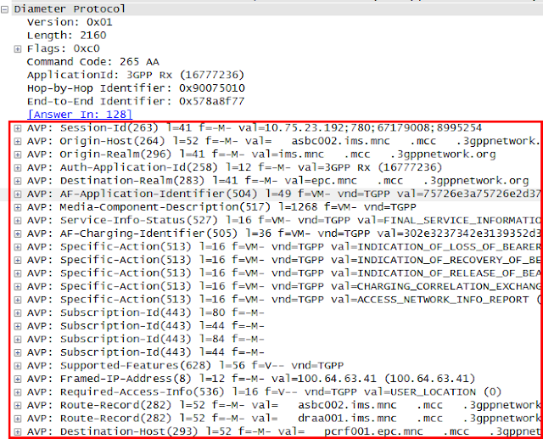](https://blogger.googleusercontent.com/img/b/R29vZ2xl/AVvXsEg4GX28unxF2RjyOVHzxCppQp8H60Ymq9V1LuVkzciKlICaqmNZ49uslThlNOAGdY4wc0r0Ese7_SWSEcpq96IPFZqUlDNwOzu-PohxzcBqMGi5oErczBJVN6qfMgeZMQFZTGq4QBK8-zU/s1600/Fig%25238.+snapshot%2523124-AAR.png)

Fig 8. AVPs in *AAR*

The Media-Component-Description AVP reflects the SDP offer and answer which includes the media type, direction and codec information.

* Media-Sub-Component AVP: descriptions for media flows. There are two sub components appears in this snapshot, one for RTP and the other one for RTCP.
* Flow-Description AVP: description for IP flow in each direction, of which IP addresses and port numbers are copied from the SDP offer and answer by the P-CSCF.
  + Uplink IP flow: UE (“100.64.63,41”, “1234”) à SBC (“10.75.23.197”, “10570”)
  + Downlink IP flow: SBC (“10.75.23.197”, “10570”) à UE (“100.64.63,41”, “1234”)
* Flow-Status AVP: permission status of each media flow.
  + ENABLED-UPLINK (0): enable associated uplink IP flow(s) only.
  + ENABLED-DOWNLINK (1): enable associated downlink IP flow(s) only.
  + ENABLED (2): enable all associated IP flow(s)
  + DISABLED (3): disable all associated IP flow(s)
  + REMOVED (4): remove all associated IP flow(s)
* Media-Type AVP: the type of media stream e.g., audio, video, data, text, message.
* Max-Requested-Bandwidth-UL/DL AVP: the Maximum Bit Rate (MBR) of the IP flow in each direction. The bandwidth contains all the overhead coming from IP layer and the layer above e.g., IP, UDP, RTP, RTP payload.
* RS-Bandwidth AVP: maximum required bandwidth for RTCP sender reports.
* RR-Bandwidth AVP: maximum required bandwidth for RTCP receive reports.
* Codec-Data AVP: codec related information known at the P-CSCF.

[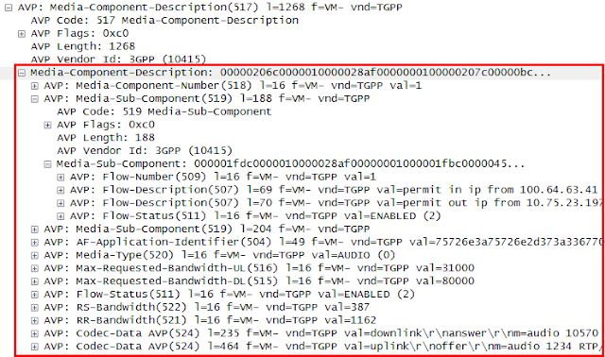](https://blogger.googleusercontent.com/img/b/R29vZ2xl/AVvXsEgsFuvdfxHHG69ClZR4ZThQZxRN5zGwpuQxXQLUo3RHNobzOU_BS16O6GNoEaEYH3eiWntNL8XzRdwsp8TOB0gPSsZywSWJWacI2yyQdEGtzneSfRVOo_kME_l0YQLv5HlcA6-P7kJrHzo/s1600/Fig%25239.+snapshot%2523124-AAR-MediaComponent.png)

Fig 9. Sub-AVPs of Media-Component-Description AVP

[51] Upon receiving the *AAR*, the PCRF generates PCC rules. PCC rules includes IP flow description for uplink and downlink (i.e., 5-tuple), QoS information, the flow status, etc. The SGW/PGW performs [bearer binding](http://hongjoo71-e.blogspot.in/2015/06/volte-bearer-binding-and-session-binding.html) between the received PCC rules and the corresponding IP-CAN bearer. The IP flow shall be mapped to a specific IP-CAN bearer based on these PCC rules by the SGW/PGW

* Charging-Rule-Definition AVP: A PCC rule. There are two PCC rules showing up for voice call, one for RTP and the other one for RTCP.
* Charging-Rule-Name AVP: A PCC rule name. It is uniquely defined within the same IP-CAN. If the PCC rule is pre-defined in PGW as is the case for default EPS bearer, it is uniquely defined within the PGW.
* Flow-Information AVP: a single IP flow packet filter. It includes the ip address and port number and the direction of the IP flow.
* Flow-Status AVP: permission status of each media flow. Refer to step#49 for the detail.
* QoS-Information AVP: QoS information to be applied to the IP flow, which includes QoS Class Identifier (QCI), GBR (Guaranteed Bit Rate), MBR (Maximum Bit Rate) and ARP (Allocation Retention Precedence).
* QoS-Class-Identifier AVP: QoS Class Identifier
* Guaranteed-Bitrate-UL/DL AVP: guaranteed for service data flow. The bandwidth contains all the overhead coming from the IP-layer and the layers above e.g., IP, UDP, RTP and RTP payload.
* Max-Requested-Bandwidth-UL/DL AVP: the Maximum Bit Rate (MBR) of the IP flow in each direction. The bandwidth contains all the overhead coming from IP layer and the layer above e.g., IP, UDP, RTP, RTP payload.
* Allocation-Retention-Priority AVP: The priority of allocation and retention. When a new media resource is required to be allocated and all the resources are already occupied, the PGW can release the allocated media resource and re-allocate it for the new IP flow based on this value.
* Precedence AVP: the order of applying the service data flow template consisting of service data flow filters to the service data flow at PGW.
* Flows AVP: Indicator of the IP flow to which this PCC rule is to be applied.

[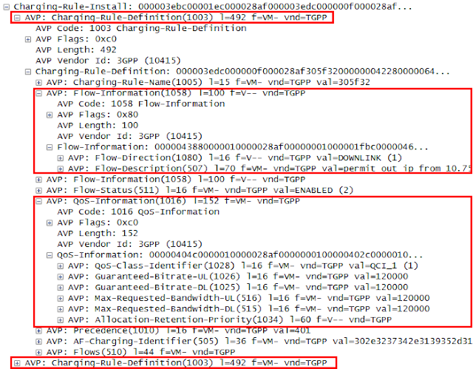](https://blogger.googleusercontent.com/img/b/R29vZ2xl/AVvXsEhb6EZrpjO1OAe3aA1SqnnirJpaehIIw3DNL22liExn7sOPc-QVfb30Kmk_Dm_QZ1uokeEJH4Pdj-vOzoVuJNizf_V4B88pLCctkC0xf4C9j_9fh2ZuOdVx5bH9wOJ95qyqwqUccz8OTfg/s1600/Fig%252310.+snapshot%2523125-RAR.png)

Fig 10. AVPs of RAR

[52] The SGW/PGW initiates the EPS bearer creation procedure and responds with the *Re-Auth-Answer* (RAA) to the PCRF.

* Access-Network-Charging-Address AVP: IP address of the network entity within the access network performing charging.
* 3GPP-SGSN-MCC-MNC AVP: MCC and MNC of the access network.
* 3GPP-User-Location-Info AVP: UE’s current location. It is composed of Tracking Area Identity (TAI) and E-UTRAN Cell Global Identifier (ECGI).

[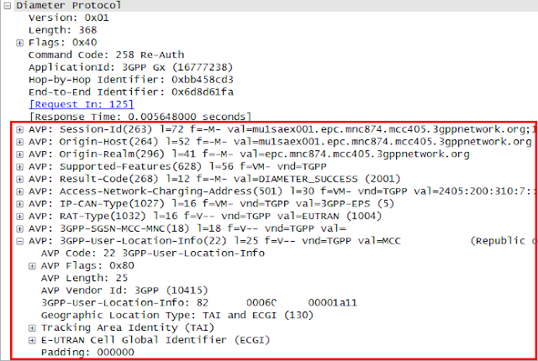](https://blogger.googleusercontent.com/img/b/R29vZ2xl/AVvXsEjk94upjz-T__1AHm5y9eqS_5Gk1izxZFqRKUqbyWXFQvspvCzJhuq52Eb4sd6cYPkLYsrqwp5eFXx0yaCgiQGSULVrh7aN7WRomLbJokU35TILLHnMEipd2I-bwmFnNEIOoIR4xT_vm-o/s1600/Fig%252311.+snapshot%2523127-RAA.png)

Fig 11. AVPs of RAA

[53] The PCRF responds with the *AAA* to the P-CSCF.

[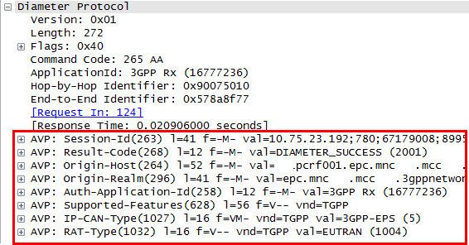](https://blogger.googleusercontent.com/img/b/R29vZ2xl/AVvXsEgp2Wuy71C_B298miL4DmDCn6Sz8nqEjtzgCZVX89fjNcLoHeJ3hSKvVror3R22O5IGerAMn59DwAfJxqjTPc6pa7XSIoI96jEy14u1igIXg5t5yVHDJQg_DKcTFyr8pM7RMbAuKEsSSmU/s1600/Fig%252312.+snapshot%2523128-AAA.png)

Fig 12. AVPs of AAA

[54] Upon receiving the successful *AAA*from the PCRF, the P-CSCF continues the SIP signaling by forwarding the *183 Session In Progress* towards the UE. The following snapshot shows headers of *183 Session In Progress* captured on Gm interface.

* P-Early-Media header: indicator of whether the UE supports the early media mode. The early media option has been disabled in the practice.

Refer to step#47 and step#48 for the detailed description for SIP headers.

[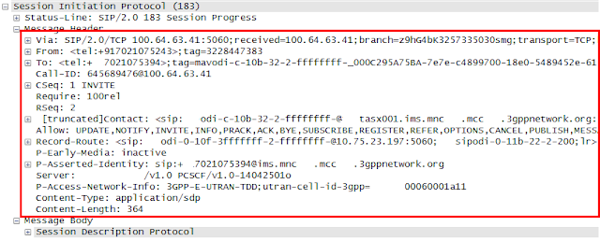](https://blogger.googleusercontent.com/img/b/R29vZ2xl/AVvXsEg9fskbYJHZ9ZiIzUORFlMPSWuv0g3QoNzZ-UeaRsOqPxXIpIlnk9Zg1TBfgf5mmspMXo0ZRDF82yhZesML7l0d5zjTh5CZnE41RNTk6KJ7ku7DtMRAejCtO3fYzFPdpnDxTBbyUghgGhA/s1600/Fig%252313.+snapshot%2523130-183.png)

Fig 13. Headers of 183 Session In Progress

The following snapshot shows the SDP answer included in the *183 Session In Progress*. The SBC is going to be a peer node from UE’s perspective. Given that, the IP address and port number represents the SBC to which the originating UE shall connect for media. The codec information represents the one supported by the SBC. Refer to step#47 for the detailed description for SDP attributes.

[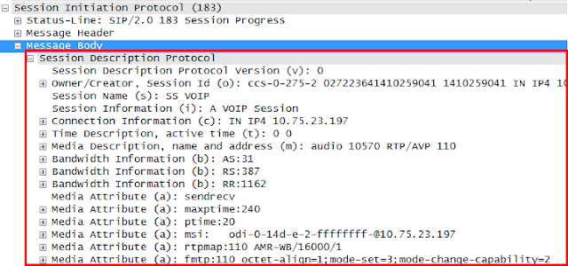](https://blogger.googleusercontent.com/img/b/R29vZ2xl/AVvXsEgw-Gkd-WstCKXN7puVE2sJfEpEW29WmOaB7tWWjZIH-OP2rH0LKLIdwobwcMWcq0DP4x1udJxXe1oZdXO_YlZEBaCnH28bu19dJa9dtJdf2a8TyukU0IZOTCzQjaiOpEdSXumekpoG4wQ/s1600/Fig%252314.+snapshot%2523130-183-SDP.png)

Fig 14. SDP answer in 183 Session In Progress

The SDP answer delivered to the originating UE shows the IP address is 10.75.23.197 and port number is 10570, which is depicted as [a] in Fig2.

[55] The UE confirms that the *183 Session In Progress*with SDP answer has been received safely by sending SIP *PRACK*.

* RACK header: the sequence number the corresponding *183 Session In Progress* and the SIP *INVITE*.

Refer to step#47 for the detailed description for other headers.

[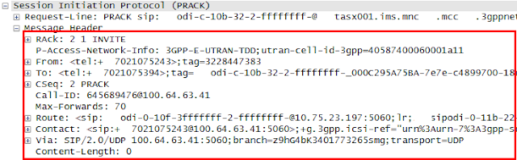](https://blogger.googleusercontent.com/img/b/R29vZ2xl/AVvXsEggIsSp3cab58J1H1IIqy-1N5o_GoQ5J_HEb8C1UMKKkIDZIRkbsbQZBdo2x0TiVXNoCIo7uDpXiK8a4aMGCsZc_zeBgOXYoPMd3uIlyphvBYj9lXbsu_ixTMDaeA8U_CqvzFJpY_1h2yU/s1600/Fig%252315.+snapshot%2523133-183-PARCK.png)

Fig 15. Headers in SIP PRACK

[56] The *200 OK* response to the SIP *PRACK* is received by the UE.

[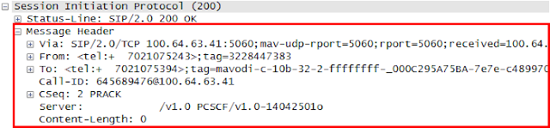](https://blogger.googleusercontent.com/img/b/R29vZ2xl/AVvXsEh8vM399A303hKjbz7zIkPGAXEvRPOWEEmxCqIiBHrxVDVBaIA_FFXYzmTPNR8psn5XZyfAr-bKfOwwoJd4-8cxMac-w5R6waM4YvrVTKyyVTOEU9vi9nYjDLNfvORrgZUCEkwwHYFxMBA/s1600/Fig%252316.+snapshot%2523150-200OK+for+PRACK.png)

Fig 16. Headers in 200 OK for PRACK

[57] The *180 Ringing* provisional response is received by the UE. It indicates the voice call setup request is being notified to the recipient. Refer to step#47 and step#48 for the detailed description for headers.

NOTE If the option tag ‘100rel’ appears in the Require header, the UE shall acknowledge the provisional response by sending *PRACK*. If it appears in Supported header, it is just informative.

[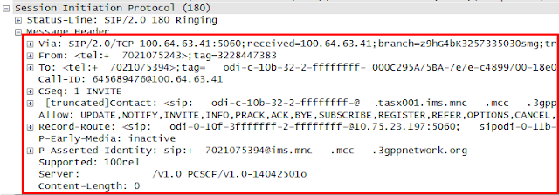](https://blogger.googleusercontent.com/img/b/R29vZ2xl/AVvXsEiXx-UV8m5l49x7CAnJ21wqdmfUibGFFya_ul1JV-ohm0PcE66WnhkAeUdAzJ082f0EsY5nv38n0rpDdv4kdaa9Bn0eX4CA9XJlJH3vWGKv54u6GMJglij6v86w4vSnez_vfSSSc7GVAgI/s1600/Fig%252317.+snapshot%2523154-180+Ringing.png)

Fig 17. Headers in 180 Ringing

[58] The 200 OK response for the SIP *INVITE* is received by the UE. It indicates that the terminating user answered the phone. Upon receiving the response, the UE allocates the media resource. Refer to step#47 and step#48 for the detailed description for headers.

[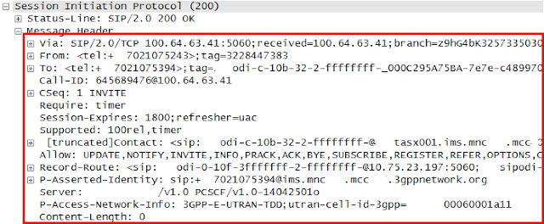](https://blogger.googleusercontent.com/img/b/R29vZ2xl/AVvXsEj1vm7kaNMmtuR4aq3EcjURB4qpIHK58hopQpelpikHRrrVAnUNWFf8E5mZr0jabFPItuHIjAwbc9KlShBRlBwqGmFGhNXz6Fz25R7UV87EpOuw-i5bGZdrlEk0QlWkHagsRJiVaZBopeE/s1600/Fig%252318.+snapshot%2523160-200OK+for+SIP+INVITE.png)

Fig 18. Headers in 200 OK for SIP INVITE

[59] The UE sends SIP *ACK* towards the terminating user. Refer to step#47 for the detailed description for headers.

[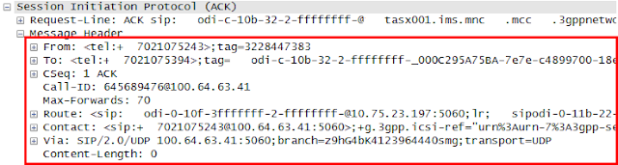](https://blogger.googleusercontent.com/img/b/R29vZ2xl/AVvXsEhX5x6kudkPFc5aBdCUFeye0l1mXAlUA3Zm2llgNtEiyZgH84Pbby3FrfUeBFxYOp7Myku1t7wb9-0_BGM7XTsT-R1h9VPB70wEalw9IRcKLDAL7QYA_-9AgB-2ltKn7slXhyphenhyphen4FBmQOKA8/s1600/Fig%252319.+snapshot%2523161-ACK.png)

Fig 19. Headers in SIP ACK

***Red Mouse***

REFERENCES

[1] 3GPP TS 23.228, "IP Multimedia System (IMS); Stage 2", v11.4.0, Mar 2012

[2] 3GPP TS 24.229, "IP multimedia call control protocol based on Session Initiation Protocol (SIP) and Session Description Protocol (SDP); stage3", v11.3.0, Mar 2012

[3] 3GPP TS 24.628, "  ", v11.3.0, Mar 2012

[4] 3GPP TS 29.212, "Policy and Charging Control (PCC); Reference points", v12.6.0, Sep 2014

[5] 3GPP TS 29.214, "Policy and Charging Control over Rx reference point", v12.5.0, Sep 2014

[6] IETF RFC7315, "Private Header (P-Header) Extension to the Session Initiation Protocol (SIP) for 3GPP", July 2014

[7] IETF RFC4028, "Session Timer in the Session Initiation Protocol (SIP)", Apr 2005

[8] IETF RFC3264, "A offer and answer model with the Session Description Protocol (SDP)", Jun 2002

[9] IETF RFC3262, "Reliability of the Provisional Responses in Session Initiation Protocol (SIP)", Jun 2002

[10] IETF RFC3608, “Session Initiation Protocol (SIP) Extension Header Field for Service Route Discovery During Registration”, Oct, 2003

**E2E VoLTE call setup(4/4) - dedicated EPS bearer creation**

|  |
| --- |
| While SIP signaling is in progress in VoLTE call setup, a dedicated EPS bearer is created for voice media transfer. The dedicated EPS bearer for voice is temporary one as it lasts only during the voice media session which is different from the default EPS bearer in that the default EPS bearer is persistent until the UE is detached from the LTE. The creation of dedicated EPS bearer is triggered by the P-CSCF sending service data information (i.e., *AAR*) to the PCRF. Once the dedicated EPS bearer is created for voice, there comes two EPS bearer created between the UE and the IMS APN, i.e., a default EPS bearer for SIP signaling and a dedicated EPS bearer for voice media. On top of this, there can be more dedicated EPS bearers created with different PCC rules and QoS according to service types. |

**I. Introduction**

The P-CSCF converts the media information in the SDP into the service data information and sends it to the PCRF. The PCRF performs session binding between IP-CAN session and the Application Session, generates PCC rules and provisions them to the SGW/PGW. The SGW/PGW requests to the MME the creation of dedicated EPS bearer using the received PCC rules. The SGW/PGW also performs bearer binding between PCC rules and the to-be-created IP-CAN bearer. The creation of dedicated EPS bearer procedure is composed of sequential procedures of creating uplink S1 bearer, DRB (Data Radio Bearer) and downlink S1 bearer across UE, eNB and SGW/PGW.

NOTE the S5 interface between SGW and PGW is not depicted in the following practice for simplicity.

**II. Creation of a dedicated EPS bearer for voice traffic**

The following scenario shows the procedure of creating a dedicated EPS bearer during VoLTE call setup.

[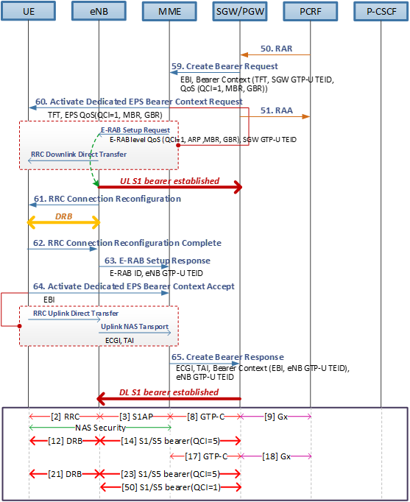](https://blogger.googleusercontent.com/img/b/R29vZ2xl/AVvXsEjlNN0077BmegTJkQb60LvzqRCIhQTCDOActCm92XhyphenhyphenGEOKzPBH8qrOSoZ7tkr_RIp4I41crhAlIvKogDeROpfB7TnKqL5koiiKhXBVf-Fzpji3hLd99Y8q1NJS2rAuOCSLbJ2W1DicjR4/s1600/Fig%25231.+call+set+up+flow.png)

|  |
| --- |
|  |
| Fig 1. dedicated EPS bearer creation |

[59] The SGW/PGW generates its own GTP-U TEID and initiates the procedure to create a dedicated EPS bearer by sending *Create Bearer Request* (CBR) to the MME. The *CBR* contains Bearer Context information of the dedicated EPS bearer to be created.

* (Linked) EPS Bearer ID: Indicate the default bearer associated with the PDN connection.
* Bearer Context: a set of information for dedicated EPS bearer to be created which contains EPS Bearer ID, Bearer TFT, GTP-U TEID and Bearer QoS.
* EPS Bearer ID : a requested EPS bearer ID to be created and shall be set to '0' at this stage.
* Bearer TFT : the uplink packet filters to be sent all the way down to the UE and applied by the UE when the UE sends out RTP and RTCP packet.
* SGW GTP-U TEID : the identifier of the SGW as an end point of the GTP-U tunnel.
* Bearer QoS : QoS for this dedicated EPS bearer which includes UL/DL MBR, UL/DL GBR and QCI.

[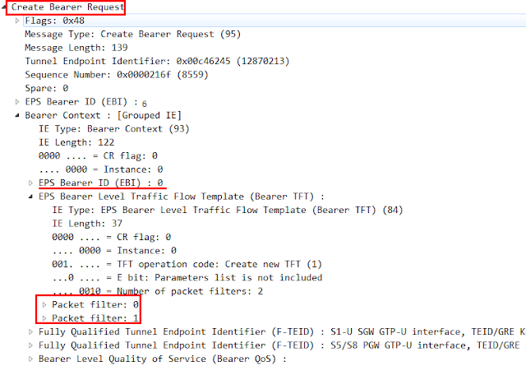](https://blogger.googleusercontent.com/img/b/R29vZ2xl/AVvXsEgKjyEJzLW4Fy6Vyv4ODteOMQ4LcQ0iESPMCQfCqIgz4pR9nMVHaZV27wIh6nNGZDl0U-7T0u5M8h3mz3erqsiemRfouS_FDQ0F6Q5QqFFx0IfTH7ikvw_pTNRFNc65lg6nLK028tzhHq8/s1600/Fig%25232.+snapshot%2523371-Create+Bearer+Request.png)

|  |
| --- |
| Fig 2. IEs in Create Bearer Request |

[60] Upon receiving the *CBR*, the MME allocates the EPS bearer ID and requests the UE to activate the dedicated EPS bearer by sending *Activate dedicated EPS bearer context request*towards the UE*.*The message is delivered to the UE being contained in the *E-RAB Setup request* and the *RRC Downlink Direct Transfer* over S1AP and RRC interfaces respectively. The *E-RAB Setup request* contains SGW GTP-U TEID and the E-RAB level QoS parameters e.g., ARP, UL/DL MBR, UL/DL GBR, etc.

* e-RAB ID: unique identifier of the E-RAB for the UE. Please note that the E-RAB ID=’5’ was for the default EPS Beaer with the Internet APN, ‘6’ was for default EPS bearer with the IMS APN and now, it is set to be ‘7’.
* e-RAB level QoS Parameters: QoS to be applied to an E-RAB, which contains QCI, ARP, MBR and GBR of the E-RAB. This is a copy of the received Bearer level QoS at step #59.
* SGW GTP-TEID: the identifier of the SGW at the end of GTP-U tunnel.

[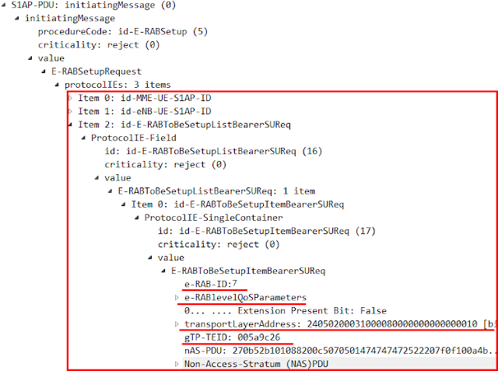](https://blogger.googleusercontent.com/img/b/R29vZ2xl/AVvXsEiZipHnLETkPPBWSnEb4LNUQvonLbLarFlNTMlMkF2XSu7b0GcvSWRrCAscPh0jm0nHbXUeml1e4c3i4Z1X4X_T-DTiBDq6QWS74Ufh9Kdj7UbI4eMTG82E0zXMurSuE_4BmvvZWKRfP2M/s1600/Fig%25233.+snapshot%2523374-E-RAB+Setup+Req.png)

Fig 3. IEs in E-RAB Setup Request

The following snapshot shows the *Active dedicated EPS bearer context request* contained in the Non-Access-Stratum (NAS) PDU container.

* EPS QoS: QoS of an EPS bearer context which includes QCI, MBR and GBR of the EPS bearer
* Traffic Flow Template (TFT): the uplink packet filters to be sent all the way down to the UE and applied by the UE when it sends RTP and RTCP packet.
* Linked Transaction Identifier (TI): the identifier of the active PDP context from which PDP address for the new PDP context could be derived.
* Negotiatiated QoS: QoS of a PDP context

[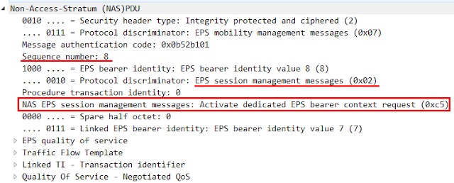](https://blogger.googleusercontent.com/img/b/R29vZ2xl/AVvXsEjaNy8h0DXexLB2HO4aK1BgmN7rCDmbT7fIrnjjUKpPIFO7Zm-AU-oQEa82K-95xXuhTIF4CRqYh5R-7vYWWlo2Hpjskiz6Ln6SkXCSas1mOQbogWDoZ0rZrpiZuiRW0s9Iug_fe0CDPV8/s1600/Fig%25234.+snapshot%2523374-Activate_Dedicated-EPS_bearer.png)

Fig 4. IEs in Activate dedicated EPS bearer context request

Upon receiving the *E-RAB Setup request*, the eNB allocates the required resources and establishes uplink S1 bearer with the SGW as part of the E-RAB establishment.

[61-62] The eNB sends the *RRC Connection Reconfiguration request* to the UE. The UE modifies the radio bearer accordingly and responds with the *RRC Conenction Reconfiguration Complete*.

[63] The eNB responds with the the *E-RAB Setup response* to the MME and it contains eNB GTP-U TEID which is allocated by the eNB.

* E-RAB ID: unique identifier of the E-RAB for one UE. This value is originally assigned by the MME and if this is already occupied, the UE can change it.
* eNB GTP-U TEID: the identifier of the eNB at the end of GTP-U tunnel. The eNB newly assigns the GTP-U TEID for this dedicated EPS bearer and it is delivered to the SGW via MME.

[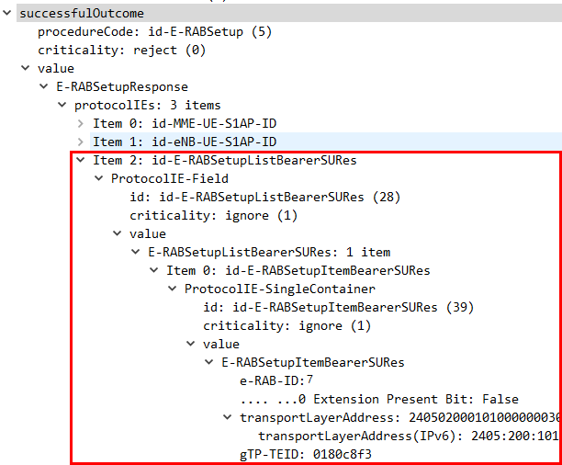](https://blogger.googleusercontent.com/img/b/R29vZ2xl/AVvXsEhPSzp6ctPs1UV2Mg9f9iSdiBfPmSWEdc5NEdqiQt2EtisQxNTuxZ57OH4KEC-zy6IC1IwRztAGYD0_F9tvRNOsP2NPjLcGtzTimDDJEJaCrhpaQ_a2d1NGU6UwRHjyHEvnEeaFl3Vw00A/s1600/Fig%25235.+snapshot%2523380-ERABSetupResp.png)

Fig 5. IEs in E-RAB Setup Response

[64] The UE responds with the *Activate dedicated EPS bearer context response* to the MME which is wrapped in the RRC*Uplink Direct Transfer* and S1AP *Uplink NAS Transport*on RRC and S1AP interfaces respectively.

* E-UTRAN Cell Group Identifier (CGI): globally unique identifier of a cell (PLMN ID + ECI)
* Tracking Area Identifier (TAI): globally unique identifier of a tracking area [PLMN ID + TAC]

[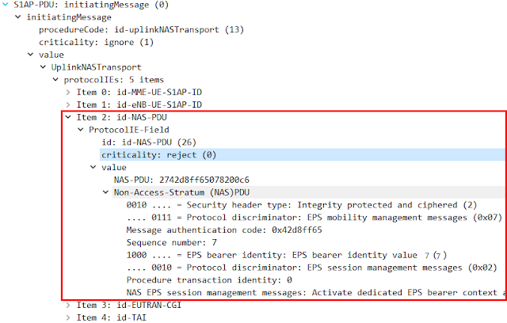](https://blogger.googleusercontent.com/img/b/R29vZ2xl/AVvXsEiepKK29T1k4GVOVDn6VMij4ZmsUfll3vxF8ZhiFUvzRD9roTNXBsXQKKgta0EMJn-sr3Z8ZxaPO9CXFoaOwKjlX9X44Y8PjWaDCFyZo5IP5LYZOEOBAdlNqJfBTUP2yM2apf1BbSuzwnc/s1600/Fig%25236.+snapshot%2523381-Activate_Dedicated-EPS_bearer_rsp.png)

Fig 6. IEs in Activate dedicated EPS bearer context response

[65] The MME responds to the SGW/PGW by sending *Create Bearer Response*. The *Create Bearer Response* contains the eNB GTP-U TEID which was received at step #63. Upon receiving the *Create Bearer Response*, the SGW establishes downlink S1 bearer towards the eNB.

[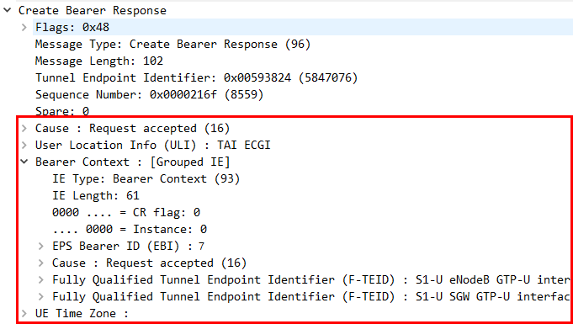](https://blogger.googleusercontent.com/img/b/R29vZ2xl/AVvXsEimowyMU_gY2rY0lWFE_s4e8D7n8TrHZhTea85yywWVJjBJD5VHKIexStR0hmmYQfQ7xyT89w2MnW5tpaoPBRzZbFGzEGwG6Su2gqvqqcV7kJUmid1QAcHNXvLxcjA-maju8kCcn5LQQpI/s1600/Fig%25237.+snapshot%2523382-Create+Bearer+Response.png)

Fig 7. IEs in Create Bearer Response

**II. PDN connectivity and EBI allocation**

The following shows the summary of all the procedures shown in the VoLTE call setup procedures, in which steps (1) to (4) are performed at the background automatically.

(1)    UE turend on.

(2)    PDN connection with the Internet APN: the QCI of the default EPS bearer = ‘9’, EBI = ‘5’.

(3)    PDN connection with the IMS APN: the QCI of the default EPS bearer = ‘5’, EBI = ‘6’.

(4)    IMS registration through the default EPS bearer with IMS APN.

(5)    The dedicated EPS bearer creation for voice upon request for VoLTE service: the QCI of the default EPS bearer = ‘1’, EBI = ‘7’.

|  |
| --- |
|  |
| Fig 8. PDN connection and EBI allocation |

***Red Mouse***

**REFERENCES**

[1] 3GPP TS25.331, "Radio Resource Network (RRC); Protocol specification", v12.3.0, Sep 2014

[2] 3GPP TS24.301, "Non-Access-Stratum (NAS) protocol for Evolved Packet System (EPS); Stage3", v12.4.0, Mar 2014

[3] 3GPP TS24.008, "Mobile radio interface Layer 3 specification; Core network protocols; Stage3", v13.4.0, Dec 2015

[4] 3GPP TS29.274, "3GPP Evolved Packet System (EPS); Evolved General Packet Radio Service (GPRS); Tunneling Protocol for Control Plane (GTPv2-C); Stage3", v13.0.0, Dec 2014

[5] 3GPP TS36.331, "Evolved Universal Terrestrial Radio Access (E-UTRA); Radio Resource Control (RRC); Protocol specification", v12.3.0, Sep 2009

[6] 3GPP TS36.413, "Evolved Universal Terrestrial Radio Access Network (E-UTRAN); S1 Application Protocol (S1AP)", v12.3.0, Sep 2014

**VoLTE : UE initiated voice call release**

When the VoLTE call session does exist, either one of users engaged in the call can release the call session by sending SIP *BYE*towards the IMS network in a normal case. The user's request comes to the IMS network and it makes a chain reaction from the IMS network to EPC and to the UE. The P-CSCF informs the release of the AF session (i.e., SIP session) to the PGW via the PCRF and the PGW initiates the release of allocated resources for that application. The following scenario shows the case where the user requested to end the voice call session.

[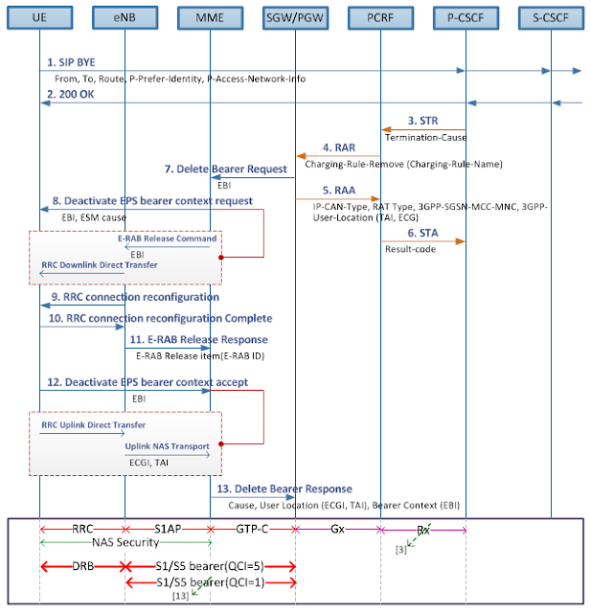](https://blogger.googleusercontent.com/img/b/R29vZ2xl/AVvXsEgWi6oavJiU3NBOXOpYqgkH5D8beiM5HPrkK8Kj3axLrnmEOag2hCwAzqG0O8ptfU4BjXlBVPJtgZVh1P-DtQ4PBSpw_I17mE0AbaVEH1N4Q48xp7X4-LD92TvvUrTpUIhCWLxXFLWVfno/s1600/Fig%25231.+normal+release.png)

[1-2] Upon request from the user, the UE sends SIP *BYE*towards the IMS network to release the existing SIP session.

* Call-ID header is a globally unique identifier of this SIP session. In this context, it will identify the SIP session to be released.
* Route header is a list of IP addresses of intermediary nodes which stays in the signaling path.
* P-Preferred-Identity header indicates the originating user's identity that is preferred by the user to be used.
* P-Access-Network-Info header includes the radio access technologies and cell id.

[3] The P-CSCF sends *Session-Terminating-Request*(STR) to inform the PCRF that the established session shall be terminated over Rx, which combines the AF session and the IP-CAN session. As a result of this procedure, the session binding between the AF session and the IP-CAN session is terminated.  
  
[4] The PCRF requests to remove the corresponding PCC rule by sending the *Re-Auth-Request* (RAR) containing the Charging-Rule-Remove AVP to the PGW. In this example, there are two charging rules to be removed for RTP and RTCP as the voice media session is to be released.

[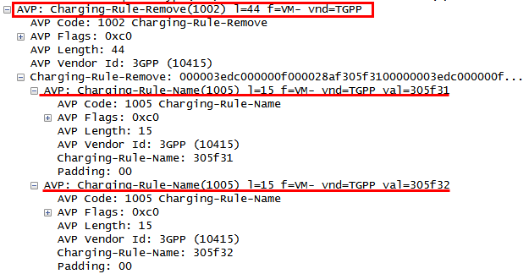](https://blogger.googleusercontent.com/img/b/R29vZ2xl/AVvXsEg6PgkfH39oA5Ws2Hn0j-lJ64GszeaRLF2dBS3aj_HKkJU1YtvSXSTKtyHHlUfQ9xf0T90fjrnd7gOx0m93_3U9tdDKrJxXXyxa78Li7kG2qvwJCz9UjoRNB3w5807MTmBLnC0r_Ovfy8Y/s1600/%25231.+snapshot+-+rar_charging_rule_remove.png)

[5-6] The PGW unbinds the PCC rules from the corresponding EPS bearer and responds with the *Re-Auth-Answer*(RAA) to the PCRF. The PCRF unbinds the AF session from the corresponding IP-CAN and responds with the *Session-Termination-Answer* (STA) to the P-CSCF.  
  
[7] The PGW sends the *Delete Bearer Request* containing the EPS Bearer Id (EBI) towards the MME.  
  
[8] The MME requests the eNB to deactivate the EPS bearer context by sending *Deactivate EPS bearer context request*, which is wrapped by the *E-RAB Release Command* and *RRC Downlink Direct Transfer* over S1AP and RRC respectively.

[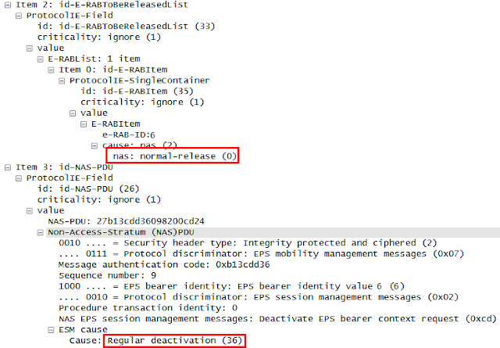](https://blogger.googleusercontent.com/img/b/R29vZ2xl/AVvXsEjP-Lfrj84sP1CVibHe-VDqYM3fHXUuf4jDCV6WFZvpbbYXLD5Xyud5h3KroZHrHS3eYVxYzo9xhUoUYxBzkqMU1gsWQaZRyL3rLmfvzyo9jahUDcDPbyibZPn_5tq0bxhv11zlYv99HQ4/s1600/%25232.+snapshot+-+deactivate_eps_bearer.png)

Upon receiving the *E-RAB Release Command,*the eNB releases allocated resources on Uu and S1 for the corresponding E-RAB(s).  
  
[9-10] The eNB sends the *RRC Connection Reconfiguration request* to release the radio bearer. The UE releases allocated resources on Uu.  
  
[11-12] The UE responds with the*Deactivate EPS bearer Context accept* to the MME and the eNB responds with the *E-RAB Release Response* to the MME.  
  
[13] Upon receiving the *E-RAB Release Response*, the MME updates the ECM and EMM state of the UE and sends *Delete Bearer Response* to the SGW/PGW. The SGW/PGW releases allocated resources on S1 and S5.

**VoLTE: Service Request scenario in IDLE mode**

The IDLE state is defined as the state when both RRC state (i.e., eNB and UE signaling connection state) and ECM state (i.e., NAS signaling connection state) are IDLE while the EMM state maintained by the MME is still REGISTERED. This indicates that the UE is logically attached to the LTE network but the physical connection and the corresponding resources have been released from the UE up to the SGW (i.e., DRB and S1 bearer). The UE may fall into the IDLE mode when there hasn't been any activities for a while between the UE and the LTE network or when it is regarded the UE connection is lost.  
  
In order to transfer any data to the UE in the IDLE mode, the MME has to wake up the UE in the first place so the UE can reconnect to the network. While reconnecting to the network, the UE and the network shall recover required resources and connections over RRC, S1AP and S1 interfaces. Once the EPS bearer is recovered, the data buffered in the SGW can be transferred to the UE. The following shows the conceptual sequence of the data transfer to the UE in the IDLE mode.

|  |
| --- |
|  |
| Fig 1. Conceptual diagram of network initiated service request |

**I. Network Initiated Service Request**

The following flow shows the detailed procedure of how the application payload is delivered to the UE in the IDLE mode. As a precondition, the UE stays in the IDLE mode and the payload (i.e., SIP Message) has arrived at SGW.

|  |
| --- |
|  |
| Fig 2. VoLTE call flow - network initiated service request |

[1] Upon receiving the data when there is no available S1 bearer at the moment as the UE is in IDLE mode, the SGW sends the *Downlink Data Notification* (DDN) to the MME to request for paging the UE. The DDN includes the EPS Bearer ID (EBI) stored in the EPS bearer context of the bearer on which the downlink data packet was received over S5 interface.  
  
[2] The MME acknowledges the request by sending *Downlink Data Notification Acknowledge.*  
  
[3] The MME initiates the paging procedures by sending PAGING message to each eNB that serves cells belonging to the tracking area in which UE is registered.  
  
The following shows paging messages distributed across multiple eNBs that belong to the target TA List.

[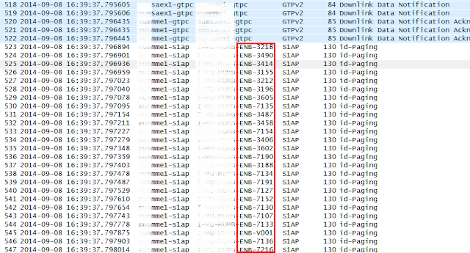](https://blogger.googleusercontent.com/img/b/R29vZ2xl/AVvXsEgz3nVAPtGlD0GiBASSbThwJ-mcvfObQhvqdNCLr5kMzNsou1WdKMByUPJUDlQxXAxdhTJXp6C_nGZ2HkViPEztjug3Hbxv2Qi6cFzog6ao5d2JFc7DNj7xmnOx7p5o-2t9uRFNJnMlIN8/s1600/Fig%25233.+paging.png)

NOTE As the paging procedure itself can cause heavy traffic in the air, the MME may need to have an optimized paging scheme to minimize the side-effect. After having been awaken, the UE performs RRC connection establishment procedure with the eNB from which the paging was sent.  
  
[4] Once the RRC connection is established, the UE requests the network to establish NAS Signaling connection, radio connection and S1 bearers by sending *Service Request*towards the MME. The *Service Request* is delivered wrapped in *RRC Connection Complete* and *Initial UE Message* on RRC and S1AP interfaces. The RRC state transits from the RRC-Idle to RRC-Connected.

[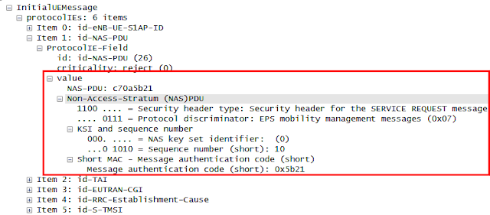](https://blogger.googleusercontent.com/img/b/R29vZ2xl/AVvXsEg1xX8dqCvJlAyKaAsR4dFiyBBbn68-fkoNnO5kwB-_OW0CaorqEqh3NzjlAsQ7Qr_iuRiWQnIE9B9y56MLL_LYWuuOizYykkNKoIg-0ovxiAEcYGDH4HMzuTL8DBtvmMzglBajQP0Mls0/s1600/%25232.snapshot+-+service+request.png)

[5] The MME requests to establish the E-RAB connection by sending the *Initial Context Setup Request* to the eNB.

* UE-AMBR indicates the maximum aggregated bit rate for non-GBR bearers for the concerned UE.
* E-RAB To Be Setup Item includes the E-RAB information for each EPS bearers to be setup.

In this example, there are three E-RABs to be setup which is the list of non-GBR bearers. Each E-RAB information contains the E-RAB ID, ARP and the SGW GTP-U TEID.

[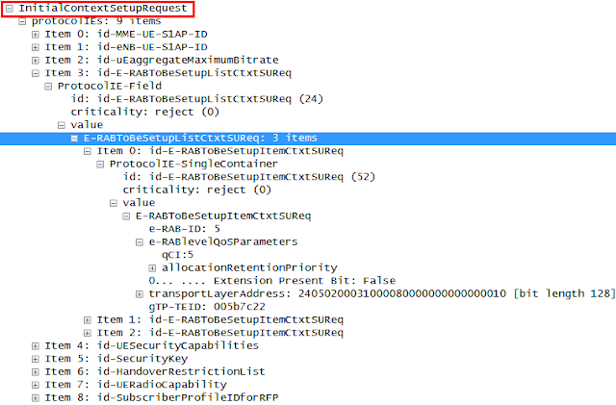](https://blogger.googleusercontent.com/img/b/R29vZ2xl/AVvXsEgjjqYlHQK4LR0u3gMBDHRH2XcFpoNhFzNRT1ZdzEMJFyvaGhkD6P9LMJ3Vl9GfiyCLyJJI2aafVm2_oghgWlXuDzEfSY6nnGfQxlgZXnrTDr1L1SfxBAldNl_uNeW9cS1jRIHnmY_oNfI/s1600/%25233.snapshot+-+initial+context+setup.png)

Upon receiving the *Initial Context Setup Request*, the eNB executes the E-RAB configuration and creates UE context based on the received parameters. In the meantime, the MME may perform the security setup procedure with the UE for integrity protection and ciphering of signaling data.  
  
[6-7] The eNB requests the UE to establish the DRB by sending *RRC Connection Reconfiguration*. Once the DRB is established successfully, the UE responds with the *RRC Connection Reconfiguration Complete*to the eNB.  
  
[8] After the DRB is successfully established, the eNB responds with the *Initial Context Setup Response* to the MME. The ECM state transits from ECM-Idle to ECM-Connected.

* E-RAB Setup List is a list of E-RABs that has been successfully established, which contains each E-RAB ID and eNB GTP-U TEID.
* E-RAB Failed Setup List is a list of E-RABs that has failed to establish.

[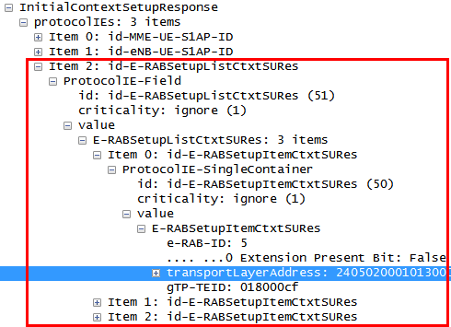](https://blogger.googleusercontent.com/img/b/R29vZ2xl/AVvXsEjzGAMxLBUZn8PiImlbsa4cjAZhDA47F18GHmtpjOzjwFKgLuSiaBEL8p5hIWmSAYInCxPBnFEH0er-v5wubM2nnbPtzv2WWPZoKEsrjf5a_2AT0peXJnSprhYQI6jZxcbgR9_M7rXAL7k/s1600/%25234.snapshot+-+initial+context+setup+response.png)

[9] The MME requests the SGW to resume the suspended S1 bearer by sending the *Modify Bearer Request*. If there were multiple APNs to which the UE was connected before falling into IDLE state, there can be multiple *Modify Bearer Request* sent, one for each APN.  
  
The Bearer Context IE contains the EBI and the eNB GTP-U TEID with which the SGW will establish the S1 bearer towards the eNB. In this example, there are two EBIs one for the default EPS bearer and the other one for dedicated EPS bearer.

[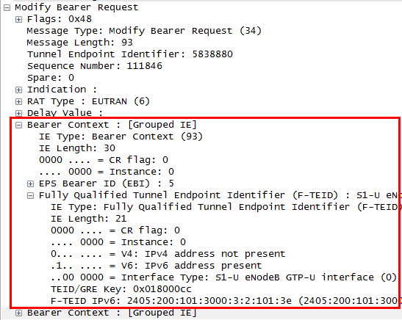](https://blogger.googleusercontent.com/img/b/R29vZ2xl/AVvXsEhNoXafcVWF-epyWAidTKecLXg6pyi9WdgZT2wUi8-78vRKMP9vHDYb_CKIFFGdqB7zb-KiRdE_ncLEBpIY80O0dFfIqY3gY7T6zOXWVIScKhOFyyKI4vofyv2kUKCra1QL6FxAPR_KlV4/s1600/%25235.snapshot+-+modify+bearer+request.png)

[10] The SGW responds with the *Modify EPS bearer response* containing the resulting cause value for each requested EBI. The Bearer Context IE contains the EBIs and the SGW GTP-U TEID which is the same value that was contained in the *Initial Context Setup Request* at step #5.

[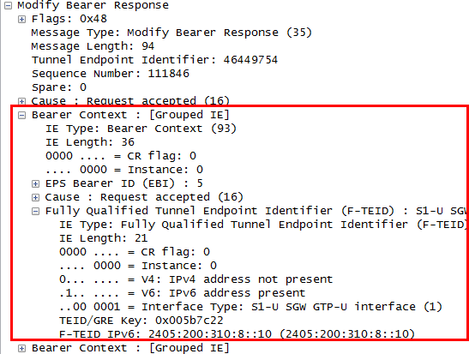](https://blogger.googleusercontent.com/img/b/R29vZ2xl/AVvXsEjqfaDdjJw6iyAkkMV3mFCBe8mYP7OfPOLT78fk9D-gGNH5ugjikDIyGqF3DkUDf6iaAb5ERLlmxvWN324wwNX-Teqjg6DBZi_C71ET6i0WcpT_YisbDjHHFaw6dLtBRB8gOawm1gR8bsQ/s1600/%25236.snapshot+-+modify+bearer+reponse.png)

Once the S1 bearer is recovered, the SGW starts sending buffered data towards the UE. This procedure happens seamlessly without necessarily user interaction.  
  
  
**II. UE Initiated Service Request**  
In the same way, the UE may initiate the service request procedure in the IDLE to perform the VoLTE call initiation or location update procedures in the IDLE mode.

[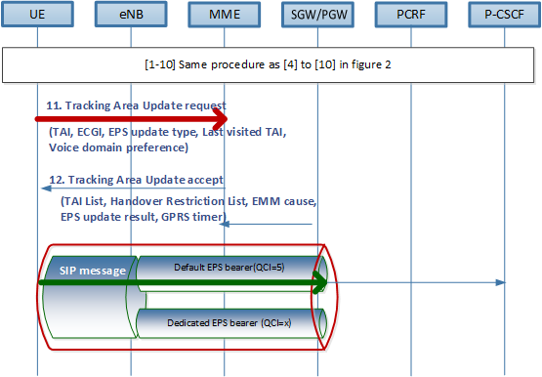](https://blogger.googleusercontent.com/img/b/R29vZ2xl/AVvXsEg9Y_Nq1sZ9vGx_kVFY0WRIhnb2x6BBGFxy80Pfn4qMJD3PU1FUxi07u03N61K_Zp4q0FtZT5fvax3dMDFZRBiRoK1KP_6Xu11X54-SLDlSk_Vv2dLV8Ci0N9XA-FUvrq9QiOsJZMWo5qU/s1600/Fig%25233.+Service+request+flow.png)

[1-10] Same as [4-10] in the figure 2. During this procedure, the RRC connection and NAS signaling connection is re-established. The UE context is recovered in MME. The EPS bearer including DRB and the S1 bearer is also re-established.  
  
[11-12] The UE may trigger the TAU procedure by sending *Tracking Area Update* (TAU) request following the criteria as defined in TS23.401. The *TAU* contains the UE's current *Tracking Area Identifier* (TAI) and the ECGI. The last visited TAI is included if the UE has a valid TAI of the last visited tracking area and used by the MME to make a good list of TAI(i.e., TAL) for the UE. The TAL is contained in the TAU Accept.

[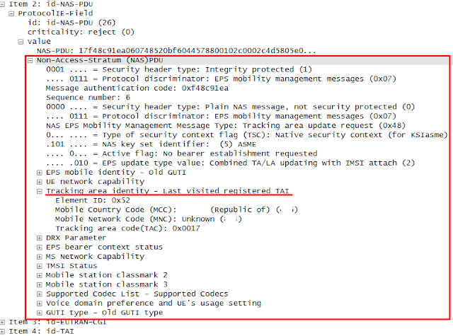](https://blogger.googleusercontent.com/img/b/R29vZ2xl/AVvXsEjuFOCp1aTCJT3yRJTpg60HI5Wv_v-BkWOzOZSQLSLKtNeIVZEBZcN3TCVPUMvF_8HC4rW872E14fGc_nihyhKl8QmbYfCDxxj0gB0pA5PxZ9sFo3WGM3j6X3ie4ZTkMUt7hNX2giTVwWQ/s1600/%25237.snapshot+-+TAU.png)

Please refer to "[*VoLTE: Tracking Area Update and Combined Attach*](http://hongjoo71-e.blogspot.kr/2015/07/volte-tracking-area-update-and-combined.html)" for the detail.  
  
  
Once the EPS bearer is recovered, the UE is able to initiate a voice call setup procedure by sending SIP INVITE. If there is no service data flow for a while, the UE and the network may again fall into the IDLE state.

***

In order to optimize the transactions between the UE and the network, the eNB shall be optimized as to criteria based on which the UE state falls into the IDLE mode. Furthermore the MME shall also provide the optimized scheme for paging schedules considering user experiences. If the paging scheme (i.e., timer values) is too loose, it will aggravate user experiences. If it is too frequent, it will cause heavy traffic in the air.

***Red Mouse***

REFERENCES  
  
[1] 3GPP TS29.274, "3GPP Evolved Packet System (EPS); Evolved General Packet Radio Services (GPRS) Tunneling Protocol for Control Plane (GTPv2-C); stage 3", v13.0.0  
[2] 3GPP TS36.413, "Evolved Universal Terrestrial Radio Access Network (E-UTRAN); S1 Application Protocol (S1AP)", v12.3.0  
[3] Netmanias, "LTE EMM and ECM States", Sep 2013

**E2E VoLTE call flow : detach (UE-initiated)**

The UE initiated detach procedure may occur when the UE is turned off or the UE needs to fall back from EPS services to non-EPS services or vice versa. Along with the detach procedure all the allocated resources are released and connections for signaling and bearer are disconnected.

[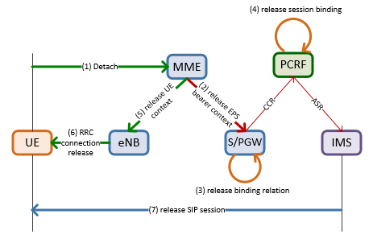](https://blogger.googleusercontent.com/img/b/R29vZ2xl/AVvXsEgA6YnvSsWxCr5GTM7xRw8LhCs3Q6xM_GsPKUIQBtiSu9fIIPihgixvKJghwsf7ePYOz4WPbeMpzgq2JVEBfJhKANwznp7u1mTHKf4zWVMHeP9wWJD4_-f3KOi5cqTyz0P4gdRc4ltvda0/s1600/fig%25231.+overall+sequence.png)

The above figure shows the overall sequence of how the UE and the network releases related resources when the UE detaches. Upon receiving the detach request from the UE(1), the MME releases the EPS bearer context towards the S/PGW(2) and in turn, the bearer binding and the session binding is released over Gx and Rx(3,4). Apart from this procedure, the MME also releases the UE context towards the eNB(5) and the eNB releases RRC connection with the UE(6). Meanwhile, the IMS network is informed of bearer release from the PCRF and proceeds the release procedure of the SIP session(7).

**I. EPS bearer release**

|  |
| --- |
|  |
| Fig 1. Detach procedure - EPS bearer release |

[1] The UE triggers the detach procedure from the LTE network by sending *Detach Request* towards the MME.

* Detach Type IE indicates the reason of detach procedure and where the UE is being detached from (i.e., EPS services only, non-EPS services only, both). In this example, the UE is being detached from the LTE network due to switch-off.
* EPS mobile identity IE is set to be GUTI when the UE has a valid GUTI. If the UE does not have the valid GUTI, the EPS mobile identity will be the IMSI.

The GUTI is a globally unique identifier of the UE. It is composed of the M-TMSI, PLMN-ID (MCC+MNC) and MMEI (MMEGI+MMEC). The M-TMSI is assigned by the MME when the UE attaches to the network and remain unchanged until the UE detaches from the network. The following shows the GUTI format and the sample message of *Detach Request*.

[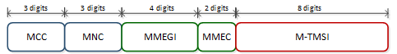](https://blogger.googleusercontent.com/img/b/R29vZ2xl/AVvXsEi3LSW8ehb0sYB_K_PG0nvjN8UWErhbwhOs8vh_snX8qr-_UgNUJP2vEw0LYlnW6ey2Fo8ATh-63tb8lDAxFLy_Abb6O68zP85FZlkus-ttCI1nonfvROHdpWwm1xVwPUMMikqyisM2ZtI/s1600/figure+%25232.+GUTI.png)

[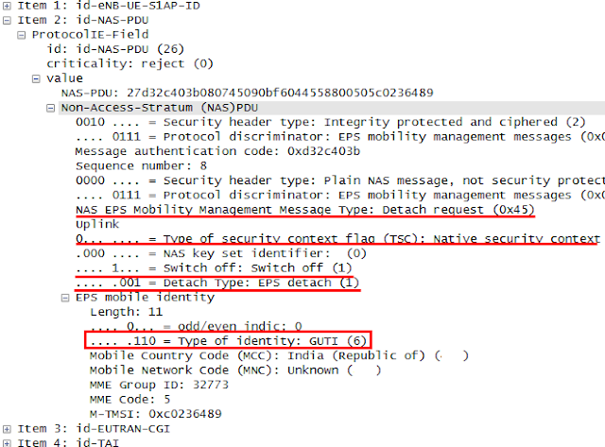](https://blogger.googleusercontent.com/img/b/R29vZ2xl/AVvXsEgLj-OfeM0yqobEboX-RA1KpSqvxIK_2zjcyzqCZlY90fStnXRuAMS2zzIFoDxiNcmbnuG6DagUk3bPhOeB3nxP60cVonq9saLzsfBfwFE6sz6pV9L-yp4NztwzQ7f9OgljCFaDVR_y4fM/s1600/%25231.snapshot+-+detach+request.png)

If it is the detach for EPS only or combined EPS/IMSI detach, the MME deactivates the EPS bearer context(s) for this UE locally and enter the state EMM-DEREGISTERED for this UE.

[2-3] The MME requests the S/PGW to delete the corresponding session by sending *Delete Session Request*. If there are multiple APNs that the UE was attached to, there will be multiple *Delete Session Request,*onefor each APN. The message contains the list of EBIs to be deleted for each APN. In case of detach, all the EBIs belong to that APN shall be included.  
  
Upon receiving the *Delete Session Request*, the SGW/PGW deactivates the EPS bearer context corresponding to the received EBIs of this UE. The bearer binding relation between EPS bearer and PCC rule is also released. The SGW/PGW responds with the *Delete Session Response*.  
  
[4] The MME sends *Detach Accept* only if the Switch off parameter is not "Switch off". Otherwise, this transaction will be spared.  
  
[5] The MME performs MME-initiated UE context release by sending *UE Context Release Command* to the eNB, which is to release the UE-associated logical connection. In this case, the message contains the cause value of "Detach". Upon receiving the *UE Context Release Command*, the eNB releases all related signaling and user data transport resources for the indicated UE by the UE S1AP ID.

[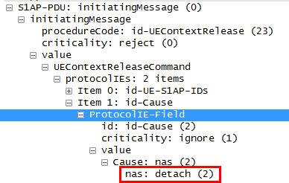](https://blogger.googleusercontent.com/img/b/R29vZ2xl/AVvXsEjqMvFfI6_9UaoP35hLoaj1u5n9H3i5kx2aDz9h0QUFu8K9zlW_0wy-KxzN6xcG1yTuiSpgHsYmkyJR0FufC8QrjOE4BWK6v1vZ9faoi6KWOf7Oe-ey-rNjy56JofKwfZB6_s16_apiDyY/s1600/%25232.snapshot+-+UE+context+release+command.png)

[6-7] The eNB sends the *RRC Connection Release* to the UE. In case the RRC connection has not been released already, the *RRC Connection Release* will be sent as an Acknowledge Mode(AM). After releasing the RRC connection, the UE responds with the *RRC Connection Release Complete*.  
  
NOTE Whether to use Acknowledge Mode (AM) or UnAcknowledge Mode(UM) is dependent on the requirements for the radio bearer such as packet loss, packet delay, etc. The basic difference between the UM and AM is that the UM would be compared with the UDP where re-transmission control is not provided, whereas the AM is more likely TCP. The detail for this technology may need to be referred to the radio expert.  
  
[8] The eNB responds with the*UE Context Release Complete* to the MME and releases the S1 signaling connection. This step would be performed without necessarily waiting for the *RRC Connection Release Complete* from the UE. Upon receiving the *UE Context Release Complete*, the MME deletes any eNB related information.  
  
  
**II. IMS de-Registration**  
  
Once the GTP-C, S1-MME connection and the corresponding S1 bearers have been released, the network starts to release remaining resources and connections towards upstream.

|  |
| --- |
|  |
| Fig 2. Detach procedure - application level release |

[9-10]  The PGW reports the event to the PCRF by sending *Credit-Control-Request*(CCR*)*. The *CCR*contains the cause value set to be "TERMINATION-REQ". The "TERMINATION-REQ" is sent only when the IP-CAN session is terminated, i.e., detach. If there are multiple APNs to which the UE attaches, there will be multiple *CCRs*sent to the PCRF, one for each APN. The PCRF acknowledges with the *Credit-Control-Answer*(CCA*)*.

[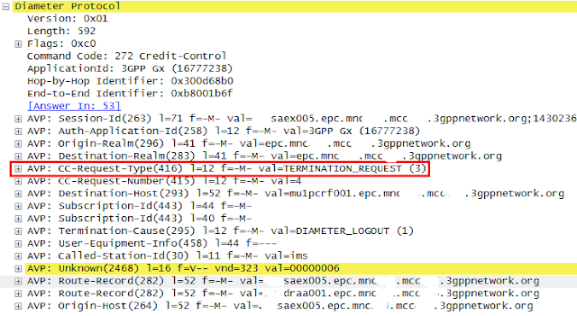](https://blogger.googleusercontent.com/img/b/R29vZ2xl/AVvXsEg8d1ZIR8rDNaadIQjPHqKaDVtZIUoJVZHQGy1VUcFP48eUf14_S8D4ePxtNodASvsdNVPrOz-Zd22CPuONnAntrTeFQ4SExon2R2QmFeejVEcdo85XmWSdlepj_j9FoKjS6S7Xi6B5_64/s1600/%25233.snapshot+-+CCR-term.png)

[11-12] Upon receiving the *CCR*from the PGW containing the IP-CAN session termination event, the PCRF releases session binding relation between IP-CAN session and the corresponding AF-session and requests to release the Rx session by sending *Abort Session Termination* (ASR) to the P-CSCF. The message contains the Abort-cause value of "BEARER_RELEASED". The PCRF acknowledges with the *Abort Session Answer* (ASA).

[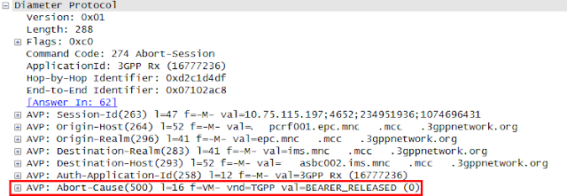](https://blogger.googleusercontent.com/img/b/R29vZ2xl/AVvXsEh1s_GWl_5wJa0ijhOehxC_rTV7U-BeRAu5DUhNyhN7iTEE1609E6f15IMbw8_-YwxIucIMc1FyWYhaK-Nxg3e3GFqdPK-gyn4t1QiiHkTIA3LoMNEIqstKzRii24fRMt6gRVuBKjvCMsA/s1600/%25234.snapshot+-+ASR.png)

[13] Upon receiving the *CCR*containing the cause value of "BEARER RELEASED", the P-CSCF performs de-registration procedure by sending the *SIP REGISTER* to the I-CSCF in the UE's home network with its Expires header set to zero. The P-CSCF performs a name-address resolution mechanism for P-Visited-Network-ID header to determine the address of the home network.

[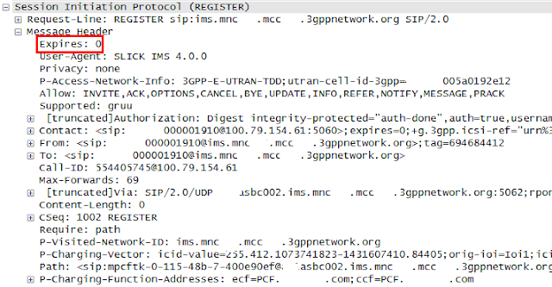](https://blogger.googleusercontent.com/img/b/R29vZ2xl/AVvXsEi0BDeKCM8vV4GVr1WvRUlidVndAVKSk4ZlB0fPgZGzs6htti90fys0cBCCXOD4mxr6lY5t_gIK27fw48gPppY0Thx9bvMb49iHdTZX3LpySuPrtLrk7vWBjVxDRjj3GOvchyphenhyphenDvWDl3NUg/s1600/%25236.snapshot+-+REGISTER.png)

[14] The I-CSCF requests the registration state of the received Public User Identity to the HSS by sending the *User-Authentication-Request*(UAR*)* with its User-Authorization-Type set to "DE_REGISTRATION". The *UAR* contains the Public User Identity, Private User Identity, Visited Network Id, etc.

[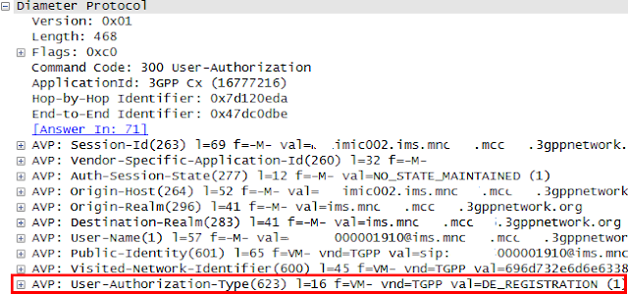](https://blogger.googleusercontent.com/img/b/R29vZ2xl/AVvXsEier-9otVca1rzVd_VXXS7CaLAirjEsVcWEn8DRvKr98xfs_xSI2e-cGOejQT9KW4Vei6heXm4zmOCsOjMK81FdpipiSktRCs7XM7dFQm23m8KV409S41vwFixYwoFK-NyzkXfWEj3FTwg/s1600/%25237.snapshot+-+UAR.png)

[15] The HSS determines if the user is currently registered and responds with the *User-Authentication-Answer*(UAA) with the corresponding S-CSCF name (i.e., Server-Name AVP).

[16] The I-CSCF determines the address of the S-CSCF through the name-address resolution mechanism and sends the *SIP REGISTER* to that S-CSCF.

[17-18] Upon receiving the*SIP REGISTER*, the S-CSCF may trigger the 3rd-party de-Registration procedure towards the application server based on the iFC mechanism. On the other hand, the S-CSCF sends the *Server-Assignment-Request*(SAR*)* towards the HSS. In this example, the Server-Assignment-Type AVP is set to "USER_DEREGISTRATION_STORE_SERVER_NAME", which indicates that the give Public User Identity is no longer considered as registered and the HSS needs to keep the S-CSCF name after this action.

[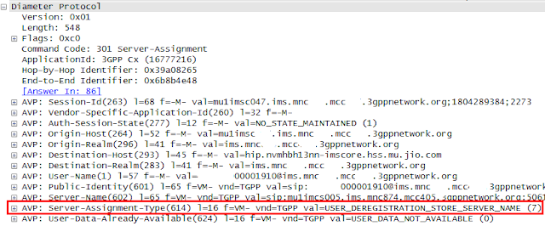](https://blogger.googleusercontent.com/img/b/R29vZ2xl/AVvXsEgdrPPhv-cKAHXSOzzUsmN1CFlDVr-rRhzQdPXaS7l-XL2GiaCfBVmCR6sazIym7CaiAU70CrM4MXecz304VM7j8h05HGqTR3rpMMkyl73Src19TQJgodIdVRQThDSeUvqfXcTmQep8LWc/s1600/%25238.snapshot+-+SAR.png)

[19-20] The 200 OK for the *SIP REGISTER* is sent towards the P-CSCF.  
  
[21] The S-CSCF may send the *SIP NOTIFY*towards the UE to inform that the subscription has terminated. The body of the *SIP NOTIFY* includes the fact that the registration state has also been terminated. This *SIP NOTIFY* transaction is correlated with the subscription procedure that was done when the UE registered to this IMS network.

[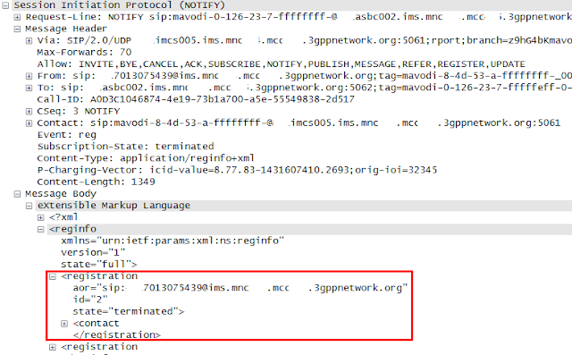](https://blogger.googleusercontent.com/img/b/R29vZ2xl/AVvXsEhD64X-m-KzHql7XxLnq7CzDOwtaMisNGgoPX57yV51mq-NjIxpt69MyFodvxce98_Hz_FTNi_X11fGtL9EMs9s5Rflp0r_uTqcbwmpaye1_gCCyuZIQIrkjJ5dmbMgtxWpQJYEQ-36QpM/s1600/%25239.snapshot+-+NOTIFY.png)

***

When it comes to IMS de-registration, it is supposed to happen before LTE attach in a normal situation and it would be a quite natural sequence considering the protocol stack. The UE shall release all the resources relating to applications before it detaches from the network. However, in this example, the UE performs LTE detach first and then the IMS Core initiates the IMS de-registration based on the bearer loss event reported from the PGW. This type of exceptional situation happens more often than not in reality. It can come from incomplete implementation of the VoLTE client in a UE or the UE might not be able to perform IMS de-registration for some reasons.

***Red Mouse***

REFERENCES  
  
[1] 3GPP TS24.301, "Non-Access Stratum (NAS) protocol for Evolved Packet System (EPS); Stage 3", v12.4.0, Mar 2014  
[2] 3GPP TS29.274, "3GPP Evolved Packet System (EPS); General Radio Packet Service (GPRS) Tunneling Protocol for Control Plane (GTPv2-C); Stage 3", v9.3.0, Jun 2014  
[3] 3GPP TS23.401, "General Radio Packet Service (GPRS) enhancements for Evolved Universal Terrestrial Radio Access Network (E-UTRAN) access", v12.4.0, Mar 2014  
[4] 3GPP TS23.228, "IP Multimedia System (IMS); stage2", v11.4.0, Mar 2012  
[5] 3GPP TS29.229, "Cx and Dx interfaces based on the Diameter Protocol; Protocol details", v12.6.0, Jun 2015  
[6] 3GPP TS36.413, "Evolved Universal Terrestrial Radio Access Network (E-UTRAN); S1 Application Protocol (S1AP)", v13.0.0, Jun 2015

[7] Netmanias, "EMM Procedure 2. Detach", Jan 2014

**Bearer level event and VoLTE call setup failure**

The application layer needs to be aware of bearer level status as the EPS bearer is tightly coupled with the application session and some events in an EPS bearer can affect the application session handling and resource management. For instance, when the VoLTE call session is about to be established, the IMS core establishes the logical connection with the UE. Meanwhile, the EPS will prepare for the EPS bearer through which signaling and payload will flow. If the EPS bearer is disconnected somehow (e.g., due to connection loss, user inactivity), the IMS core needs to be informed of it so the corresponding application session shall be handled accordingly. The PCC architecture handles the binding relations between the application session, PCC rules and the EPS bearers as is described in "[Bearer binding and Session binding](http://hongjoo71-e.blogspot.kr/2015/06/volte-bearer-binding-and-session-binding.html)".  
  
The following diagram shows the Policy and Charging Control (PCC) architecture that controls the EPS bearer related QoS policies and is used to request the bearer level event reporting and deliver the bearer events to application layer.

|  |
| --- |
|  |
| Fig 1. PCC architecture |

[1] Upon receiving the request for voice call (i.e., SIP INVITE), the P-CSCF triggers the *Authentication-and-Authorization Request* (AAR) towards the PCRF containing the service information like source/destination ip addresses and ports, codec information, etc. The *AAR* also accommodates the list of events that the P-CSCF wants to be informed of.  
  
[2-3] The PCRF generates the PCC rule for this application session and sends *Re-Authorization Request* (RAR) which contains the PCC rules.  
  
[4] The EPC binds the received PCC rules and the EPS bearers so it can map the IP flow to the corresponding EPS bearer.  
  
[5] When there is an event occurred that corresponds one of events listed in the received parameters, the P-GW reports the event to the PCRF by sending the *Credit-Control Request* (CCR) towards the PCRF.  
  
[6] The PCRF unbinds the AF session from the IP-CAN and sends the *Re-Authentication Request* (RAR) or the*Abort-Session Request* (ASR) to the P-CSCF reporting the occurred event. Upon receiving the *RAR* or *ASR*, the P-CSCF may release or update the application session by sending appropriate error response to end points.  
  
NOTE Refer to procedures described in "[*Voice Call Setup*](http://hongjoo71-e.blogspot.kr/2015/08/e2e-volte-call-flow-34-voice-call-setup.html)*"* and "[*dedicated EPS bearer creation*](http://hongjoo71-e.blogspot.kr/2015/08/e2e-volte-call-flow-44-dedicated-eps.html)" for the detail.  
  
The following flow shows the voice call setup procedure where the voice session is about to establish but fails due to the error event occurred in the EPS bearer.

[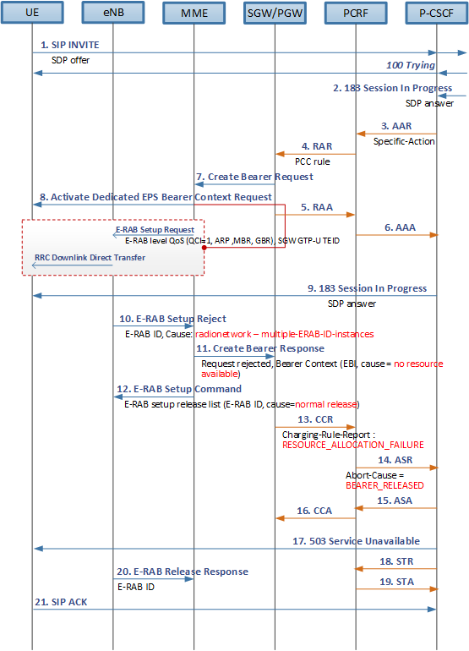](https://blogger.googleusercontent.com/img/b/R29vZ2xl/AVvXsEgb6A57HFLZe_XjaEs2RLFaCStMMoA9sSP46o7eCr7tdsVM1s7iIK5lD8_1y1_7Fz2g0D6Be-1_ddFsALCFrhQNYzDfjYCrNcnWnBHCvngHwMS7k0x61K-aYByaX0CLYpSv6fLpIivKWsw/s1600/fig%25232.+flow.png)

NOTE The step #1 to step #8 follows the normal procedure for VoLTE call setup as described in "[*dedicated EPS bearer creation*](http://hongjoo71-e.blogspot.kr/2015/08/e2e-volte-call-flow-44-dedicated-eps.html)".

[1-2] While VoLTE call setup procedure, the P-CSCF receives the SIP *INVITE* and *183 Session In Progress* with SDP offer and SDP answer, respectively.  
  
[3] The P-CSCF triggers the binding procedure by sending *AAR*towards the PCRF. The *AAR*includes the list of events that it wants to be informed of.

[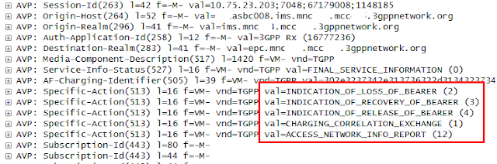](https://blogger.googleusercontent.com/img/b/R29vZ2xl/AVvXsEgMRK1e_AmmW5P1hwqhFE3ADgjKam5u3USqMkCC5AwsRnDiAdQEn5lEDY6G2lJj7Tl_R4_xASzfo7ZWDfNAyzkwmbVSLcgkS-rxAA2HNakuNOCp1b3tfToUVGrP0KCMdpwvC08iAe_Ok0k/s1600/snapshot%25231.+AAR.png)

[4-6] The PCRF sends the PCC rule to the SGW/PGW so it can enforce the rule for the incoming IP flow. The SGW/PGW binds the received PCC rules with an EPS bearer and responds with the *RAA* towards the PCRF and in turn, the PCRF responds with the *AAA* towards the P-CSCF.  
  
[7-8] The SGW/PGW initiates the EPS bearer creation procedure by sending the *Create Bearer Request* towards the MME. The MME request to activate the EPS bearer by sending *Activate EPS bearer context request*towards the eNB. The *E-RAB Setup request* over S1AP interface which delivers the NAS message to the eNB includes the list of E-RAB to be setup.  
  
[9] Upon receiving the *AAA* from the PCRF, the P-CSCF proceeds the call setup procedure by sending the *183 Session In Progress* which contains the SDP answer.  
  
[10] In this example, the eNB responds with the error response with its cause value set to "multiple-E-RAB-ID-instances" which is the case when the eNB receives the same E-RAB ID as the one that already does exist.

[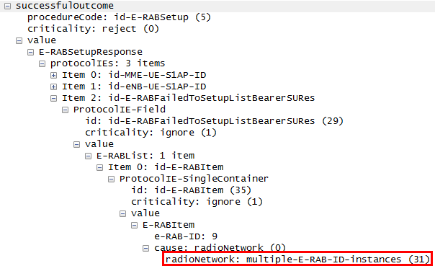](https://blogger.googleusercontent.com/img/b/R29vZ2xl/AVvXsEjdWA9DhZQTQ6X1gYiSV7EPYNsoAKLaVX_jUrral09pYUBcv9QgJ9tO-tnmT_KSh7vSC3qDrTjmTCZWwmxiUOjm4PTYknJogFPDvm5r9KhFPUvnqfQ9Z6xL6Pe6IqkYDjpbMNGdglgSCBs/s1600/snapshot%25232.+E-RAB+setup+response.png)

Skimming over the trace history on S1AP interface, there was an attempt to delete the E-RAB but failed due to a problem in a radio interface, which is followed by X2 handover several times. It is suspected that the MME might have deleted the E-RAB ID anyway without considering the failure response and later on, re-assigned the same value for E-RAB in the *E-RAB Setup Request* while the eNB is still maintaining the value as the E-RAB release procedure has failed.

[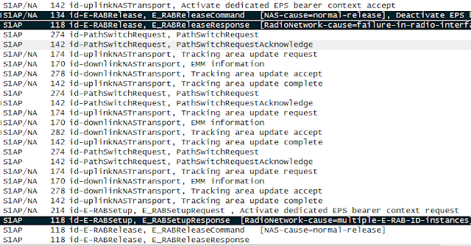](https://blogger.googleusercontent.com/img/b/R29vZ2xl/AVvXsEieJGiso0TLb1vDKqZYbopqh2gb5SjSlOBZXpV9FKyB6TXeXWCzM7KoPhIEGV1NrcEgknvV-ruzW-WcjgvO2vvUmT6tApMt4Wj-9xZjnS6l-zqzMACmXVgHiL5iVWh_XEZgknjQaxc6gSQ/s1600/snapshot%25233.+s1ap.png)

[11] The MME rejects the request for bearer creation by sending the *Create Bearer Response* to the SGW/PGW with its cause value set to "No resource available".

[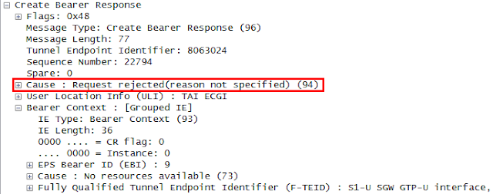](https://blogger.googleusercontent.com/img/b/R29vZ2xl/AVvXsEienZhXRBKWEI2uZi_hUjBvlI3YhLHucQLZQiuDY8w9GSh6btSVf_jPvPdjQj352FifA51xACzeORd7UVRFwcvSkkjqJxZKNoGBjgfniYZBnGCiGdvreQeOJUEKdLKygOSU1GxDxfBd76E/s1600/snapshot%25233.+Create+Bearer+response.png)

[12] The MME also initiates the E-RAB release procedure for the concerned E-RAB ID.

[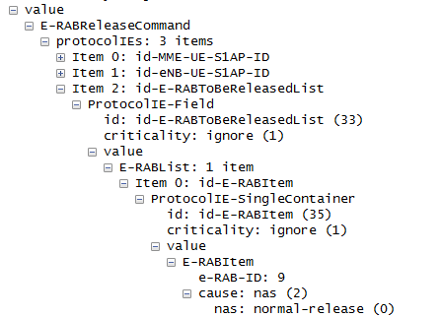](https://blogger.googleusercontent.com/img/b/R29vZ2xl/AVvXsEhyS0OiOu4cw9DrGi3QHci5CW1YsSf9lvLDwKQCo6iYs3bMbHeIiEn3_Wb3xFuzS1pYvPm0-Yrej_g83zqhhGbfhE0X7S0YEgU_Zz7tpNDVZT5Cnt3fkudvrLEn1wvVLecz50Q31w2teRY/s1600/snapshot%25234.+E-RAB+release+command.png)

[13] Meanwhile, the SGW/PGW may internally revoke the bearer binding and informs the bearer event to the PCRF by sending *CCR* with its Charging-Rule-Report AVP set to RESOURCE_ALLOCATION_FAILURE.

[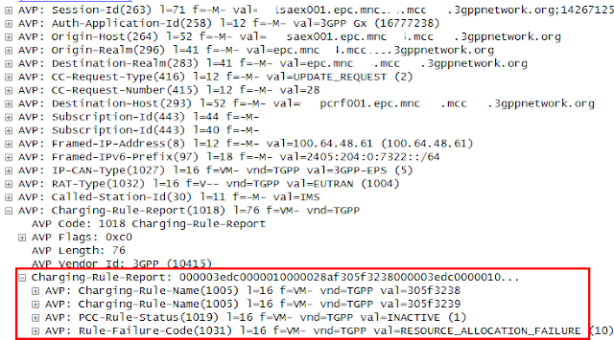](https://blogger.googleusercontent.com/img/b/R29vZ2xl/AVvXsEjr9RjHpGLZioPkMm454byXNarJWjJzmJ7jFYmPh_3V1aOUoxVKI5x3YrqJSVBcovf0hRtCNOVZ7mCpQECI_yeAg4MbQPJyK9Z9hfVDw0zWMskSUA1fUkBNXUtHy2m_Nh_XhWC_joxiICU/s1600/snapshot%25235.+CCR.png)

[14] The PCRF informs the P_CSCF of the received bearer event by sending *ASR* with its Abort-cause AVP set to BEARER_RELEASED in this example. The *ASR* is sent when all the service data flows regarding the AF session are deleted. Otherwise, the PCRF would send RAR.

[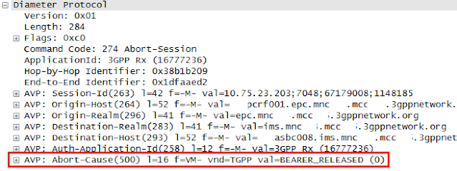](https://blogger.googleusercontent.com/img/b/R29vZ2xl/AVvXsEik7UyvkI8GC_vEj6wnESzLb2N9tq5Tq4s9WacrpELHUftDTRfi9jngcbRwn-h45GIfdZpmq5ocax4_um7cq7r8SCISM-AnZkDJTZP9Zsrf-I9E5nFVD6Y641FSlC-W-hMTmwjyUk28wxc/s1600/snapshot%25236.+ASR.png)

[15-16] The P-CSCF responds with the *ASA* and the PCRF with *CCA*.  
  
[17, 21] Upon receiving the event report indicating the bearer release, the P-CSCF abort the call processing by sending the *503 Service Unavailable*. The UE responds with the SIP *ACK* and releases all the resources regarding this application session.  
  
[18-19] The P-CSCF sends the Session-Termination-Request towards the PCRF indicating that the application session has been terminated.  
  
[20] The eNB responds to the *E-RAB Release Command* by sending the *E-RAB Release Response* towards the MME.

***Red Mouse***

REFERENCES  
  
[1] 3GPP TS 29.213, "Policy and Charging Control signalling flows and Quality of Services (QoS) parameter mapping", v12.3.0, Mar 2014  
[2] 3GPP TS 29.214, "Policy and Charging Control over Rx reference point", v13.2.0, June 2015  
[3] TS 36.413, "Evolved Universal Terrestrial Radio Access Network (E-UTRAN); S1 Application Protocol (S1AP)", v13.0.0, June 2015

**X2 handover**

Handover is a process for a UE to transfer its sessions from the current network to another one while it is moving towards a neighbor cell. So, the handover procedure ends up with a new connection between the UE and the new eNB. The intra E-UTRAN handover indicates the case where the SGW and/or MME is not relocated whereas the inter E-UTRAN handover is the case where the SGW and/or MME shall be relocated. In this post, the intra E-UTRAN will be described.  
  
It is a serving eNB that determines whether to initiate the handover procedure or not based on measurement reports received from the UE periodically. When handover is to happen, the serving eNB also chooses the target eNB from the list of neighbor eNBs and the type of handover, i.e., X2 handover or S1 handover. If there is an established X2 connection with the target eNB and it is available at the moment, the source eNB performs X2 handover. Otherwise the eNB will perform the S1 handover.

**I. Overall scenario**

The X2 handover procedure involves signaling transactions among two eNBs and the MME. The following diagram shows the conceptual flow of X2 handover procedure.

|  |
| --- |
|  |
| Fig 1. overall scenario - X2 handover |

(1) UE periodically sends measurement reports to the source eNB.  
(2) The source eNB determines X2 handover and requests X2 handover to the target eNB. The target eNB establishes uplink S1 bearer with the same SGW with which the source eNB has been connected. The source eNB establishes a direct tunnel with the target eNB.  
(3) UE handover is successfully performed. Hencefortjh, the buffered media is transferred to the UE from the target eNB.  
(4) The target eNB informs the SGW of the fact that the handover has been completed successfully. The SGW establishes downlink S1 bearer with the target eNB.  
(6) The SGW switches the media path from the source eNB to the target eNB and releases the old S1 bearer.

**II. X2 handover flow**

|  |
| --- |
|  |
| Fig 2. X2 handover call flow |

[1] The UE periodically sends a measurement report to the serving eNB. This reporting mechanism is intended for the UE to find out the best cell to communicate with the network. The measurement report may contain the list of neighbor cells, their signal strength and its current condition.  
  
[2] Based on the received report, the serving eNB determines whether the handover is required and if it is required, the serving eNB selects a target eNB among the list of neighbor eNBs with which X2 connection is established. The source eNB requests the target eNB to prepare for handover by sending *Handover Request*. The message contains the target Cell ID and the UE Context. The following shows some of parameters included in the UE Context.

* *UE-AMBR* indicates aggregated maximum bit rate for all the bearers of the UE.
* *E-RABsToBeSetupList* indicates a list of radio access bearer. Each E-RAB is defined by E-RAB ID and corresponding QoS parameters like ARP, QCI, GBR, etc.
* *UL GTP TEID* indicates the SGW endpoint of the S1 bearer for delivery of uplink packets. It is delivered to the target eNB so the target eNB can establish the UL S1 bearer with the same SGW as like the source eNB.

Upon receiving the *Handover Request*, the target eNB allocates required resources to proivde the same quality of service to the UE as the source eNB. The required resources will include resources for RRC to communicate with the UE and resources for S1 bearer to communicate with the SGW. Additionally, the target eNB also allocates a new DL GTP TEID that will be delivered to the source eNB in step#3 and used for direct GTP Tunnel between two eNBs.

[3] The target eNB informs the source eNB about the prepared resources by sending *Handover Request Acknowledge*.

* *E-RABs Admitted List* contains the list of E-RABs for which the resources have been allocated. It also contains the DL GTP TEID that identifies the X2 transport bearer that shall be used by the source eNB to forward the downlink packets towards the target eNB.
* *E-RABs Not Admitted List* contains the list of E-RABs for which resources won't be allocated.
* *Target eNB to source eNB transparent container* is used by the target eNB to deliver the message to the UE through the source eNB transparently. In this case, it contains the *Handover Command*which is a command to the UE for handover execution.

Upon receiving the acknowledgement, the source eNB establishes the X2 direct tunnel with the target eNB. Henceforth, the traffic received by the eNB is forwarded to the target eNB and will be buffered until the UE handover is completed.  
  
[4] The source eNB requests the UE to reconfigure the RRC connection by sending *RRC Connection Reconfiguration,*which also contains *Handover Command* that was received from the target eNB.

* *C-RNTI (Cell Radio Network Temporary Identifier)* is a temporary UE identifier assigned by the serving eNB. It is persistent while the UE is connected to that eNB and re-assigned whenever the serving eNB changes.
* *DRB-ID (Data Radio Bearer Identifier)* is an identifier of the data bearer between UE and the eNB to be established with the target eNB.

Upon receiving the *Handover Command*, the UE executes handover from the current eNB to the target eNB.  
  
[5] The source eNB informs the target eNB of the current status of packet transmitter and receiver by sending *SN Status Transfer*. The message includes the uplink/downlink PDCP SN and HFN.

* *PDCP(Packet Data Convergence Protocol) SN* indicates the sequence number assigned for each packet data unit.
* *HFN (Hyper Frame Number)* is used to limit the actual number of sequence number bits that's needed to be sent over the radio. When the PDCP SN reaches the maximum value, the PDCP SN is restarted from zero and HFN is incremented by one. This value shall be synchronized between the UE and the eNB.

[6] After the UE has successfully synchronized to the target cell, it sends a target eNB a *Handover Confirm* informing that the handover has been completed. The buffered data at the target eNB is forwarded to the UE through the DRB. The uplink data from the UE can also be sent hereafter.  
  
[7] The target eNB creates the S1 eNB GTP TEID and sends the MME the *Path Switch Request* to inform that the UE has changed the cell.

* *ECGI (E-UTRAN Cell Global Identifier)* is a globally unique cell identifier to which the UE is camping on.
* *TAI (Tracking Area Identity)* is a globally unique tracking area identifier.
* *E-RAB to be switched*indicates the list of EPS bearers to be switched.
* *S1 eNB GTP TEID* indicates the end point of the GTP Tunnel that will be used by the SGW to identify the target eNB.

[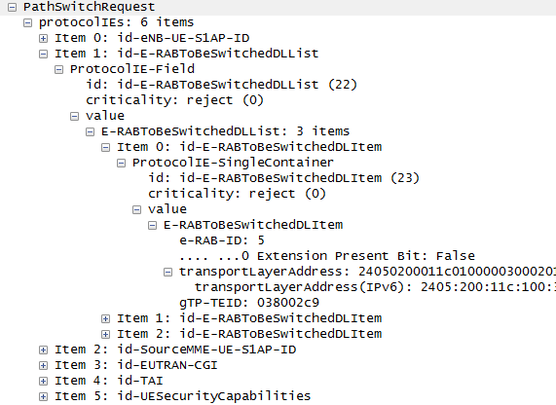](https://blogger.googleusercontent.com/img/b/R29vZ2xl/AVvXsEjDRR9AyDgXuec-JgwWjvf7nKoKnZI3c5xiyrXrImoWhclta2B3DtulzlkFiB8NFvEn7HOdyteGz_QRFP85-7xWicN5k9dW6kcdZuqShcW5u4CJLbdC8I4O_s1WHRRGhtkhksVL-3MbeUQ/s1600/%25231.+snapshot+-+pathswitch.png)

[8] Upon receiving the *Path Switch Request*, the MME requests the SGW to modify EPS bearers by sending *Modify Bearer Request*per PDN connection. The *Modify Bearer Request* contains the list of EPS bearers to be modified.

[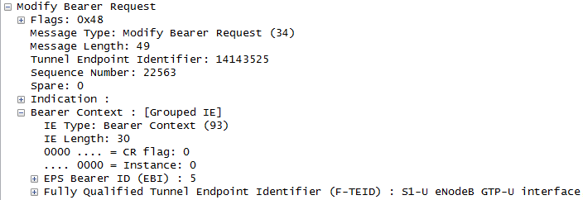](https://blogger.googleusercontent.com/img/b/R29vZ2xl/AVvXsEhKveao3RGnggj5h6mJIpdf7gawzfz6WHopJ_KCCrSzYoCQQIbbYEVVzQSUPAzNLeYb0HH5sxa0jJGi3rN23bu2rm2grEW6nBKYNmNhqA7elEqARpoVD3BX_htsmsJUwW3Klg0d4TxKO4k/s1600/%25232.+snapshot+-+modify+bearer+request.png)

The PGW may need to inform the PCRF of the fact that the UE's location has been updated based on the request from the PCRF when the Gx session was established. Refer to "[Bearer level event and VoLTE call setup failure](http://hongjoo71-e.blogspot.kr/2015/09/bearer-level-event-and-volte-call-setup.html)" for basic understanding as to how the bearer level event reporting mechanism is realized within the PCC architecture.  
  
[9] The SGW establishes the downlink S1 bearer with the target eNB and responds with the *Modify Bearer Response*, which includes the list of successfully modified EPS bearers.

[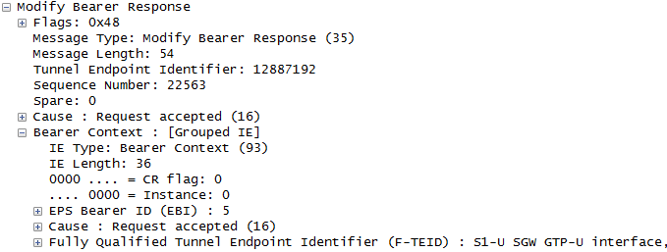](https://blogger.googleusercontent.com/img/b/R29vZ2xl/AVvXsEgbykDH2NKlMLYuKi1CykOvwR6vDLKxfaMgDCAiYJrE7lBDwE2r2zhf2r2IXR1dK_xJ55PCfw2ZUtJxw2lhB4zTc8gvWe7aSN3pN0vdzxUIDUIUWHJQ0P32Ms8DbQkG5hgegxCkuMoFhyE/s1600/%25233.+snapshot+-+modify+bearer+response.png)

[10] The SGW acknowledges the target eNB by sending Path Switch by sending Path Switch Acknowledge.

[11] The target eNB informs the source eNB that the handover has been completed successfully by sending *UE Context Release*. Upon receiving the *UE Context Release*, the source eNB releases all the resources associated with the received UE context.

***

As a result of X2 handover, the UE context that was maintained by the source eNB is moved to the target eNB. The UE's location will be updated (e.g., ECGI, TAI) and the UE's C-RNTI will be re-assigned by the target eNB. The target eNB shall also assign a new eNB S1AP UE ID which will be updated at MME. The S1 bearer between the SGW and the source eNB will be replaced by another S1 bearer between the same SGW and the target eNB, which requires updates of eNB S1 GTP-U TEID. The PCRF may need to update UE's location.  
  
Please note that all these changes does not affect the existing VoLTE session. All the EPS bearers being used to transfer VoLTE signaling and data moves to the target eNB. In case there is an existing voice media session, the voice data arriving at the source eNB while the UE handover is in progress will be transferred to the target eNB through the direct tunnel between two eNBs and buffered at the target eNB. The buffered data is eventually transferred to the UE when the handover is completed. Assuming that the handover takes less than a few milliseconds, the user won't notice a voice cracking.

***Red Mouse***

REFERENCES  
  
[1] GPP TS23.401, "General Packet Radio Service (GPRS) enhancement for Evolved Universal Terrestrial Radio Access Network (E-UTRAN) access", v12.4.0, Mar 2014  
[2] 3GPP TS36.423, "Evolved Universal Terrestrial Radio Access Network (E-UTRAN); X2 application protocol (X2AP)", v13.1.0, Sep 2015  
[3] 3GPP TS25.331, "Radio Resource Control (RRC) Protocol specification", v10.0.0, Jun 2010  
[4] 3GPP TS36.331, "Evolved Universal Terrestrial Radio Access Network (E-UTRAN); Radio Resource Control (RRC) Protocol specification", v12.7.0, Sep 2015  
[5] 3GPP TS25.323, "Packet Data Convergence Protocol (PDCP) specification (release 9)", v9.0.0, Dec 2012  
[6] 3GPP TS36.300, "Evolved Universal Terrestrial Radio Access (E-UTRA) and Evolved Universal Terrestrial Radio Access Network (E-UTRAN); Overall description; Stage 2", v10.0.0, Jun 2010  
[7] EventHelix.com, "[LTE X2 handover sequence diagram](https://www.eventhelix.com/lte/handover/x2/lte-x2-handover-sequence-diagram.htm#.VhERzfntmko)", 20th Apr 2013  
[8] Netmannias, "[EMM Procedure 6. Handover over without TAU - Part2. X2 handover](http://www.netmanias.com/en/post/techdocs/6257/emm-handover-lte/emm-procedure-6-handover-without-tau-part-2-x2-handover)", Mar 21th 2014

**VoLTE S1 Handover preparation (1/3)**

While UE crosses the border towards the neighborhood cell, the source eNB determines whether there needs a handover based on the received measurement report from the UE. When there is no established X2 connection with the target eNB, the source eNB determines to perform S1 handover. In this post, the handover preparation phase will be addressed. The handover preparation procedure includes the determination of handover by the eNB, handover request by the MME, the allocation of required resources and establishing the indirect data forwarding tunnels among NEs.

**I. Indirect Data Forwarding Tunnel**

S1 handover is different from the X2 handover in that the media is anchored by the SGW under the control of MME rather than by eNB. During the S1 handover, a temporary indirect data forwarding tunnel is established between two eNBs via the common SGW. All the media arriving at the source eNB while S1 handover is in progress, which can be uplink data from UE side or the downlink data from the network side, will be re-directed to the target eNB through this indirect data forwarding tunnel and buffered at the target eNB. When the S1 handover is completed, the buffered media at the target eNB is transferred to the UE. The following diagram shows Indirect Data Forwarding Tunnel established between the source eNB and target eNB anchored by the common SGW during S1 handover procedure.

[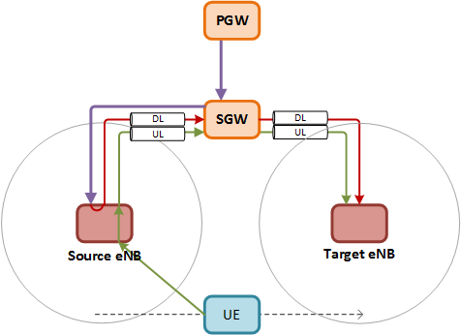](https://blogger.googleusercontent.com/img/b/R29vZ2xl/AVvXsEjgvvNuVs-kPWavV4rYS7XvNBkTnVZCOJfcoZAGKUJu7D7D9opXS6elwo5i3mFLtwEYrxqzQKgH21hxuD0LIQ-fLIwhsyO0x5AfvuWKXHHf3OP-0MskLl3XLTquC6duJhm1np91leCPfAE/s1600/Fig1.+S1+handover+diagram.png)

Figure 1. Indirect Data Forwarding Tunnel in S1 handover

**II. S1 handover preparation**

As a precondition of this practice, the UE has PDN connections with the internet APN and IMS APN and there are three EPS bearers established in total with EPS bearer ID of ‘5’, ‘6’ and ‘7’ and the relocation of SGW/PGW does not occur. The S1 handover procedure is triggered by the source eNB. The MME controls establishing the Indirect Data Forwarding Tunnel by intermediating required data between two eNBs like Bearer Context. The Bearer Context contains EPS bearer ID and their GTP-U TEIDs corresponding to each EPS bearers. The SGW anchors the media transfer between source eNB and the target eNB. As the SGW and two eNBs are involved in the media control, they allocate the required media resources, generate their own GTP-U TEIDs and establishes S1 bearer and indirect data forwarding tunnels based on the GTP-U TEID of the peer node delivered via MME.

[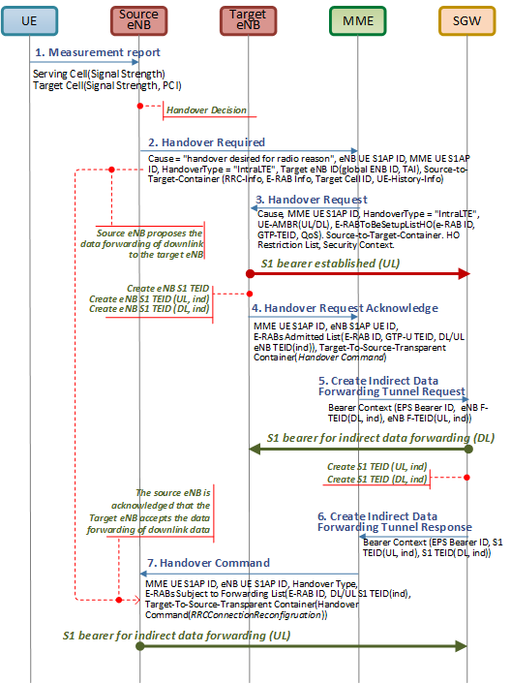](https://blogger.googleusercontent.com/img/b/R29vZ2xl/AVvXsEg11w2BTtFJCGqQaqqYrOoTZ4FreZyaH9paKwT7-C0mfJoGYTPqn3snc23v8FBn6DSNN0vZF6YoGBUNXv21Co_iA4SS3gV8pYzRqmRC5p5BfQ_vVhVLb4A5EyOMcZOG1EmiXscryd-2aDs/s1600/Fig2.+flow+-+handover+request.png)

Figure 2. S1 handover procedure - preparation

[1] The UE periodically sends a measurement report to the serving eNB. This reporting mechanism is intended for the UE to find out the best cell to communicate with the network. The measurement report may contain the list of neighbor cells, signal strength, current condition, etc.

[2] Based on the received report, the serving eNB determines whether the handover is required and if it is required, the serving eNB selects a target eNB among the list of neighbor eNBs. If there is no X2 connection with the target eNB, the source eNB performs S1 handover and sends *Handover Required* to the serving MME requesting to prepare for resources at the target.

* MME UE S1AP ID: Unique identifier of the UE association over the S1 within the MME
* eNB UE S1AP ID: Unique identifier of the UE association over the S1 within the eNB
* Handover Type: The type of triggered handover in the source side (i.e., intraLTE, LTEtoUTRAN, LTEtoGERAN, UTRANtoLTE, GERANtoLTE)
* Cause: A reason for a particular event for the S1AP. In this practice, the value “Handover Desirable for Radio Reasons” indicates that the cause is related with radio. Refer to section 9.2.1.3 *Cause* of [TS36.413] for the detail.
* Target ID: The target eNB for the handover. It is composed of “Global eNB ID” and “selected TAI”. The Global eNB ID is composed of PLMN ID (MCC+MNC) and macro eNB-ID identifying the specific eNB of a certain operator in a certain country. The selected TAI uniquely identifies the target Tracking Area i.e., PLMN ID + TAC, identifying a specific tracking area that is served by that eNB.
* Source to Target Transparent Container: Information elements created by the source eNB and transmitted to the target eNB, which contains the RRC related information, E-RAB information, Target Cell-ID and UE History Information as shown in the following bullets.
* RRC Container: RRC Information used by the target eNB during handover preparation including UE capability information. Refer to “HandoverPreparationInformation” in section 10.2.2 “Message definitions” of TS36.331 for the detail.
* e-RABInformationList: The list of eRAB to be handed over. The E-RAB ID identifies a radio access bearer for a particular UE, which makes the E-RAB ID unique over one S1 connection. The “dL-Forwarding-proposed” indicates that the source eNB proposes the list of E-RABs for forwarding of data. In this practice, there are three E-RABs (i.e., E-RAB ID=’5’,’6’ and ‘7’) proposed and they actually represent existing E-RABs of the source eNB. If the target eNB accepts it in the *Handover Request Acknowledge*, the downlink data received by the source eNB during the handover will be forwarded to the target eNB through the indirect data forwarding tunnel.
* Target Cell ID: Globally unique cell identifier. It is composed of PLMN ID and Cell ID.
* UE-HistoryInformation: The list of cells that a UE has been served by in the active state prior to the target cell.

[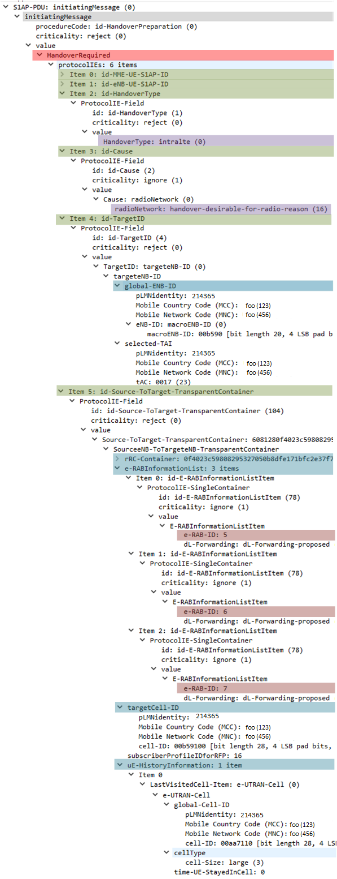](https://blogger.googleusercontent.com/img/b/R29vZ2xl/AVvXsEh8jnGBEWg6uBKGCjLxpSnKFtp1fTiLWkFprYDEpnHUuJYqp3jYAgZgYl1dH1c4aLdQdRFUu0SX0vcXN4Tm8t4i2g56w0n9kMOH-MHH2xZWQ1-kPriwQyLcUw2MBd996_y9KuKig9CyZik/s1600/Fig3.+snapshort+%2523148+-+handover+required.png)

Figure 3. Handover Required

[3] the MME initiates the procedure by sending the *Handover Request* to the target eNB requesting to prepare for resources for handover.

* MME UE S1AP ID: refer to step#2.
* Handover Type: refer to step#2.
* Cause: refer to step#2.
* UE-AMBR: Aggregated maximum bit rates per UE being applicable for Non-GBR bearers.
* E-RAB to be SetupList: A list of E-RAB to be setup where each item contains E-RAB ID, Transport Layer Address, GTP-TEID and E-RAB level QoS parameters as addressed in the following bullets.
* E-RAB ID: Refer to step#2
* The Transport Layer Address : IP address of the source eNB.
* The GTP-TEID : The GTP Tunnel Endpoint Identifier of the SGW towards the source eNB. This has been known to the MME during the initial attach of the UE and used by the source eNB to maintain the S1 bearer with the SGW. Now, the MME intends to take this to the target eNB to replace the existing S1 bearer in the end.
* E-RAB Level QoS Parameters indicates the QoS to be applied to the corresponding E-RAB. It is composed of QCI and ARP. Refer to the section 9.2.1.60 “Allocation of Retention Priority” in TS36.413 for the detail.
* Source to Target Transparent Container: Information elements created by the source eNB and transmitted to the target eNB. Refer to step#2.
* UESecurityCapabilities: Supported algorithms for encryption and integrity protection in the UE.
* HandoverRestrictionList: Roaming or access restrictions for subsequent mobility action for which the eNB provides information about the target of the mobility action towards the UE.
* SecurityContext: Security related parameters to the eNB which are used to derive security keys for user plane traffic and RRC signaling messages and to generate security parameters for the current S1 handover.

[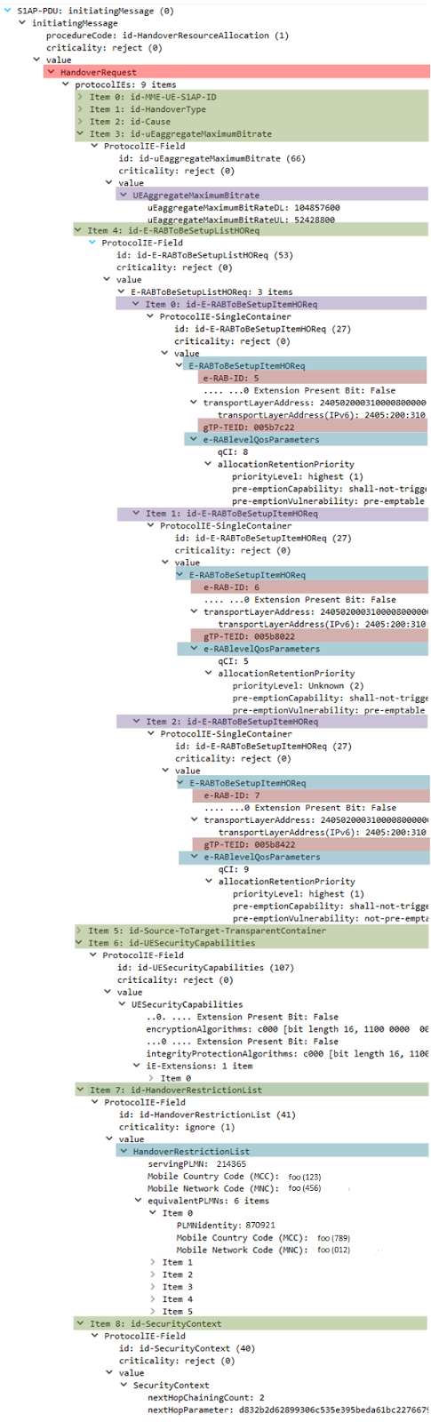](https://blogger.googleusercontent.com/img/b/R29vZ2xl/AVvXsEhQA78DjSwbz8SmkzHF-cMwBZplHOSskfxAHjLbEfgRsGmt5z9eErdAfhJwwJFaMKatMarBz8RklWnioXS7mRhmQqWb35lH8IYKwikZE8FRLoSip5rC4m5o6cGyf1VNPz8Zsk-hDFGXzpU/s1600/Fig4.+snapshort+%2523149+-+handover+request.png)

Figure 4. Handover Request

[4] The target eNB allocates all the necessary resources for the admitted E-RABs and establishes uplink S1 bearer with the SGW. The target eNB creates its own GTP TEID for S1 bearers which will be delivered to the SGW later and used by the SGW to establish the downlink S1 bearer (SGWàtarget eNB), thereby replaces that the source eNB. The uplink and downlink GTP-TEID for each admitted E-RABs are also included. These DL/UL GTP-TEIDs are used for indirect media transfer. The target eNB responds with the *Handover Request Acknowledge* to the MME.

* MME UE S1AP ID: refer to step#2.
* eNB UE S1AP ID: refer to step#2.
* E-RAB Admitted List: The list of E-RAB for which the target eNB admitted to establish. This is composed of E-RAB ID, GTP-TEID, UL/DL GTP-TEIDs and the Transport Layer for each Admitted Item as addressed in the following bullets.
* E-RAB ID : Refer to step#2.
* GTP-TEID indicates GTP Tunneling Endpoint Identifier of the target eNB which will replace the corresponding GTP-TEID of the source eNB in the end (i.e., downlink S1 bearer).
* The DL/UL GTP-TEIDs indicate the Tunneling Endpoint Identifiers of the target eNB for Indirect Data Forwarding Tunnels. The following diagram shows the GTP TEID for indirect data forwarding dedicated for one E-RAB.
* Target to Source Transparent Container: Information element that is used to transparently pass radio related information from the handover target to the handover source through the MME. The *Handover Command* is transparently delivered to the source eNB.

[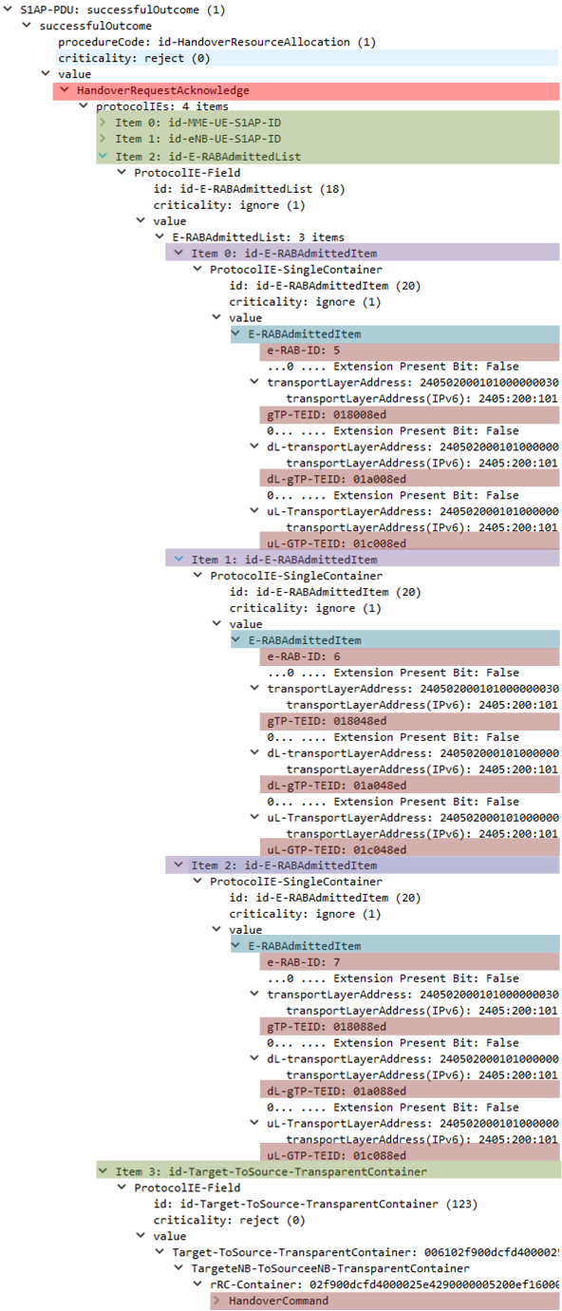](https://blogger.googleusercontent.com/img/b/R29vZ2xl/AVvXsEgo86IwbyVqTo_5eV2-MEllpeqVSZPzAO56gq3yl-7b41tgXLXCD_F2mYh9Gc831XtaK6t5Yqyj745pt4t3nKjYzDeiqxmqBHjtOjOF29qXokQGvZH50tKw8rtJ_S5BnsIEBdn5b_Hppvk/s1600/Fig5.+snapshort+%2523150+-+handover+request+ack.png)

Figure 5. Handover Request Acknowledge

[5] Upon receiving the *Handover Request Acknowledge*, the MME sends the *Create Indirect Data Forwarding Tunnel Request* to the SGW, which contains the Bearer Context for each bearer which was received at step #4 from the target eNB. The Bearer Context represents the attributes of each bearer including bearer identifier and TEIDs as below:

* EPS Bearer ID : Identifier of EPS bearer to be established.
* eNB F-TEID for DL data forwarding: GTP Tunneling Endpoint Identifier created by the target eNB for downlink data forwarding. Refer to step#4
* eNB F-TEID for UL data forwarding: GTP Tunneling Endpoint Identifier created by the target eNB for uplink data forwarding. Refer to step#4

[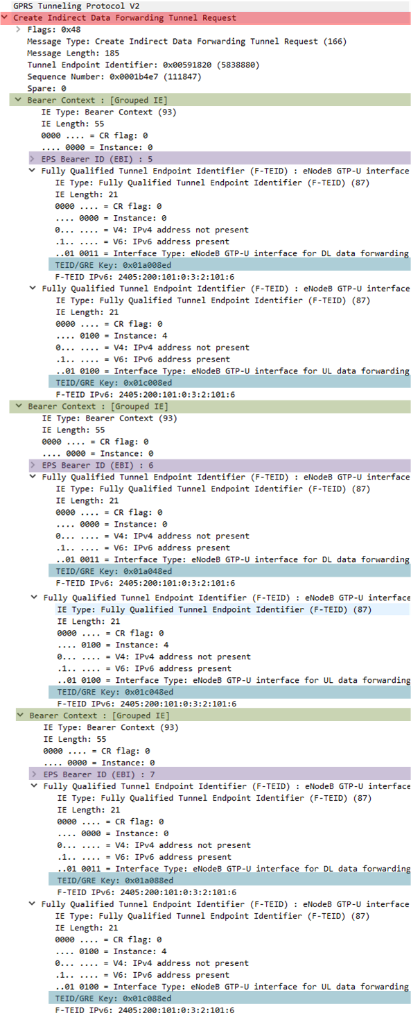](https://blogger.googleusercontent.com/img/b/R29vZ2xl/AVvXsEi9q3Z59WW9IXpc719O3dQw44ZKDpLxFKOPemIUL25yzaISI5W5yT8xYaltV3QTWYeoKOu89OtE9r6m8W34syy7IHZLMrrJ8RQ65EgEq1qgR-mJNarKbPq6PYG0ZYVLh_43suaS0uxaH2Y/s1600/Fig6.+Snapshot%2523151+-+Create+Indirect+Data+Forwarding+Tunnel+Request.png)

Figure 6. Create Indirect Data Forwarding Tunnel Request

[6] Upon receiving the *Create Indirect Data Forwarding Tunnel Request*, the SGW establishes the Indirect Data Forwarding Tunnel towards the target eNB using the received DL/UL eNB F-TEIDs. The SGW allocates its own UL/DL F-TEID for indirect data forwarding tunnel, which is delivered to the source eNB via MME at step #7. The SGW responds to the MME with the *Create Indirect Data Forwarding Tunnel Response* which contains the Bearer Context of the SGW.

* Cause : Indicates if the Indirect Data Forwarding Tunnel has been created in the SGW. Refer to section 7.2.19 “Create Indirect Data Forwarding Tunnel Response” of TS29.274 for the detail.
* EPS Bearer ID : refer to step #5.
* SGW F-TEID for DL data forwarding: GTP Tunneling Endpoint Identifier created by the SGW for downlink data forwarding.
* SGW F-TEID for UL data forwarding: GTP Tunneling Endpoint Identifier created by the SGW for uplink data forwarding.

[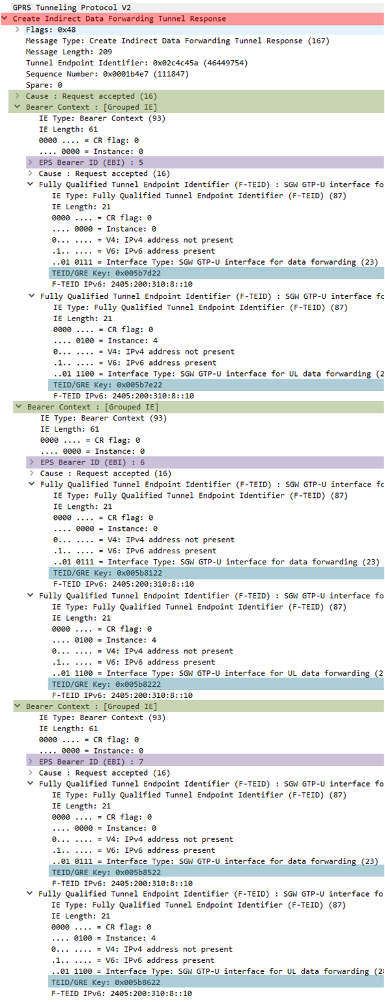](https://blogger.googleusercontent.com/img/b/R29vZ2xl/AVvXsEhzoRdRiHD480FoC0vvUzDGWOq5wA4DUAW7tPbupjEDeaeEhitGnKrxhA2sXY39bPWQw3AAwgsv92IKnlY0EQZSZrfeZmFHV-eV_HbIK_-6SkIndCmbmOo1J8wTQTFpiwE8oP-6qt7qUkU/s1600/Fig7.+Snapshot%2523156+-+Create+Indirect+Data+Forwarding+Tunnel+Rsp.png)

Figure 7. Create Indirect Data Forwarding Tunnel Response

[7] The MME sends the *Handover Command* to the source eNB informing that resources for handover has been prepared at the target eNB. Upon receiving the *Handover Command*, the source eNB establishes Indirect Data Forwarding Tunnel towards the SGW using the received E-RAB Subject to Data Forwarding List, i.e., DL/UL GTP-TEIDs for each E-RAB.

* MME UE S1AP ID: refer to step#2.
* eNB UE S1AP ID: refer to step#2.
* Handover Type: refer to step#2.
* E-RAB Subject to Data Forwarding List : The list of E-RAB items to be used for indirect data forwarding. Each E-RAB Data Forwarding Item identifies the E-RAB context of each E-RAB and it consists of E-RAB ID, DL/UL GTP-TEIDs as addressed below.
* E-RAB ID: Refer to step #2.
* DL/UL GTP-TEIDs : Tunneling End Point Identifier of the SGW created and delivered at step #6 for the Indirect Data Forwarding Tunnel.
* Target To Source Transparent Container: Radio related information transparently delivered to the source eNB through the MME. It was created by the target eNB and sent to the MME at step #4.

[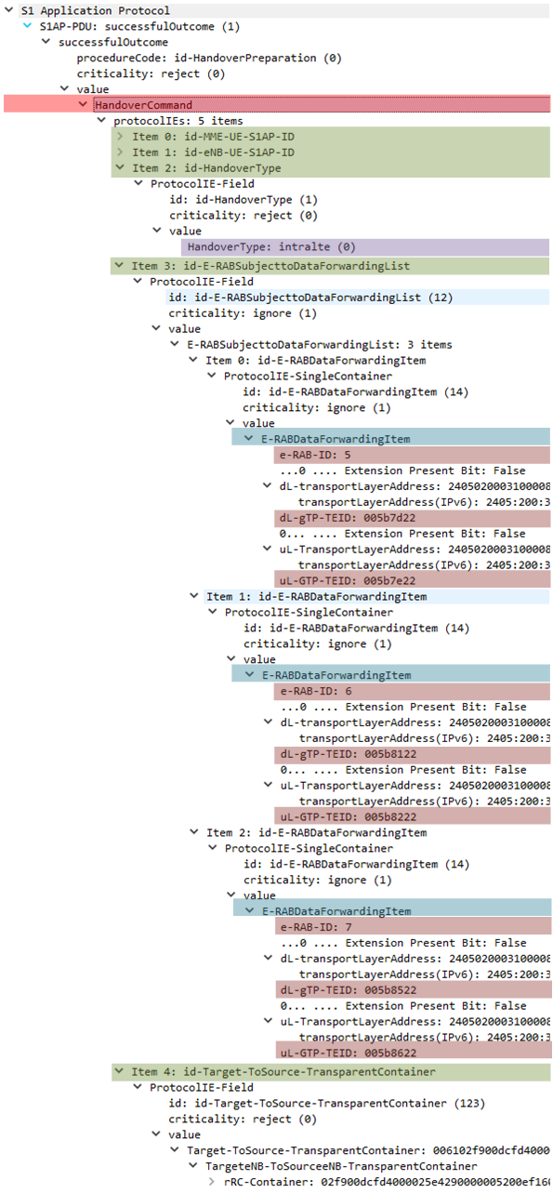](https://blogger.googleusercontent.com/img/b/R29vZ2xl/AVvXsEiSVQY_4VtsCBpWkTgKbdxB8ZYxFSLKiiswSD8BaPPZ42eBrpSSJWcnNlhlPjOYCZUo1gS6oSYSSR60mM3_FsQi1QTkHXlZKW7_kAkEgwhUMxKpTHgWKEfHPi7p97iyxJZpjsDNQEmwUx8/s1600/Fig8.+Snapshot%2523157+-+Handover+Command.png)

Figure 8. Handover Command

***Red Mouse***

**REFERENCES**

[1] 3GPP TS25.331, "Radio Resource Network (RRC); Protocol specification", v12.3.0, Sep 2014

[2] 3GPP TS24.301, "Non-Access-Stratum (NAS) protocol for Evolved Packet System (EPS); Stage3", v12.4.0, Mar 2014

[3] 3GPP TS24.008, "Mobile radio interface Layer 3 specification; Core network protocols; Stage3", v13.4.0, Dec 2015

[4] 3GPP TS29.274, "3GPP Evolved Packet System (EPS); Evolved General Packet Radio Service (GPRS); Tunneling Protocol for Control Plane (GTPv2-C); Stage3", v13.0.0, Dec 2014

[5] 3GPP TS36.331, "Evolved Universal Terrestrial Radio Access (E-UTRA); Radio Resource Control (RRC); Protocol specification", v12.3.0, Sep 2009

[6] 3GPP TS36.413, "Evolved Universal Terrestrial Radio Access Network (E-UTRAN); S1 Application Protocol (S1AP)", v12.3.0, Sep 2014

**VoLTE S1 handover execution (2/3)**

S1 handover preparation procedure includes the decision of S1 handover by the source eNB, allocation of network resources to establish Indirect Data Forwarding Tunnel among two eNBs and common S-GW and establishment of uplink S1 bearer from the target eNB to the S-GW. Once the S1 handover preparation procedure is completed, the MME initiates the S1 handover by sending *Handover Command* to the UE via the source eNB. The UE executes the handover by detaching from the source eNB and attaching to the target eNB. Meanwhile, the downlink data is forwarded to the target eNB and buffered while the UE handover is in progress. Lastly, the UE informs the target eNB of the fact that the handover has been successfully completed and thereafter, the buffered data and downlink data is forwarded the UE through the target eNB.

[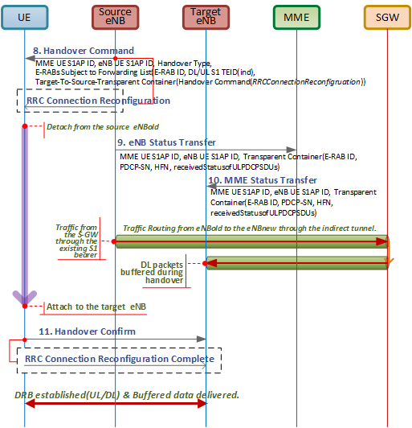](https://blogger.googleusercontent.com/img/b/R29vZ2xl/AVvXsEg4-yRuaZtG7tqWv4iPYz05xK2BUIfWrWaZCbcM_NTtRig5UmbjSvJ1TGQXqDfchmjRg0JMF2Jh1d9ovIkDt5JcTgbk8OHX4NkrdLEcmnsLcJUknE3ths9DfmyhUKR_dg0OM4ftYZY80yg/s1600/Fig1.+S1+handover+execution+flow.png)

Figure 1. S1 handover procedure - execution

[8] The *Handover Command* received from the MME is wrapped by the source eNB within the *RRC Connection Reconfiguration*and sent to the UE. The *RRC Connection Reconfiguration*is the message to perform logical, transport and physical channel configurations. In this case, it is used to send NAS signaling to the UE to reduce the latency. Upon receiving the *Handover Command*, the UE detaches from the source eNB and performs handover to the target eNB.

[9] The source eNB stops assigning PDCP-SNs to downlink packets and sends the *eNB Status Transfer* to the target eNB via MME that contains uplink and downlink PDCP-SN and HFN (Hyper Frame Number) for each respective E-RAB. This procedure is initiated by the source eNB at the moment when it considers the transmitter/receiver status to be frozen. The use of PDCP-SN and HFN is part of overflow control mechanism for radio. The PDCP-SN is the serial number of PDCP packets increasing up to MAX-PDCN-SN. If the number reaches the MAX-PDCP-SN, the HFN is incremented by one.

* Subject to Transfer Items: contains uplink/downlink PDCP-SN and HFN for each respective E-RAB.
* E-RAB ID: Identifies a radio access bearer for a particular UE. This value remains the same after S1-handover.
* uL-/dL-Count value: contains the PDCP-SN and HFN values
* Received Status of UL PDCP SDUs: indicates the missing and the received uplink SDUs (Service Data Units) for each bearer for which the source eNB has accepted the request from the target eNB for uplink forwarding.

[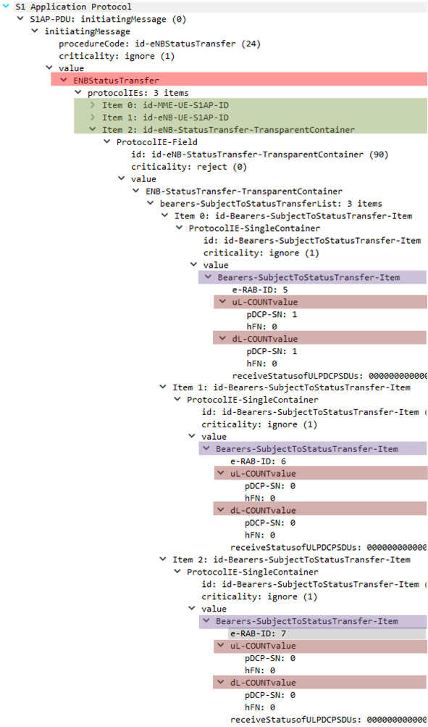](https://blogger.googleusercontent.com/img/b/R29vZ2xl/AVvXsEichnEaBO2J46dGpEtgAnhd2oLEVzwe-WOe71OIpKGDbKjr3uNzTyyeuCFXhXnIUvFpWHGnR5TCcIxuZQfOxk8WTsgx3_ChQHWFpZVf5G6Q1eVCIm2S337yUqqr6ME6ajPrC3v-FtEFOf4/s1600/Fig2.+S1+handover+execution+flow+%2528158%2529.png)

Figure 2. eNB Status Transfer

[10] The MME forwards the received PDCP-SN and HFN information to the target eNB by sending *MME Status Transfer*. Upon receiving the *MME Status Transfer*, the target eNB does not deliver any uplink packet whose PDCP-SN is lower than the value received in the PDCP-SN in the uL-COUNT value. The target eNB uses the received PDCP-SN in the dL-COUNT value for the first downlink packet for which no PDCP-SN is assigned yet. The downlink traffic received by the source eNB is routed to the target eNB following the *Indirect Data Forwarding Tunnel*.

[11] After the UE successfully synchronized with the target cell, it sends a *Handover Confirm*to the target eNB. The *Handover Confirm* is contained in the *RRC Connection Reconfiguration Complete* message on RRC. Please note that, at this moment, there is no direct S1 bearer established yet between S-GW and the target eNB. Therefore, the downlink data is sent to the source eNB and forwarded to the target eNB following the Indirect Data Forwarding Tunnel. The uplink data from the UE will be forwarded to the S-GW following the direct S1 interface.

***Red Mouse***

**REFERENCES**

[1] 3GPP TS25.331, "Radio Resource Network (RRC); Protocol specification", v12.3.0, Sep 2014

[2] 3GPP TS23.401, “General Packet Radio Service (GPRS) enhancements for Evolved Universal Terrestrial Radio Access Network (E-UTRAN) access”, v12.4.0, Mar 2014

[3] 3GPP TS36.331, "Evolved Universal Terrestrial Radio Access (E-UTRA); Radio Resource Control (RRC); Protocol specification", v12.3.0, Sep 2009

[4] Blog, “[How LTE Stuff Works?: RRC Connection Reconfiguration](http://howltestuffworks.blogspot.kr/2011/10/rrc-connection-reconfiguration.html)”, Oct 2011

**VoLTE S1 handover completion (3/3)**

After the UE confirms the completion of the S1 handover in a new cell, the target eNB initiates the completion procedure by sending towards the network. The completion procedure involves the SGW and PGW replacing the downlink S1 bearer from the source eNB to the source eNB releasing the UE associated resources and lastly, the release of Indirect Forwarding Tunnels by the SGW.

[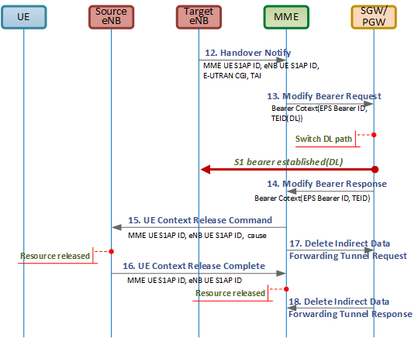](https://blogger.googleusercontent.com/img/b/R29vZ2xl/AVvXsEhzfSaqD8lzFk7Q82UvxeRKhwn6aUXwPTUkobt9MVpw6qkab3t2Lfq1hpwU3VMbpfG-IXlhcp9GM_zXpG7SBbMDFgb9Frax5BdUbBR-ahiNvsIsgkF5ofsGZIxqLNwqhbpuT7Q5bYwKwWA/s1600/Fig1.+S1+handover+complete+flow.png)

Figure 1. S1 handover procedure - complete

[12] The target eNB sends the *Handover Notify* to the MME notifying that the UE has been identified in the target cell and S1 handover has been completed.

* E-UTRAN CGI: globally identifies a cell and composed of PLMN identity and Cell identity.
* TAI: uniquely identify a Tracking Area and composed of PLMN identity and TAC (Tracking Area Code).

[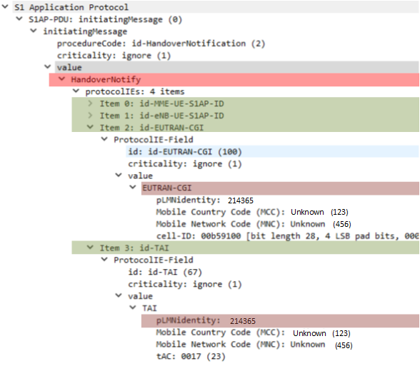](https://blogger.googleusercontent.com/img/b/R29vZ2xl/AVvXsEh6hPjcOvaTf3frDHcuMeWfTH6HLGrRV_QkftHU1NQlNl0T_J0G17fd_cNLVssD4wuXpr1AUEMq3pHjFZQp9KxbmCMvqGuHhKQc7wABHZka6GvxF-l118P0v_uXjei1r2tvUwbHsmay7Oo/s1600/Fig2.+Handover+Notify+%2528159%2529.png)

Figure 2. Handover Notify

[13] The MME sends the *Modify Bearer Request* to the SGW requesting to switch the media path from the source eNB to the target eNB. The switch of media path from the SGW is done by updating the S1 bearer tunneling end point.

* Indication: includes various application flags. Refer to section 7.2.7 “Modify Bearer Request” in [TS 29.274].
* Bearer Context: identifies the bearer to be modified. It is composed of EPS Bearer ID and S1 eNB F-TEID sub elements.

In this practice, there are three bearers, i.e., bearer id = 5,6,7. The bearer 5 and 6 belongs to the internet APN, meanwhile the bearer 7 belongs to the IMS APN. The MME sends multiple Modify Bearer Request for each APN.

Note that in the following message, the value of F-TEID is set to 0x018088ed. This value is the one that was sent by the target eNB in step [4] *Handover Request Acknowledge* where it represents the tunneling end point of the target eNB for the downlink S1 bearer. Now, the MME deliver this value to the S-GW so the S-GW can use this value as a new target end point for the media path. As such, the downlink media path on S1 bearer is switched from the source eNB to the target eNB.

[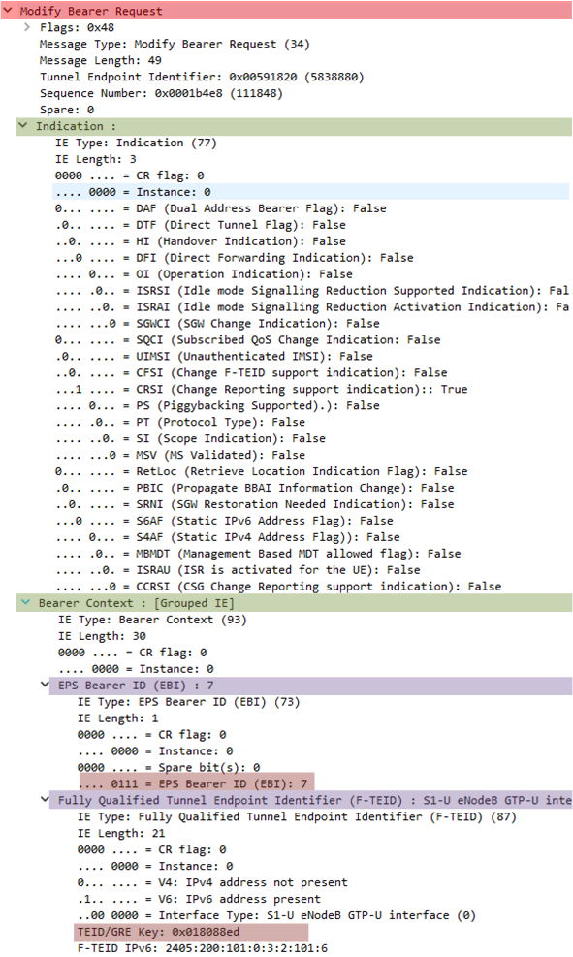](https://blogger.googleusercontent.com/img/b/R29vZ2xl/AVvXsEhBgRP5aD7o1q8_eLLIrELNw9eNnh85N7zapcjQ1VaFQ9HHOtNWcq-snzSfurtIPskGH1O4gjg2cjzdVQTbNs4nCnsjjn9Wm4RWvDf97zYZP-mCg4EgsYYfwqohmfQjA-duoM1r1cnZzww/s1600/Fig3.+Modify+Bearer+Request%2528160%2529.png)

Figure 3. Modify Bearer Request for bearer 7

The following message shows the *Modify Bearer Request* for the bearer 5 and 6. In the same as described in the above, the value of F-TEID is set to 0x018008ed and 0x018048ed for bearer 5 and 6, respective. They are the same values as were sent by the target eNB in step [4] *Handover Request Acknowledge* where they represent tunneling end points of the target eNB for the downlink S1 bearer.

[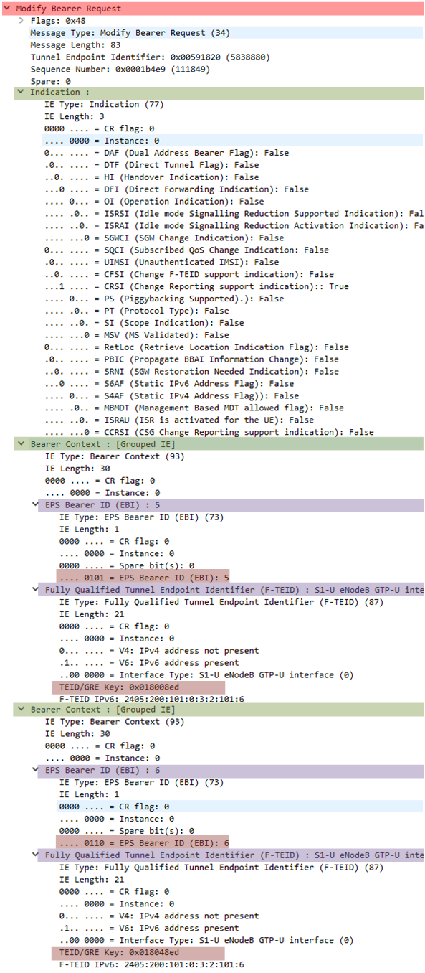](https://blogger.googleusercontent.com/img/b/R29vZ2xl/AVvXsEhyW7jON0GFguA0H_m-Z-n7QJAKxRzxDzBnsghwezEzKPYkOgTGKwU4JU0IhOpMerBHRGDswEw-lGzhzpQQIvdn7Y-LBAAyfhcVqrdDCjDZeuTd_0cQCUJNULwgUDX6TgdN08Cylaz1FQE/s1600/Fig4.+Modify+Bearer+Request%2528163%2529.png)

Figure 4. Modify Bearer Request for bearer 5 and 6

Note that the *Modify Bearer Request* is also sent by the SGW to the PGW which is not depicted here. The SGW and PGW are logically separated but in many cases, they are deployed on the same platform.

[14] The *Modify Bearer Response* sent from the PGW to the SGW and from the SGW to the MME.

* Cause: indicates the result of modifying the requested bearer.
* Bearer Context: identifies the bearer that has been modified. It is composed of EPS Bearer ID, Cause and S1 eNB F-TEID sub elements.

Note that in the following message, the value of F-TEID is set to 0x005b8422. This value is the one that was sent by the MME to the target eNB in step [3] *Handover Request*where it represents the tunneling end point of the SGW for the uplink S1 bearer. The tunneling end point values of SGW is created when the UE attaches the network at the very beginning. Upon S1 handover, the MME sends this value to the target eNB and the target eNB establishes uplink S1 bearer to the SGW using this value. At this moment, the source eNB also has uplink S1 bearer connection with the SGW with the same tunneling end points. As both source eNB and target eNB can send traffic to the SGW, there is no change that the data sent by the UE gets lost during handover procedure.

Now, the SGW sends this TEID to the MME for the downlink S1 bearer informing the tunneling end point for the downlink S1 bearer.

[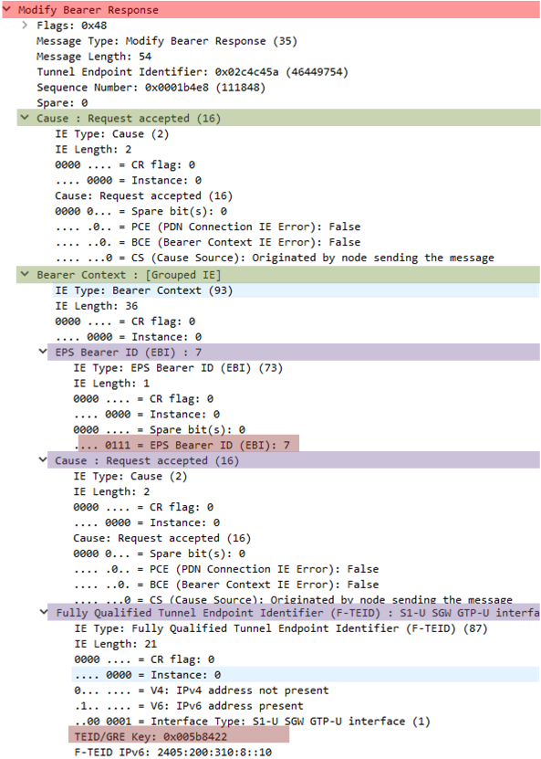](https://blogger.googleusercontent.com/img/b/R29vZ2xl/AVvXsEibYZokFd_tva71zPAKY58cK0RcVplCiQcp5SK05QphC141eAzRdisa01G5XlApDUNzCiy5xw7MZpsGcn7j52-vBarng_fkqJUYyJC_kucIkqltA-nYNKArcf6hieEW8cJVfTKaWKg7vxo/s1600/Fig5.+Modify+Bearer+Response%2528168%2529.png)

Figure 5. Modify Bearer Response for bearer 7

The same principal is applied to the following message which is for bearer 5 and 6.

[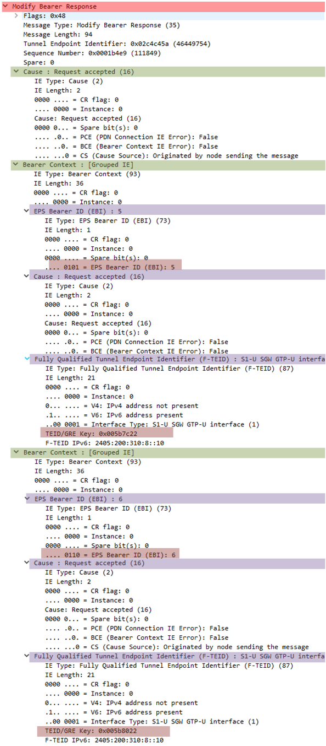](https://blogger.googleusercontent.com/img/b/R29vZ2xl/AVvXsEjs1UaTJGPBzAic2DdbuETHv5Ws8gztGGb7ZgfeXdplrkHtl5cfn0DGq6iLRzApNzwxc5Aw8_g8833d87XZehMCfrwBBKh4AkxlJdMPEnnOf6xwC2tTkqM3v0E7prARjmHzNQiQqIoXp0c/s1600/Fig6.+Modify+Bearer+Response%2528171%2529.png)

Figure 6. Modify Bearer Response for bearer 5 and 6

[15] The MME requests the release of UE-associated S1 logical connections over S1 interface by sending *UE Context Release Command*. The source eNB releases its resources related to the given UE.

* UE S1AP ID Pair: contains the UE S1AP identifiers. It is composed of MME UE S1AP ID and eNB UE S1AP ID
* Cause: indicates the reason for this command. Refer to section 9.2.1.3 “*Cause*” in TS36.413 for the detail.

[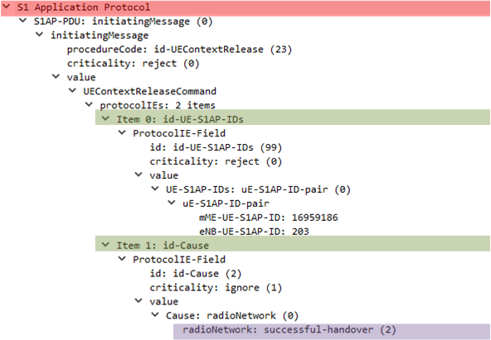](https://blogger.googleusercontent.com/img/b/R29vZ2xl/AVvXsEhK5UAJBTK1sxVD6JerqE08SYb7_0s2mIO0BT6UViY73Jz3x3QikUqlNeVnP-R8Ocz54oh03OLb9NBuGXmearN7_U4A2EglPKjF-SEsfFht3tqkVtKFiPB9bmWp-KTX4S04PrAjit0_nls/s1600/Fig7.+UE+Context+Release+Command%2528172%2529.png)

Figure 7. UE Context Release Command

[16] The source eNB confirms the release of UE-associated S1 logical connections over S1 interface by sending *UE Context Release Complete*.

* MME UE S1AP ID: uniquely identifies the UE association with the S1 interface within the MME.
* eNB UE S1AP ID: uniquely identifies the UE association with the S1 interface within the eNB.

[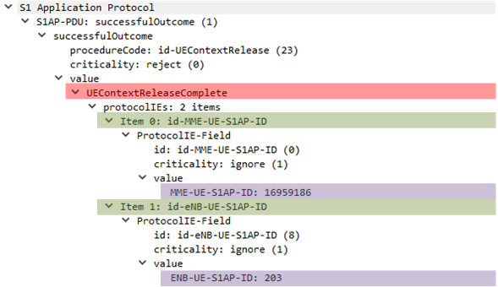](https://blogger.googleusercontent.com/img/b/R29vZ2xl/AVvXsEjg2uqFTLBG-_V58mZVKBqXL_gxEO_GxOmCJYYC8jrAQatwmlBaTGvOw2o4JO59WqTlRJjKyRuI1rQ60JAFeVxnD9yJzsKgjDEaWGMoMMFUp77xbcxeAImx76jytqtolltjZypP5-0Ll8s/s1600/Fig8.+UE+Context+Release+Complete%2528179%2529.png)

Figure 8. UE Context Release Complete

[17] The MME requests the SGW to delete the Indirect Forwarding Tunnels by sending *Delete Indirect Data Forwarding Tunnel Request*.

[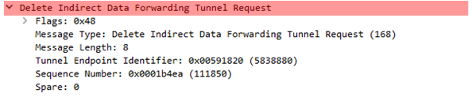](https://blogger.googleusercontent.com/img/b/R29vZ2xl/AVvXsEg8Q8D8SfGdPKf-HuJzJDOz4Jl7yB0M7IyVt0CdyZfjCGUOiJc9QdWFe-Fp0qUjW-bwXA77Q21XUBf95hPLUYGar-wN9VV4T5oL_sJRweYNKSsqasi-KbGQ_KiMtdTVkx3yMfxF_BOoKq4/s1600/Fig9.+Delete+Indirect+Data+Fowarding+Tunnel+Req%2528173%2529.png)

Figure 9. Delete Indirect Data Forwarding Tunnel Request

[18] The SGW responds with *Delete Indirect Data Forwarding Tunnel Response* to the MME.

[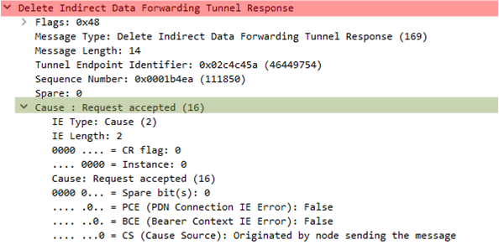](https://blogger.googleusercontent.com/img/b/R29vZ2xl/AVvXsEhIOdgc1sS_0qEwhGuXwOSuom1bF6DxCopYnSaTgG64cy4pqcuXFiXZaoTgZ5oT6-M-C1Eik5wtCU-hAh-I5aq4eN_hm5UrHhuVgri-xET9aBwj2AEM1gSRKnhu4mT7JgM-QaCu3pMSRxg/s1600/Fig10.+Delete+Indirect+Data+Fowarding+Tunnel+Rsp%2528178%2529.png)

Figure 10. Delete Indirect Data Forwarding Tunnel Response

***Red Mouse***

**REFERENCES**

[1] 3GPP TS23.401, “General Packet Radio Service (GPRS) enhancements for Evolved Universal Terrestrial Radio Access Network (E-UTRAN) access”, v12.4.0, Mar 2014

[2] 3GPP TS29.274, “Evolved General Packet Radion Service (GPRS) Tunneling Protocol for Control Plane (GTPv2-C); Stage3”, v13.2.0, Jun 2015

[3] 3GPP TS36.411, "Evolved Universal Terrestrial Radio Access (E-UTRA); S1 Application Protocol (S1AP)", v13.0.0, Jun 2015